1. Purpose
   1. These repair instructions sequentially detail the complete disassembly and reassembly process for the Ready Warm Tissue Bath. Repair or replace components as needed before reassembling the device. If a full disassembly is not required, omit steps as deemed necessary.
   2. These repair instructions are valid for Revision A of the Ready Warm Tissue Bath (101384-A).
   3. Certain components require manual removal of the rivets. To avoid this, it is recommended to acquire and use new components where necessary.
2. Contents
   1. Equipment/Software
   2. Disassembly Guide
   3. Wiring Guide and Diagram
   4. Reassembly Guide
   5. Unit Setup
3. Equipment/Software
   1. Item List

|  |  |  |  |
| --- | --- | --- | --- |
| **ITEM #** | **PART #** | **DESCRIPTION** | **QTY.** |
| 1 | 100061 | Screw; Machine; M3 x 0.5 5mm | 2 |
| 2 | 100099 | Power Switch | 1 |
| 3 | 100179 | Terminal; quick disconnect; 16-14 AWG; Blue Insulation; 0.187” x 0.032” Tab | 3 |
| 4 | 100196 | Wire; Black; 16 AWG; 600 V; spool of 250” | 53” |
| 5 | 100197 | Wire; Red; 16 AWG; 600 V; spool of 250” | 38” |
| 6 | 100385 | Wire; Black; 18 AWG; 300 V; spool of 250” | 31” |
| 7 | 100386 | Wire; Red; 18 AWG; 300 V; spool of 250” | 24” |
| 8 | 100404 | Washer; fender; M4; 1.00mm OD; stainless steel | 4 |
| 9 | 100411 | Adhesive Wire Clamp | 2 |
| 10 | 100729 | Pull Handle w/ Threads, Round, 304 SS, Polished, 3” Center-to-center | 1 |
| 11 | 100738 | 18-8 Stainless Steel Flat-Head Socket Cap Screw, 8-32 Thread, 3/4" Long | 2 |
| 12 | 101398 | Disc Thermostat; snap action; open on rise | 1 |
| 13 | 100764 | Relay; Solid State; 5-220VDC, 10A output; 3-32VDC input | 1 |
| 14 | 100814 | Rubber feet; Bumper; 8-32 Stud Thread | 6 |
| 15 | 100879 | Blind rivet; domed head | 8 |
| 16 | 100987 | Rivet; Blind; Soft Materials; .125 x .512; Aluminum | 2 |
| 17 | 101043 | Terminal; Closed end splice; 22-10AWG; Purple insulation | 2 |
| 18 | 101071 | Screw; Machine; M4 x 8mm; BHCS; SS | 14 |
| 19 | 101084 | Screw; Machine; M4 x 6mm; Pan Head; Philips; SS | 6 |
| 20 | 101229 | Label; Caution Hot Surfaces | 1 |
| 21 | 101250 | Arduino MEGA 2560 R3 microcontroller board | 1 |
| 22 | 101251 | Touchscreen, 2.8in TFT LCD display, ILI9341 chip | 1 |
| 23 | 101340 | HEX Standoff #4-40 Nylon 5/8” | 4 |
| 24 | 101341 | HEX NUT #4-40 Nylon 1/4” | 4 |
| 25 | 101373 | Tissue Bath Front Label | 1 |
| 26 | 101374 | Lid; Acrylic | 1 |
| 27 | 101375 | Body Plate; SS; 20ga | 1 |
| 28 | 101376 | Base Plate; SS; 20ga | 1 |
| 29 | 101377 | Stainless Bowl; SS 20ga | 1 |
| 30 | 101378 | Aluminum Heat Plate; Anodized; Black | 1 |
| 31 | 101379 | Heating Element; 24V; 40W | 3 |
| 32 | 101380 | LEDs; Waterproof Strip; Reel | 7.8” |
| 33 | 101382 | Pyrex Dish | 1 |
| 34 | 101383 | Gooseneck, brushed steel | 1 |
| 35 | 101385 | Temperature Sensor Probe | 1 |
| 36 | 101386 | LED Strip Connector; IP67; Click Tight | 1 |
| 37 | 101387 | PCB; Heated Products | 1 |
| 38 | 101390 | Butyl Sealant Tape 1/4” x 1/2” x 20’ | 6” |
| 39 | 101391 | Terminal; quick disconnect; 20-16 AWG; Red insulation; 0.250” x 0.032” | 2 |
| 40 | 101392 | CONN Power Jack; 2.5 x 5.5 | 1 |
| 41 | 101393 | Splice Lever 10-20AWG 5POS | 2 |
| 42 | 101394 | Water Slide Bracket; SS 20g | 1 |
| 43 | 101395 | Fan; Axial 80x25mm 24VDC Wire; 4 Wire Lead | 1 |
| 44 | 101396 | Label; Power requirement specifications; 24V 6A VDC | 1 |
| 45 | 101399 | Two-Piece Push-In Rivets | 2 |

* 1. Tools Needed
     1. #1 Philips screwdriver
     2. 2.5mm Hex Bit
     3. 2mm flathead screwdriver
     4. Loctite Blue 242

1. Disassembly Guide
   1. Confirm that all necessary components are available to replace damaged or missing components.
   2. Confirm the unit is powered off and no water is present in the Pyrex Dish or the unit. Remove the Pyrex Dish and Lid from the unit.

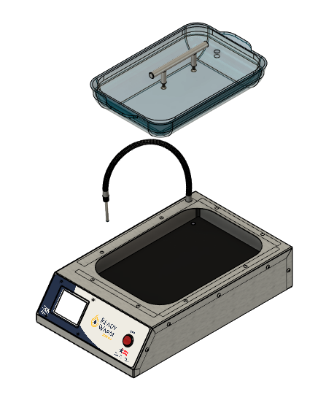

* 1. Unscrew 14 101071 screws from the unit.

* 1. Unscrew 6 100814 rubber feet from the unit.

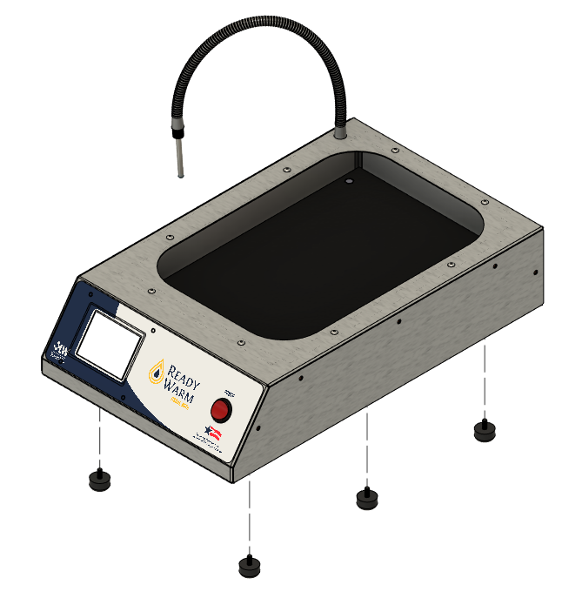

* 1. Remove the base from the unit. Note that wires from the fan and the SSR will be connected to components fastened on the base; unfasten the wires to fully separate the base from the body. Unscrew 2 101084 screws from the Solid State Relay and remove the Solid State Relay from the unit. The fan (101381) is riveted to the unit and cannot be removed without manually removing the rivets. If the fan has been rendered nonfunctional or damaged, acquire a new base.

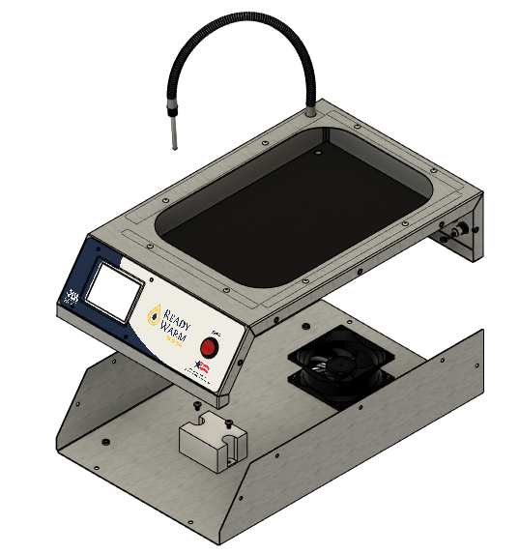

* 1. Unscrew two 100061 screws to remove the Disc Thermostat.

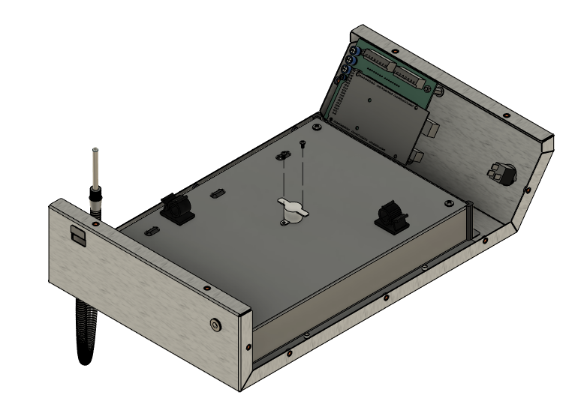

* 1. Unfasten all wires and quick disconnect terminals connected to the Heated Products Control Board (101387) and Power Switch (100099) to facilitate disassembly.
  2. Unthread the Temperature Probe (101385) through the Gooseneck (101383) and remove the hex nut associated with 101383 to remove the Probe and Gooseneck from the unit.

* 1. Remove all Butyl Sealant Tape (101390) from the unit.
  2. Remove the Power Switch (100099) and the Power Jack (101392) from the unit. Preserve wiring if components are still functional and not damaged.

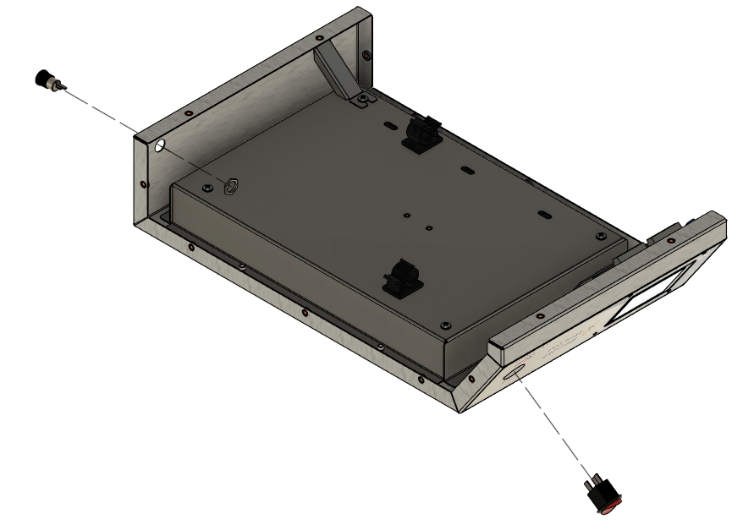

* 1. Unscrew 1 101084 screw located where the Water Slide Bracket (101394) is fastened to the Stainless Bowl (101377) to enable removal of the Water Slide Bracket.

* 1. Remove the Arduino Drive Board (101250) from the Heated Products Control Board

* 1. Unfasten 4 Nylon Hex Nuts (101341) from the Heated Products Control Board.

* 1. Remove the Heated Products Control Board.

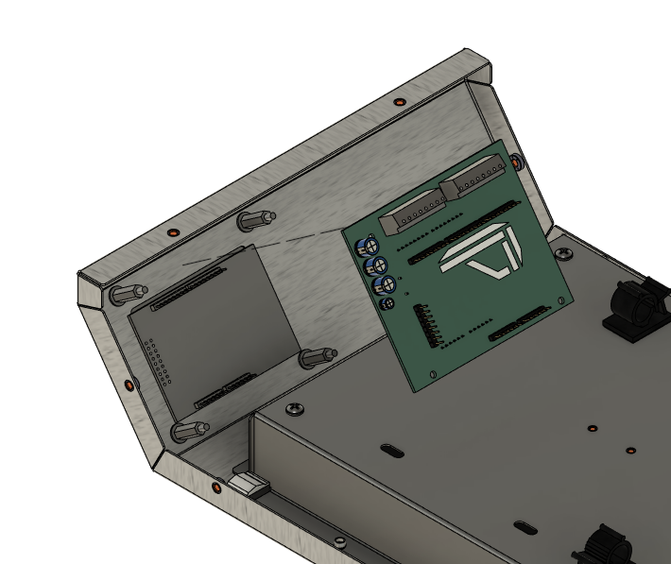

* 1. Remove the Arduino Touchscreen (101251)

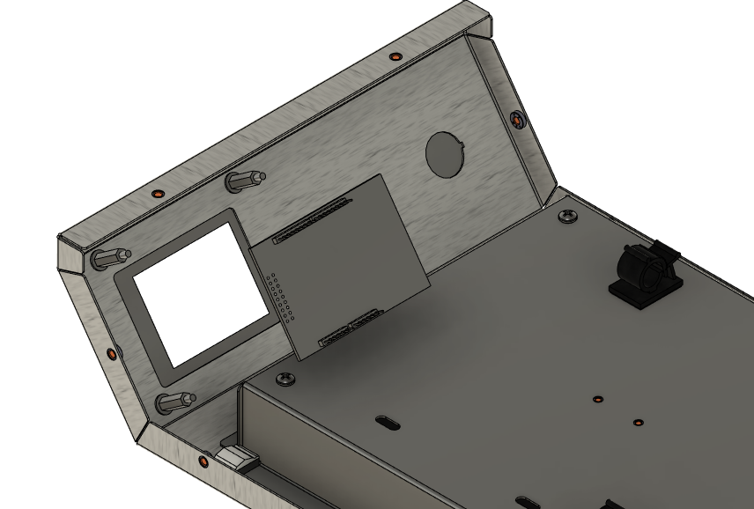

* 1. Remove 4 Nylon Hex Standoffs (101340)

* 1. Remove 4 100404 washers from the unit.

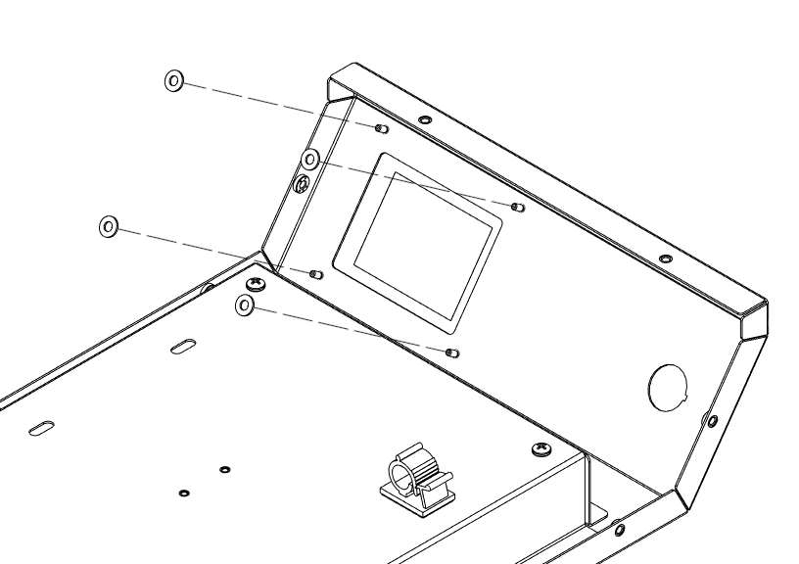

* 1. Remove the front label from the unit.

* 1. The Stainless Tub (101377) is riveted to the Body (101375) and cannot be removed from the unit without manually removing the rivets. The Waterproof LED Strip (101380) is attached under Stainless Bowl and cannot be removed without manually removing the rivets. The Aluminum Heat Plate (101378) cannot be removed without manually removing the rivets. It is recommended to acquire replacements for these components.
  2. After completing step 4.19, the unit cannot be disassembled further without manually removing the rivets. Acquire replacement components as needed in accordance with the Parts List in section 3.0.

1. Wiring Guide and Diagram

1. Reassembly Guide
   1. At this stage, all components requiring replacement for the Tissue Bath must be acquired and prepared for use in reassembly.
   2. Begin by ensuring the replacement Control Board is flashed with the correct software.

* 1. If the fan was removed, attach the new fan (101395) to the base plate (101376) using 2 push-in rivets (101399) diagonally across from each other as shown in Figure 5, ensuring that the sticker side of the fan (the side where air flows outward) is facing the fan grate. Snip off excess shank. Position the fan wires so that they protrude from the bottom right corner of the fan when facing the base plate form the front, extending towards the front angled end of the base plate. Otherwise, acquire a new base plate and fan combination.
  2. Attach the solid-state relay (100764) to the base plating using 2 screws (101084).
  3. Attach 6 rubber feet (100814) to the base plate.

100987

101376

Output

Input

101395

101084

100764

100814

* 1. Removing the 3 24V 50W heating elements (101379) from the Heat Plate (101378) requires manual removal of rivets. If the heating elements are still functional, the following steps detailing the placement and assembly of the heating elements are not required.
  2. Attach 3 24V 50W heating elements to the Heat Plate using the adhesive on the bottom of each heating element, ensuring the wires of each heating element are threaded through the respective 3 openings in the heat tub.

* 1. Attach the disc thermostat (101398) to the heat tub (101377) using two screws (100061).

* 1. Align the Water Slide Bracket (101394) with the hole on the heat tub adjacent to the rectangular opening.
  2. Attach the heat plate to the heat tub using four screws (101084), ensuring the wires for all 3 heating elements are threaded through the 3 openings on the side of the heat tub.
  3. Attach two adhesive wire clamps in the position shown below.

* 1. Cut approximately 6 inches of Butyl Tape (101390). Divide the length of butyl tape into 3 sections of .5 inch length and 4 sections of 1.5.
  2. Using the 3 sections of .5 inch length, apply and mold the tape around the wires protruding from the three openings on the heat tub to create a watertight seal around the wires.
  3. Using the 4 sections of 1.5 length, apply and mold the tape around the four corners of the heat tub to create a watertight seal.

* 1. Attach the Arduino Assembly to the Body Plate (101375) using 4 washers (100404), 4 nylon standoffs (101340), and 4 nylon nuts (101341). The Arduino Control Board can be temporarily removed throughout this step as needed for ease of assembly.

* 1. Cut the LED Strip (101380) to a length of approximately 7.8” at a designated cut line to create a strip 4 sections long. Peel off the adhesive. Lift the clear plastic cover of the LED strip Connector (101386) and slide the strip in until it hits the backstop. The LED strip should sit under the lowest clear tab. Push the tab down using pliers to ensure a secure connection. The teeth should pierce through the metal terminals of the strip. Lift the other clear end and slide two 18 AWG wires of 8” length to slide the wires in the grooves. These two wires are specified in the wiring diagram. Click the cap down using pliers as necessary. Use the adhesive on the LED Strip to adhere the strip to the bottom side of the Top Plate. Place a small amount of butyl tape on the other end of the strip.

* 1. Align the power jack (101392) with the cutout for the power jack on the Top Plate Assembly. Attach the power jack using the included nut. Solder wires to the power jack in accordance with the wiring diagram.

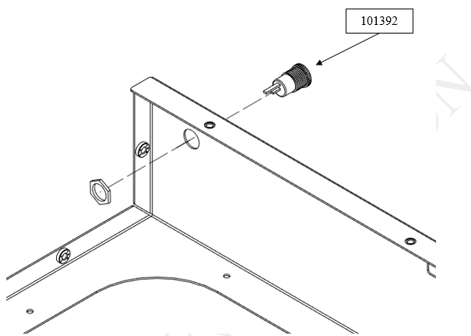

* 1. Align the water slide bracket (101394) with the hole located in the back of the Body Assembly before lowering the Heat Tub assembly into the unit. Attach the Heat Tub and Heat Plate Assembly to the Body Plate using 8 rivets (100879), ensuring that the front edge of the Heat Tub is aligned with the LED strip.

* 1. Apply the label (101373) to the front of the body.

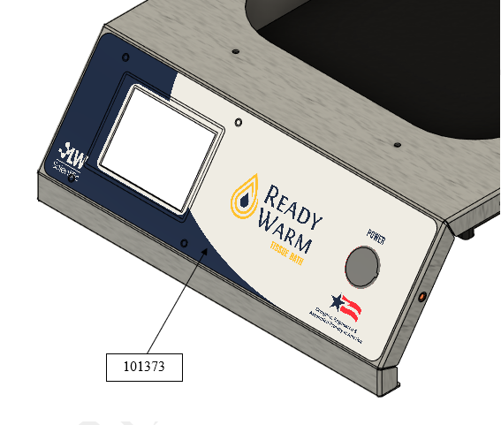

* 1. Align the key of power switch (100099) to the keyway of the large hole on the front of the body assembly and press the switch into the body.

* 1. Attach the gooseneck tubing (101383) through the Top Plate Assembly and through the Heat Tub and Heat Plate Assembly using the hole cutout. Tighten the gooseneck using Loc-Tite Blue 242 and the provided nut. Thread the Temperature Probe (101385), wire end first through the gooseneck tubing from the male end protruding outside the unit to the other male end.

* 1. Place the Base Plate Assembly next to the Top Plate, Heat Tub and Heat Plate Assembly and wire the unit in accordance with the wiring diagram.
  2. Attach the Top Plate Assembly to the Base Plate Assembly using 14 screws (101071).

* 1. Attach the handle (100729) to the acrylic lid (101374) using two screws (100738).

* 1. Place the Pyrex Dish (101382) onto the Tissue Bath.

* 1. Place the Lid onto the Pyrex Dish with the hole for the temperature probe facing the rear end of the unit.

* 1. Attach the electrical specifications label (101396) on the back of the unit to the right of the power jack.
  2. Attach the “Caution Hot Surface” (101229) label to the top of the unit above the label.

1. Unit Setup
   1. Plug the unit in using a 24V 6A power adapter (101357). Remove the lid from the Pyrex Dish.
   2. Fill the Pyrex Dish with water to a height of approximately 0.8 inches. Replace the lid so that the opening for the probe is positioned at the back of the unit.
   3. Insert the temperature probe into the probe opening and ensure the probe is submerged in the water.
   4. Turn on the unit and display the temperature in Fahrenheit using the toggle on the right side of the screen.

* 1. Set the unit to 113°F and allow the unit to come to temperature for 1 hour. The water should be stable at 113°F, +/- 1°F
  2. Use a calibrated IR thermometer to confirm the actual temperature of the water in the unit. If the temperature is different than what is displayed on the unit, adjust the offset until the display of the unit and the IR thermometer match readings.
  3. If it is necessary to adjust the offset, navigate to the PID Settings page by pressing the gear icon in the bottom left, selecting Diagnostics, then selecting PID settings.
  4. Use the up and down arrows to modify the 0 (Offset) value as needed. Increasing/decreasing the offset will increase/decrease the temperature reading by the equivalent amount.

* 1. The unit is now ready for use.