1. Purpose
   1. The following work instructions describes the procedure to replace the E8 Lid Latch.
   2. These repair instructions are valid for E8V rev F, E8F rev D, E8T rev F.
2. Equipment/Software

|  |  |  |  |
| --- | --- | --- | --- |
| ITEM # | PART # | DESCRIPTION | QTY. |
| 1 | 100073 | Latch | 1 |
| 2 | 100473 | Cam Latch; 1.5” | 1 |

* 1. #1 Screwdriver.
  2. Loc-Tite Blue 425.
  3. Hios CL-6500 electric driver with #3 Phillips screwdriver bit.

1. Instructions
   1. Confirm that all components are present to complete the conversion.
   2. Open lid. Remove old latch by untightening the cam lock (100473) to the latch, removing the existing latch nut, and cleaning residual Loc-Tite Blue 425.
   3. Install new latch by tightening the latch to the lid (100202) using Loc-Tite Blue 425 and the provided latch nut, ensuring that the latch is at the open position (maximum counter-clockwise rotation when viewing from the top) and can rotate approximately 90° clockwise to the lock position. Ensure the nut is fully seated against the lid.

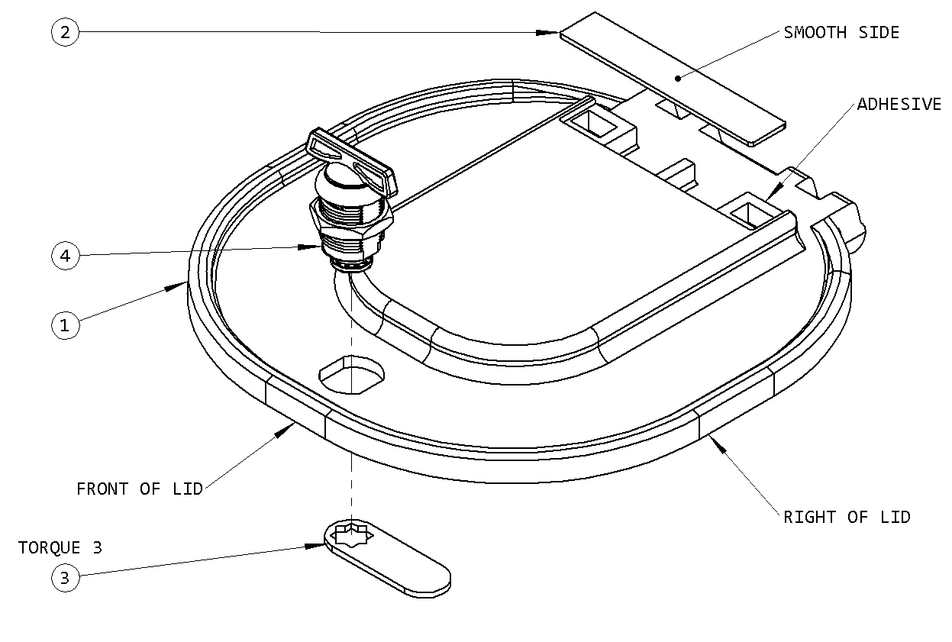

1 x Latch (100073)

1 x Cam Latch (100073)

1 x Lid (100202)

* 1. With the latch in the open position, tighten the cam lock (100473) to the latch, with the cam lock facing the right side of the lid, using Loc-Tite Blue 425 and the screw provided with the latch. Tighten to torque setting 3 using the Hios CL-6500 electric driver and a #3 Phillips screwdriver bit.
  2. Close lid and ensure normal laboratory operations.