- Purpose
  - This work instruction describes the process of replacing the Power Input on the MX12 centrifuges.

- Equipment/Software

ITEM # | PART # | DESCRIPTION | QTY.
1 | 100053 | Power Input | 1

  - TOOLS NEEDED
  - Philips-screwdriver
- Instructions
  - Confirm that all necessary components are present to complete the conversion.
  - Turn off the power on your MX12 unit and disconnect the power cord.
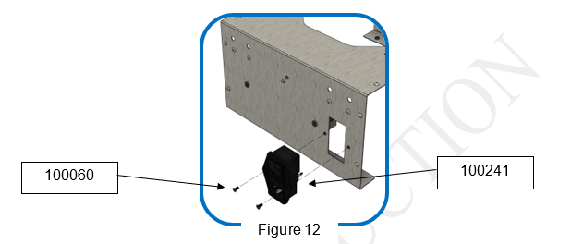
  - Using your Philips-screwdriver to unscrew 2 M3x6mm screws (100060), carefully remove the Power Input (100053) from the unit. Do not remove it completely as there will be wires connected from inside. Figure 1
100053
Figure 1

  - Unplug the 3 wire (101023) connecters from the old Power Input (100053), remove the old Power Input and discard it. Figure 2
  - Plug in the 3 wire connecters (101023) in the new Power Input (100053). Figure 2
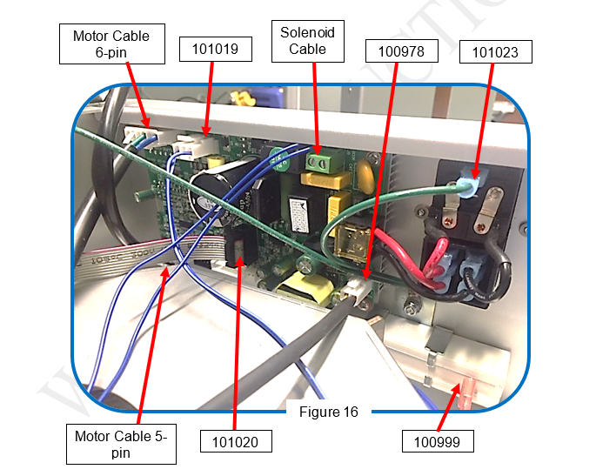
Figure 2

  - Install the new Power Input (100053) into the unit. Use your Philips-screwdriver to tighten the 2 M3x6mm screws (100060) till they are snug.
  - Connect your MX12 unit to power and turn it on to verify successful replacement of the new Power Input (100053).
  - This completes the repair.

