1. Purpose
   1. This work instruction describes the process for replacing the MXU Speed Wheel.
   2. These repair instructions are valid for revision C MXU Digital Centrifuges. For revisions older than C, please consult Product Development.
2. Equipment/Software

|  |  |  |  |
| --- | --- | --- | --- |
| ITEM # | PART # | DESCRIPTION | QTY. |
| 1 | 101103 | Speed Sensor Wheel | 1 |
| 2 | 101104 | Speed Sensor Hub | 2 |
| 3 | 101105 | Speed Sensor Hub Stop | 1 |
| 4 | 100787 | Blind Rivet, SS | 2 |

* 1. Phillips Head Screwdriver

1. Instructions
   1. Confirm that all necessary components are present to complete the conversion.
   2. Open the lid and remove the rotor and tube shields from the unit. *Figure 1*

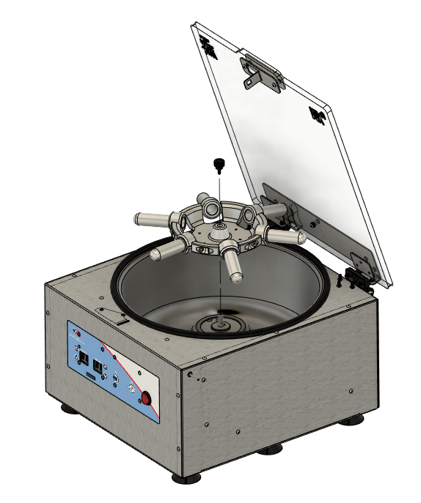

*Figure 1*

* 1. Turn the unit over onto its lid and remove the base plate. *Figure 2*

**NOTE: Avoid overextending****connected wires when removing the base plate.**

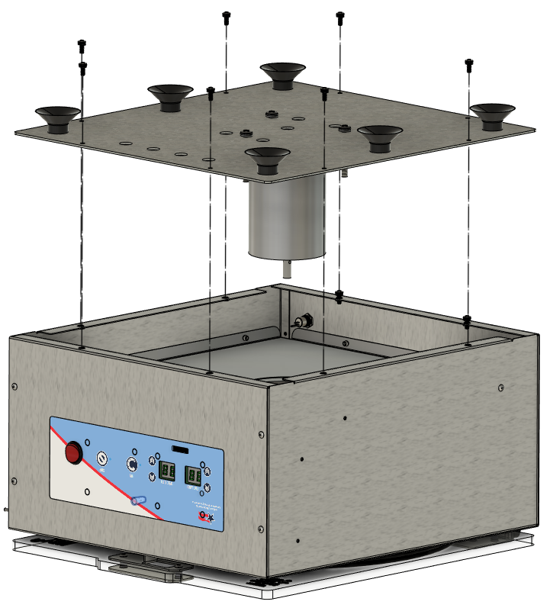

*Figure 2*

* 1. Disconnect the Motor (J3) and the Speed IR Sensor (J6) from the Motor Drive Board. *Figure 3*

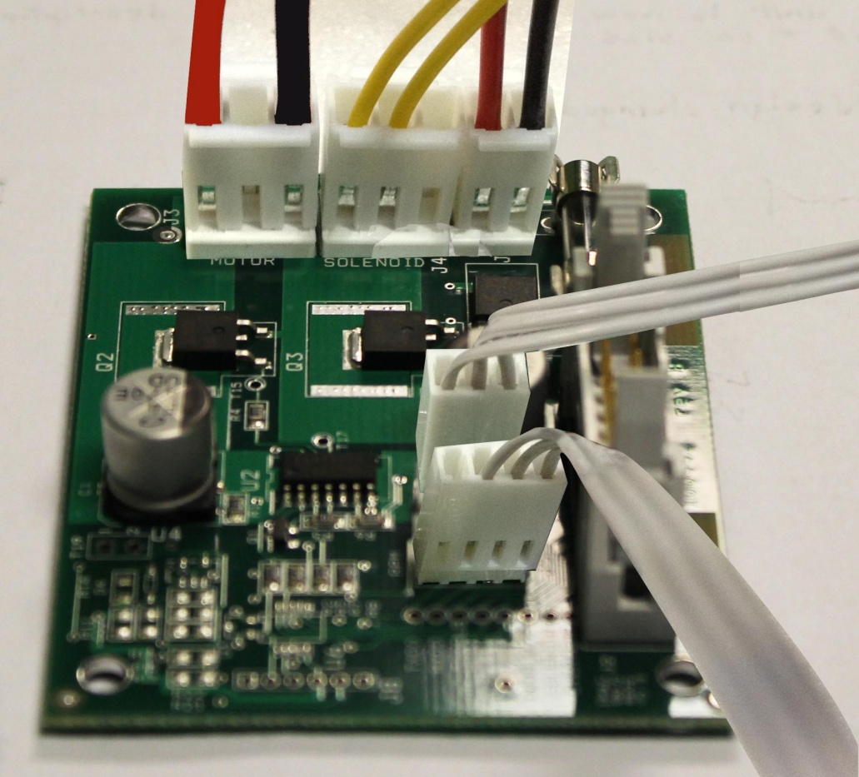

**J3**

**J6**

*Figure 3*

* 1. Remove the Motor Assembly from the Base Plate. Set the Base Plate aside. *Figure 4*

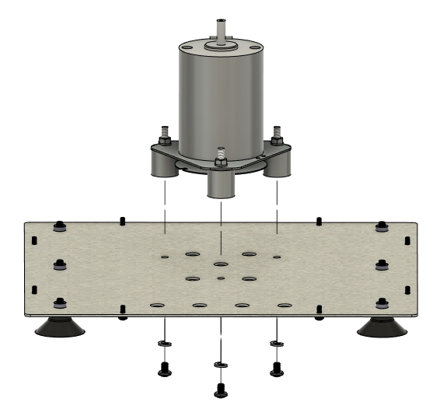

*Motor Assembly*

*Base Plate*

*Figure 4*

* 1. Remove the Speed Wheel Assembly from the Motor Assembly. *Figure 5*

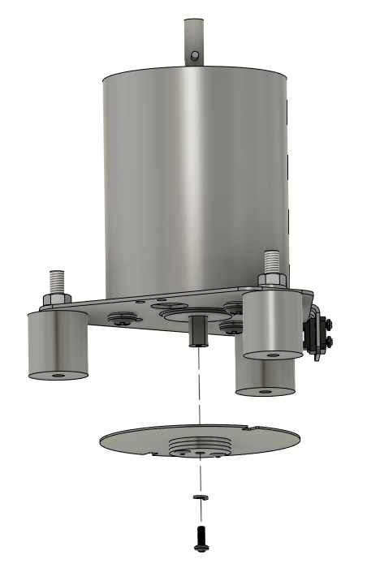

*Speed Wheel Assembly*

*Figure 5*

**Speed Wheel Assembly**

1. Align the Speed Wheel (101103), Speed Wheel Hubs (101104), and Speed Wheel Hub Stop (101105) as shown in Figure 6.
2. Ensure that all pieces lay flat together and no burrs are present.
3. Rivet the pieces together with Blind Rivets (100787)

|  |  |  |  |
| --- | --- | --- | --- |
| ITEM # | PART # | DESCRIPTION | QTY. |
| 1 | 101103 | Speed Sensor Wheel | 1 |
| 2 | 101104 | Speed Sensor Hub | 2 |
| 3 | 101105 | Speed Sensor Hub Stop | 1 |
| 4 | 100787 | Blind Rivet, SS | 2 |

*Figure 6*

* 1. Re-attach the new Speed Wheel Assembly to Motor Assembly. *Figure 7*

*Figure 7*

* 1. Re-attach Motor Assembly to Base Plate. *Figure 8*

*Figure 8*

*Motor Assembly*

*Base Plate*

* 1. Re-connect the Motor and Speed IR Sensor to the Motor Drive Board. *Figure 9*



**J3**

**J6**

*Figure 9*

* 1. Re-attach the Base Plate to the Body. Power the unit on and verify it functions under normal laboratory use. *Figure 10*



*Base Plate*

*Body*

*Figure 10*