1. Purpose
   1. This work instruction describes the process for replacing the MXU Power Jack.
   2. These repair instructions are valid for revision C MXU Digital Centrifuges. For revisions older than C, please consult Product Development.
2. Equipment/Software

|  |  |  |  |
| --- | --- | --- | --- |
| ITEM # | PART # | DESCRIPTION | QTY. |
| 1 | 100300 | Power Jack Wiring Assembly | 1 |

* 1. Phillips Head Screwdriver
  2. Crescent Wrench

1. Instructions
   1. Confirm that all necessary components are present to complete the conversion.
   2. Open the lid and remove the rotor and tube shields from the unit. *Figure 1*

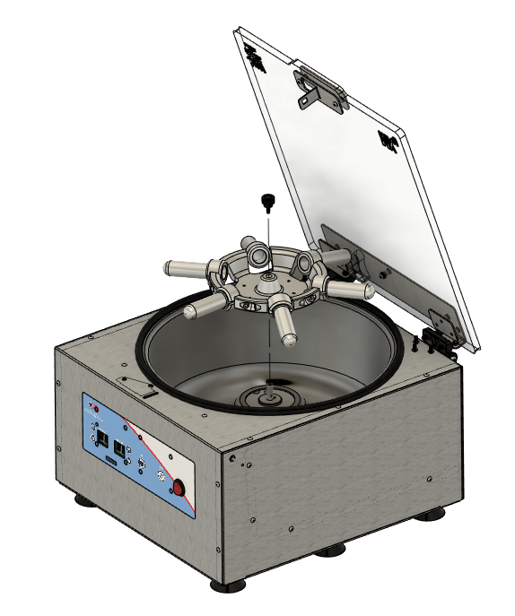

*Figure 1*

* 1. Turn the unit over onto its lid and remove the base plate. *Figure 2*

**NOTE: Avoid overextending****connected wires when removing the base plate.**

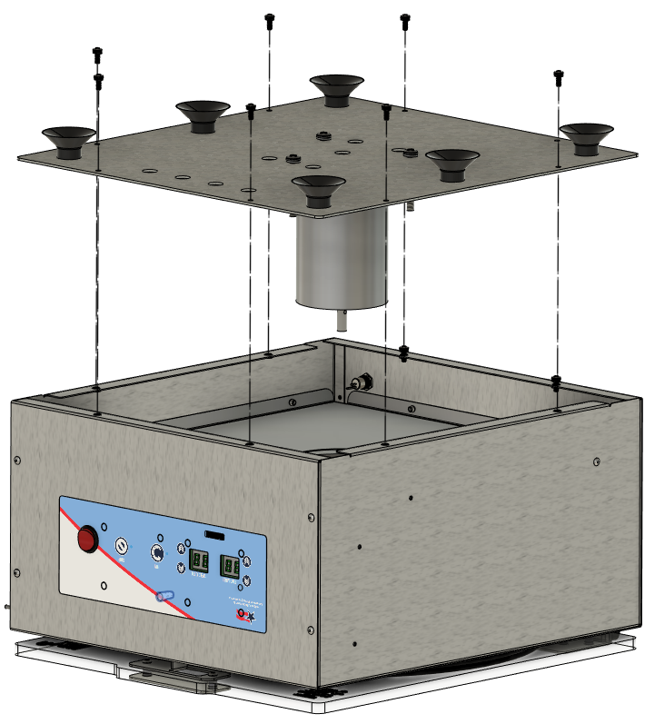

*Figure 2*

* 1. Disconnect the Motor (J3) and the Speed IR Sensor (J5) from the Motor Drive Board. *Figure 3*

**J3**

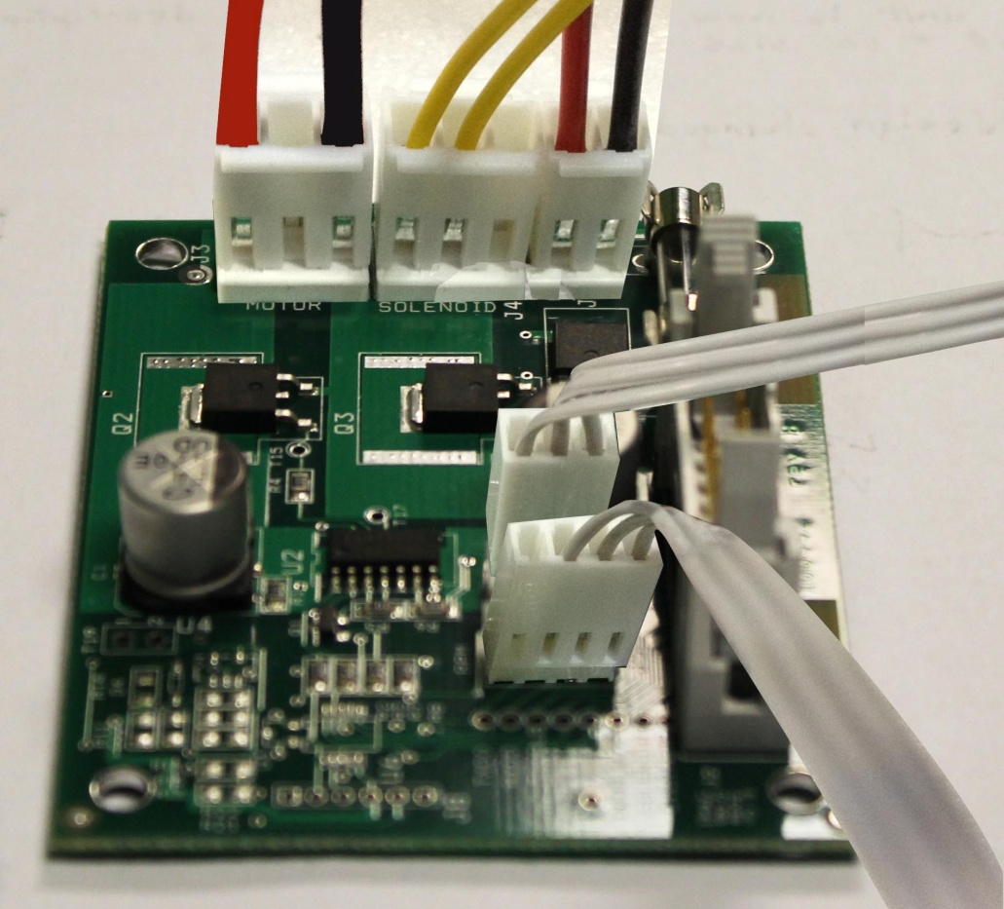

**J5**

*Figure 3*

**Wiring Harness Assembly**

1. Disconnect the 100300-B and 100325-B Wires shown in Figure 4.
2. Remove the washer and nut holding the Power Jack in place at the back of the body.
3. Pull the wires of the power jack wiring assembly (100300-B) through the small hole on the back of the body assembly and then replace it with the new one.
4. Tighten the power jack to the body assembly using the provided power jack washer and nut.
5. Attach the quick disconnect of the power connector wiring assembly (100325-B) to the power switch lead indicated in Figure 19.
6. Attach the quick disconnect of the power jack wiring assembly to the power switch lead indicated in Figure 19.
7. Place the female terminal of the power jack wiring assembly in the 2 circuit housing of the power connector wiring assembly.
8. Route the wires through the two Wire Clamps (100411) adhered to the underside of the Electronics Shield (101113-B)

|  |  |  |  |
| --- | --- | --- | --- |
| ITEM # | PART # | DESCRIPTION | QTY. |
| 1 | 100300-B | Power Jack Wiring Assembly | 1 |
| 3 | 100325-B | Power Connector Wiring Assembly | 1 |

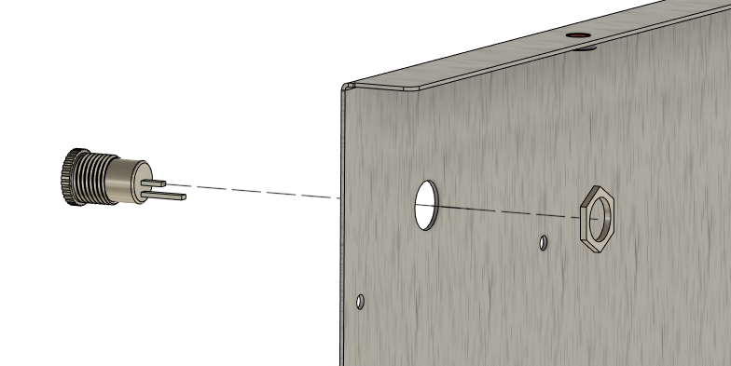

*Figure 7*

*Figure 4*

*Figure 7*

* 1. Re-connect the Motor (J3) and the Speed IR Sensor (J5) to the Motor Drive Board. *Figure 5*



**J3**

**J5**

*Figure 5*

* 1. Re-attach the Base Plate Assembly to the Body. *Figure 6*



*Figure 6*

* 1. Replace Rotor, close the lid, and verify the unit powers on and functions under normal laboratory use.

