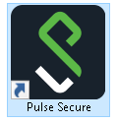
- Launch Pulse Secure using the Start menu or Desktop
  - Desktop

  - Start Menu
- Click the Connect button

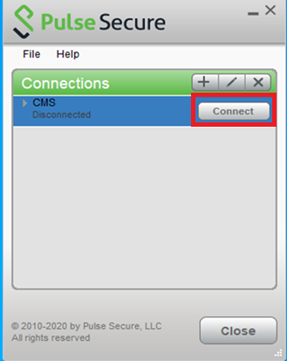

- Enter your CMS username and password and click Connect
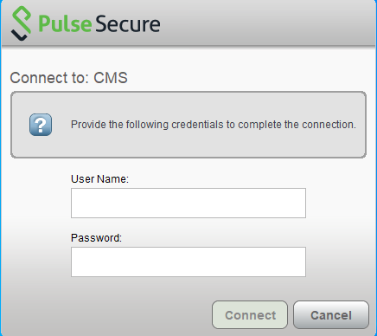

- Open Google Chrome and paste the following link (save to bookmarks for convenience)
https://web.qiesnet.org/qiesmds/mds_home.html

