Clearing Cache in Google Chrome
- While Google Chrome is open, click the three dots icon on the top right of the screen.
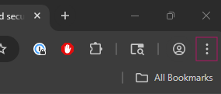
- Select “Delete Browsing Data” from the list.
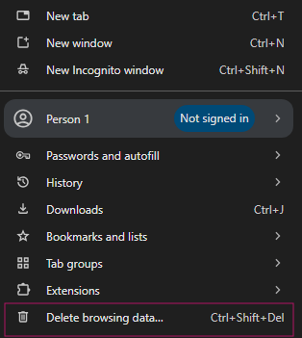

- In the window that pops up, select the “Advanced” tab.
  - Time Range: 7 Days.
  - Make sure only “Cookies...” and “Cached...” are checked in the list.
  - Click “Delete Data”
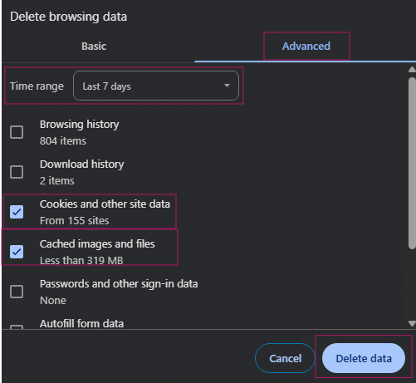
- Close out of Chrome and re-open.

