



**IN-OFFICE ACNE HOME CARE GUIDELINE**

***Revised 9-29-18***

**TABLE OF CONTENTS**

|  |  |
| --- | --- |
| Introduction – The Basics | 2 |
| Assessing Skin Type | 3 |
|  |  |
| Acne Type and Severity | 5 |
| Fitzpatrick Skin Types | 6 |
| Bi-weekly Regimen Changes | 7 |
| What Your Client Needs to Know | 10 |
| Do’s and Don’ts | 11 |
| Chapter 2 – Combination Acne | 12 |
| Chapter 3 – Inflamed Acne | 14 |
| Chapter 4 – Non-inflamed Acne | 22 |
| Chapter 5 – Back Acne | 28 |
| Chapter 6 – Acne Rosacea | 33 |

Chapter 1 – The Basics

Acne Home Care Guideline

This **Acne Home Care Guideline** is organized by acne type and acne severity. We have included variables for skin type (dry, normal or oily) and also for Fitzpatrick types.

This guide explains in detail what products your client will start using. It also includes a detailed explanation of specific recommendations for *how to adjust* a client’s home care regimen every two weeks.

**Assessing Your Client’s Home Care Regimen**

You will need to take five things into consideration when assigning a home care regimen:

1. Skin Type

3. Acne Type and Severity

4. Fitzpatrick Type

5. Environment

Armed with this information, you will help you to determine which products they will start with and what the Bi-weekly Regimen Changes will be.

1. Skin Type

Skin Types are determined by:

• Genetics

• Age

For the most part, people are born with their skin “type”. It has to do with the size of the oil glands. Some people get “dry skin” and “dehydrated skin” confused. Dry skin means the type of skin one has (not much oil production at all); whereas, dehydrated skin means a skin condition where the skin does not have enough water / moisture in it. This may be from harsh products or a dry environment that lacks humidity.

The blue zones on the faces below are the T-zones of each skin type. As oil production increases with each skin type, the T-zone becomes wider and the follicle size becomes larger.

As we age, the skin becomes less oily. Environments affect skin “conditions”. Skin conditions are not inherent but what your skin is at the effect of, like climate, medications, products, etc. For example, skin will be more oily in humid climates, drier in dry climates. The exception is the use of isotretinoin (Accutane**™**) which can affect skin type. It will make the skin less oily than before as it affects sebum output.

|  |  |
| --- | --- |
|  | Very Dry Skin Type  • Follicle size is extremely small  • T-zone in nose only (if any at all)  • Never feels oily after cleansing |
|  | Dry Skin Type  • Follicle size is small  • T-zone extends to the inner corner of the eye  • May feel oily 10 to 12 hours after cleansing |
|  | Normal Skin Type  • Follicle size is medium  • T-zone extends to inner corner of iris  • May feel oily 7 to 9 hours after cleansing |
|  | Oily Skin Type  • Follicle size is large  • T-zone extends to the middle of the eye  • May feel oily 4 to 6 hours after cleansing |
|  | Very Oily Skin Type  • Follicle size is very large  • T-zone extends to the entire face  • May feel oily 1 to 3 hours after cleansing |

3. Assessing Acne Type and Severity

**Acne Type**

• Inflamed – pimples, pustules, cysts, nodules

• Non-inflamed – blackheads, whiteheads (open and closed comedones)

• Combination of inflamed and Non-inflamed

**Acne Severity**

You will assess whether your client’s acne is mild, moderate, or severe:

• mild = 10 lesions or less,

• moderate = 10 to 30 lesions,

• severe = 30+ lesions.

You don’t need to count the lesions – just make an estimate. If the client has combination acne, note the severity of the inflamed AND the severity of the Non-inflamed acne. Note all findings in your client treatment notes.

**Inflamed Acne**

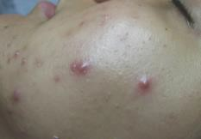

**Non-inflamed Acne**

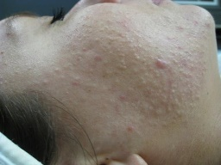

**Combination Acne**

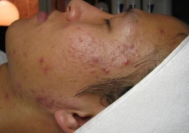

4. Fitzpatrick Skin Types

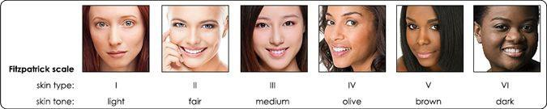

|  |  |  |  |  |  |
| --- | --- | --- | --- | --- | --- |
| Very white or freckled | White | White to Olive | Brown | Dark Brown | Black |
| Always burns  Never tans | Usually burns  Sometime tans | Sometimes burns  Always tans | Rarely burns  Always tans | Rarely burns  Always tans | Rarely burns  Always tans |

When figuring out someone’s home care regimen, another variable you must consider besides skin and acne type, is someone’s **Fitzpatrick type.**

The darker someone’s skin is, the more cautious you have to be about strong products. Always err on the side of caution, especially with benzoyl peroxide, when assigning a home care regimen. If their acne warrants Acne Med 5%, but they are a Fitzpatrick IV or higher, give them Acne Med 2.5%. You can always adjust up later if their skin doesn’t react to the Acne Med 2.5%.

Below is a picture of hyperpigmentation from benzoyl peroxide use. Don’t worry, because the pigmentation is new, it will lift much more easily than pigmentation that is caused by the sun or melasma. It will still take some time – give it four to six weeks. Assure your client of this, if this happens.

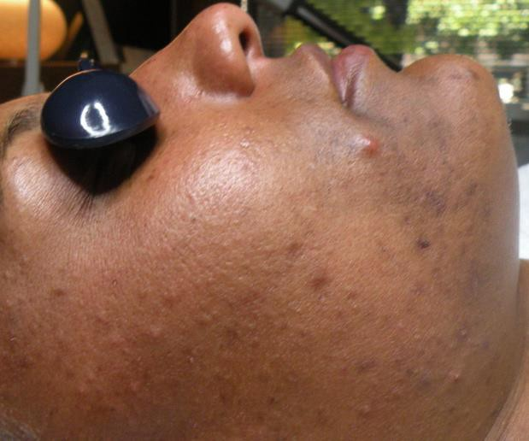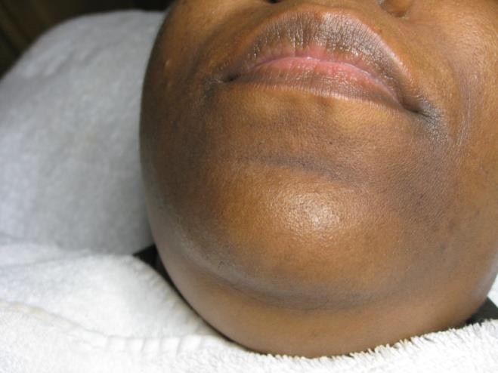

Bi-weekly Regimen Changes for *Active Products

**Week One through Week Six**

*active products refer to serums and benzoyl peroxide

Once you determine what products your client will use by using the **Acne Home Care Guideline**, this is HOW they will use the active products.

• For most clients, you will not change the *strength* of the serum, *just the frequency* of use for the first six weeks.

• If they have never used benzoyl peroxide before (or have only spot-treated with it),

always have them use the timed schedule. Timed schedule is on the next page.

Weeks

1 and 2

Weeks

3 and 4

Weeks

5 and 6

**Morning Routine**

**Serum every other day

**Morning Routine**

**Serum every day

**Morning Routine**

**Serum every day

**Evening Routine**

Acne Med Timed Schedule

**Evening Routine**

Acne Med Overnight

**Evening Routine**

**Serum every night

Acne Med Overnight

**Benzoyl Peroxide (Acne Med) Timed Schedule**

When a client who is not using benzoyl peroxide (or has used it only as a spot treatment) begins the home care routine for the first time, they will follow a timed schedule for the first two weeks. This will help their skin acclimate to benzoyl peroxide and also prevent their skin from getting worse before it gets better. This schedule is in the client home care instructions:

Day 1: Apply thin coat to face, avoiding neck and eye area. **Leave this on for 15 minutes** and wash off with cleanser.

Day 2: Same as Day 1

Day 3: Same as Day 1

Day 4: Same as Day 1, but leave on for 30 minutes

Day 5: Same as Day 4

Day 6: Same as Day 4

Day 7: Same as Day 1, but leave on for 60 minutes

Day 8: Same as Day 7

Day 9: Same as Day 7

Day 10: Same as Day 7, but leave on for 2 hours

Day 11: Same as Day 10

Day 12: Same as Day 10

Day 13: Same as Day 10

Day 14: Wear Acne Med all night; stop using Balancing Lotion (go to instructions for weeks 3 and 4: apply Cleanser, Toner and Acne Med only)

**Week Seven and Beyond**

The **Acne Home Care Guideline** goes into detail about when to adjust your client’s products in their

process of getting clear, but here are the basics:

**The variables you will need to take into consideration:**

**1. Where are they in the clearing process?**

**a. Do they still have inflamed acne?**

i. Strengthen Acne Med; or,

ii. Strengthen serum percentage

**b. Do they still have Non-inflamed acne?**

i. Add Vivant Vitamin A II or III or Glycolic Serum as a bump up.

**2. What skin *conditions* you need to correct?**

**a. Dehydration and/or irritation–**

i. Find out what is stinging in routine – change that product. Don’t assume what

it may be – it could be the toner or the sunscreen. You must ask them. ii. Give a more hydrating regimen:

1. Give HydraBalance

2. Change cleanser to non-active one

3. Give a more moisturizing toner

4. Give a more moisturizing sunscreen

**Remember!**

With acne management, the home care protocol is a constant balancing act of pushing the skin to clear, but not irritating or drying it out too much. *You are only making your best educated guess as to the next step.*

Sometimes you will be wrong and the worst that can happen is that your client will get dehydrated, irritated skin, which is not the end of the world. **We have all made that mistake.** Just reduce the strength of their regimen and allow the skin to adapt more slowly. If you need to adjust the product to a lesser strength, do not take back the stronger product. Have them keep it, make a note of that in their treatment notes and when it’s time to adjust them back up, they will have it.

Once you are familiar with the properties of each product, it will become second nature to guide them in their process of getting clear. **\*Please refer to the Product Knowledge document for descriptions of each product.**

What Your Clients Need to Know

• Tell your clients that this is *not* an overnight process. It takes an average of 3 months if coming into the office and 4 months if virtual to get their acne clear (up to 5 or 6 months if they have moderate to severe Non-inflamed acne). There WILL be breakouts during that time.

• Even though they are experiencing breakouts, this does not mean that the program is not working. Acne lesions could have started to form *up to three months prior* and are just now surfacing. The products will keep new acne lesions from forming, and you will extract the old lesions as they surface. That is why it takes a minimum three months to achieve clear skin. (This is a great thing to say in a consultation).

• Tell your clients that home care compliance is the number one factor in getting and staying clear. Without compliance, their skin will chronically break out.

Do’s and Don’ts

• When giving a home care regimen to someone who is very young, DO opt for milder products, especially cleanser and toner.

• When the client comes in for a treatment and is severely dehydrated, postpone the adjustment to their home care. If their products burn when applied, have them stop all active for 48 hours, apply Aquafor to any visibly irritated areas and resume the same regimen after the skin has had a few days to calm down. Give them their next regimen change but have them wait a week to start. If they are coming into the office for treatments, postpone their next treatment by 1 week.

To normalize the skin: Be sure they are using plenty of moisturizer, sunscreen and HydraBalance.

• If a client is not dry or dehydrated, or just slightly dehydrated, DO adjust their home care as directed in the **Bi-weekly Regimen Changes**.

• If the skin remains irritated and/or dehydrated for an extended period of time, consider the following in order:

*1.* Make sure the client is moisturizing twice a day with HydraBalance under their Acne Med.

If they are not using Acne Med in the morning, they can apply Balancing Lotion under their sunscreen.

*2.* Give the client a milder cleanser and/or toner.

*3.* Adjust down the strength of their serum and/or Acne med only if they are not able to continue using them consistently on a regular basis.

• Once a client is getting close to being out of a product, especially serums, DO consider strengthening the serum if they are still breaking out.Have them alternate the weaker serum with the stronger one for up to one week but no longer.

• If your client was on antibiotics prior to seeing you, DO consider recommending a good probiotic. Also, let them know their skin will most likely get worse before it gets better.

• Don’t give clients products that are too strong. For example, we rarely give anyone Acne Med 10% with Sulfur or Mandelic 15% Serum for the face. Those are only used with exceptionally tough acne, if tolerated; **and we would never start a client with those strengths.**

• DO read the Product Knowledge Guide. It will also aid you in choosing products for your clients.

Chapter 2

Combination Acne: All Types

Mild Combination Acne

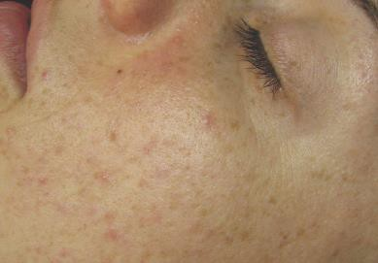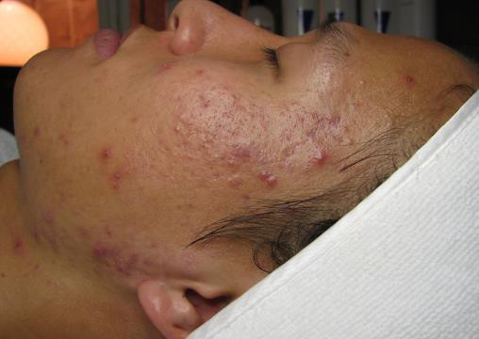

Moderate Combination Acne

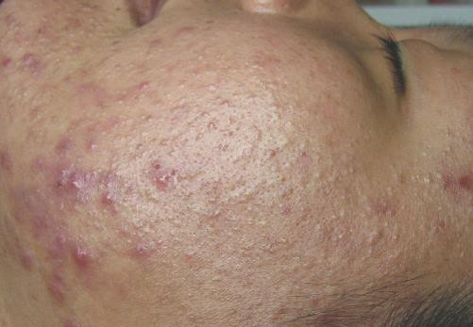

Severe Combination Acne

**Combination Acne: All Types**

Characteristics of combination acne (inflamed and Non-inflamed):

• Redness

• Hot/warm to the touch

• Pimples, pustules, nodules, open and closed comedones

• May be cysts

This is the most common type of acne. This type of acne is a combination of inflamed and Non-inflamed acne lesions. The majority of your clients will begin with combination acne.

Treat the combination client as an inflamed acne client to begin with. Determine whether they are mild/moderate inflamed or severe inflamed and determine their home care products and home care schedule based on the **Inflamed Acne Guideline, Chapter 3**.

When all their inflamed acne is gone, determine the appropriate home care products and home care schedule based on the **Non-inflamed Acne Guideline, Chapter 4**. Start your client with the instructions for weeks 5-6 under Moderate and Severe (even if they are more than 5 to 6 weeks into treatment with you).

Consider transitioning the client from a cleansing wash to a scrub cleanser.

You should also consider adding the Vivant Vitamin A Serum or Glycolic Serum for the remaining Non-inflamed lesions.

Transition to vitamin A if:

1. All inflamed acne is gone

2. If there is still Non-inflamed acne that is not clearing with mandelic serum

3. If there is still brown hyperpigmentation from acne

Chapter 3

Inflamed Acne Types:

Mild, Moderate and Severe

Mild Inflamed

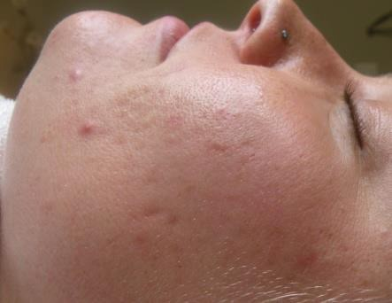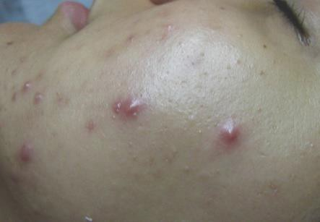

Moderate Inflamed

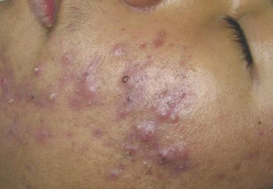

Severe Inflamed

Characteristics of inflamed acne:

• Redness

• Hot/warm to the touch

• More pimples, pustules, and inflamed lesions with very few Non-inflamed lesions

**Inflamed Acne Guideline: Mild and Moderate**

We do not differentiate between mild inflamed acne and moderate inflamed acne. They are treated the same way. The only difference is in the number of inflamed acne lesions the client has.

This type of acne consists of pimples and pustules, sometimes cysts and nodules. Fortunately, inflamed acne usually responds quickly to home care and treatments.

Icing will be your client’s best friend! They will definitely get the best results if they ice their inflamed lesions twice a day after cleansing.

Benzoyl peroxide is also incredibly effective for quickly eliminating the inflammation.

The chart below shows the typical lineup of products used for mild and moderate inflamed

acne for face and/or chest. If a client is more sensitive or reactive, opt for milder products. If a client is sensitive or allergic to Mandelic serums, opt for the Salicylic Gel Serum.

You can also recommend Healthy Skin supplements and/or EPA/DHA fish oil supplements to reduce inflammation.

Recommend that your client begin using benzoyl peroxide (Acne Med) in the evenings, following the timed schedule on page 8.

**Home care products for mild and moderate inflamed acne:**

|  |  |  |  |  |  |
| --- | --- | --- | --- | --- | --- |
| **Skin Type** | **Cleanser** | **Toner** | **Exfoliating Serum** | **Sunscreen** | **Antibacterial** |
| **IRRITATED** | Ultra Gentle  Cleanser | Moisture  Balance Toner | Mandelic 8% or 5% | Moisturizing  SPF30 | Acne Med 2.5% |
| **NORMAL** | Acne Wash AND Ultra Gentle Cleanser | AcneBeta-C Toner | Mandelic 8% | Moisturizing  SPF30 | Acne Med 5% |
| **OILY** | Acne Wash | AcneBeta-C Toner | Mandelic 8% | Daily SPF or Clove Hill | Acne Med 5% |
| **MATURE** | Acne Wash  Cleanser | AcneBeta-C Toner | Mandelic 8% or 5% | Moisturizing  SPF30 | Acne Med 5% |
| **FITZ 4+** | Acne Wash | AcneBeta-C Toner | Mandelic 8% | Moisturizing  SPF30 | Acne Med 5% |

Consider Mandelic Wash if the client has folliculitis, or brown hyperpigmentation from acne, provided their skin type can tolerate it.

Remember, if a client’s skin starts to get dehydrated from products, give them **HydraBalance**, a water-based emulsion that they can use under their Acne Med at night, once they are wearing it overnight. It will not interrupt the antibacterial action of benzoyl peroxide like other moisturizers can.

**With mature clients, they often will have acne in only one area of the face. The chin area is typical of older hormonal acne clients. In this case, you would only have them use the Acne Med *in that area only*, not the entire face.

**In-office Clients Bi-weekly Regimen Changes – Mild and Moderate Inflamed Acne**

**Weeks 1-2**

**Morning Routine:** Acne Wash, ICE, Mandelic Serum 8% **every other day**, Balancing Lotion, Daily SPF or Clove Hill (Chemical) for normal/dry OR Clove Hill (Tinted or Non-tinted) SPF 40 (Chemical-free)

**Evening Routine:** Acne Wash, ICE, Acne Med 5% using timed schedule, Ultra Gentle Cleanser, Balancing Lotion

**Weeks 3-4**

**CHANGE: add toner to PM, increase Acne Med to all night, increase serum to every day**

**Morning Routine:** Acne Wash, ICE, Mandelic Serum 8% **everyday**, Balancing Lotion, Daily SPF or Clove Hill (Chemical) for normal/dry OR Clove Hill (Tinted or Non-tinted) SPF 40 (Chemical-free)

**Evening Routine:** Acne Wash or Ultra Gentle Cleanser, ICE, AcneBeta-C Toner, HydraBalance (optional), Acne Med 5% all night

*\*Clients can use Balancing Lotion in the morning if their skin feels dry, but not in the evening – it will interfere with the antibacterial action of Acne Med.*

*\*Add Acne Med 5% w/ Sulfur to spot treat Bacterial breakouts*

**Weeks 5-6**

**CHANGE: increase AM to 10% from 5% (or 5% from 2.5%), add toner to morning regimen**

**Morning Routine:** Acne Wash, ICE, AcneBeta-C Toner, Mandelic Serum 8% **every day**, Spot Treat inflamed acne with Acne Med 5%*, Balancing Lotion, Daily SPF or Clove Hill (Chemical) for normal/dry OR Clove Hill (Tinted or Non-tinted) SPF 40 (Chemical-free)

**\*** apply Balancing Lotion, Sunscreen around areas treated with Acne Med

**Evening Routine:** Acne Wash or Ultra Gentle Cleanser, ICE, AcneBeta-C Toner, HydraBalance (optional), Acne Med increase to 5 or 10% all night (alternate between lower and higher concentration for up to one week and no longer)

**Weeks 7-8**

**CHANGE: increase Mandelic Serum from 8% to 11% (or from 5% to 8%)**

**Morning Routine:** Acne Wash, ICE, AcneBeta-C Toner, Mandelic Serum 11%, Spot Treat inflamed acne with Acne Med 5%, Balancing Lotion, Daily SPF or Clove Hill (Chemical) for normal/dry OR Clove Hill (Tinted or Non-tinted) SPF 40 (Chemical-free)

**\*** apply Balancing Lotion, Sunscreen around areas treated with Acne Med

**Evening Routine:** Acne Wash, ICE, AcneBeta-C Toner, HydraBalance (optional), Acne Med 10% all night

*NOTE: If the client began with combination acne and the inflamed acne is now gone:*

*Switch Mandelic 8% to Glycolic 10% or Vivant Vitamin A II*

*Add Acne Scrub. DIRECTIONS: Use in place of Acne Wash in the morning*

**Weeks 9-10**

**CHANGE: add exfoliating serum to evening routine every other night**

**IF PIH, ADD VITAMIN A CORRECTIVE TO AM REGIMEN**

**Morning Routine:** Acne Wash, ICE, AcneBeta-C Toner, HydraBalance (optional), Mandelic Serum 11%, Spot treat flat, dark marks/areas with Vitamin A Corrective Serum (optional), Spot Treat inflamed acne with Acne Med 5%, Balancing Lotion, Daily SPF or Clove Hill (Chemical) for normal/dry OR Clove Hill (Tinted or Non-tinted) SPF 40 (Chemical-free)

**\*** apply Balancing Lotion, Sunscreen around areas treated with Acne Med

**Evening Routine:** Acne Wash, ICE, AcneBeta-C Toner, HydraBalance (optional), Mandelic 8% every other night, Acne Med 10% all night, Acne Med with sulfur to spot treat inflamed lesions (optional)

**Weeks 11-12**

**CHANGE:** **Increase Mandelic 8% at night to every night**

**ADD VITAMIN A CORRECTIVE TO PM REGIMEN**

**Morning Routine:** Acne Wash, ICE, AcneBeta-C Toner, HydraBalance (optional), Mandelic Serum 11%, Spot treat flat, dark marks/areas with Vitamin A Corrective Serum (optional), Spot Treat inflamed acne with Acne Med 5%, Balancing Lotion, Daily SPF or Clove Hill (Chemical) for normal/dry OR Clove Hill (Tinted or Non-tinted) SPF 40 (Chemical-free)

**Evening Routine:** Acne Wash, ICE, AcneBeta-C Toner, HydraBalance (optional), Mandelic 8%, Spot treat flat, dark marks/areas with Vitamin A Corrective Serum (optional), WAIT 15 MINUTES TO APPLY Acne Med 10% all night, Acne Med with sulfur to spot treat inflamed lesions (optional)

**Weeks 13-14**

**IF STILL BREAKING OUT, ADD ACNE MED TO MORNING REGIMEN AND RE-BOOK IN 2-WEEKS. ALSO ADD ICING STEP FOR 5 MINUTES AFTER APPLYING ACNE MED AT NIGHT**

**Morning Routine:** Acne Wash, ICE, AcneBeta-C Toner, HydraBalance (optional), Mandelic Serum 11%, Spot treat flat, dark marks/areas with Vitamin A Corrective Serum (optional), Spot Treat inflamed acne with Acne Med 5%, Acne Med 5 or 10% all over to treat inflamed lesions (optional) WAIT 30 MINUTES to apply Balancing Lotion, Daily SPF or Clove Hill (Chemical) for normal/dry OR Clove Hill (Tinted or Non-tinted) SPF 40 (Chemical-free)

**Evening Routine:** Acne Wash, ICE, AcneBeta-C Toner, HydraBalance (optional), Mandelic 8%, Spot treat flat, dark marks/areas with Vitamin A Corrective Serum (optional), WAIT 15 MINUTES TO APPLY Acne Med 10% all night, Acne Med with sulfur to spot treat inflamed lesions (optional), ICE FOR 5 MINUTES

**If they are not clear at this point, re-book for another treatment in 2-weeks.**

**At the 7th treatment, if they are clear, have them continue the same regimen for 1 month and re-book them for follow-up Acne Peel or Pore Cleanse** **(one month out) and to discuss maintenance.**

**Additional Options for strengthening home care**

**(usually from Weeks 7 and beyond):**

• Generally, you will strengthen active products (serums and benzoyl peroxide) first, before strengthening cleanser and toner.

• Bump up to a stronger serum. Alternate the two serums until the weaker one is gone and then have the client use the stronger serum every day and/or night.

• Bump up to a stronger Acne Med. Alternate the old and new Acne Med until the weaker one is gone. Then have the client use the stronger Acne med every day and/or every night.

• Recommend Healthy Skin and/or omega-3 fish oil supplements to reduce inflammation if the client is not already taking them.

• Bump up to a stronger toner.

• Increase icing time.

**Inflamed Acne Guideline: Severe**

This type of acne consists of mostly pimples, pustules, nodules and cysts (sometimes called cystic acne) and is usually quite sensitive, unless the client has been using benzoyl peroxide for a long time. You definitely want antibacterial products with this skin. Fortunately, inflamed usually responds rather quickly to home care and treatments.

Icing will be your client’s best friend! They will definitely get the best results if they ice their inflamed lesions twice a day after cleansing. Benzoyl Peroxide is incredibly effective for quickly eliminating the inflammation. Recommend Healthy Skin, Oil of Oregano and/or omega-3 fish oil supplements to reduce inflammation and kill bacteria.

The chart below shows the typical lineup of products used for severe inflamed acne for face and/or chest. If a client is more sensitive or reactive, opt for milder products. If a client is sensitive or allergic to mandelic serums, test the Salicylic Gel Serum.

Recommend that your client begin using benzoyl peroxide (Acne Med) in the evenings, following the timed schedule on page 8.

For very severe cases of inflamed acne, if your client has gotten used to Acne Med 10%, is still inflamed, and ***does not tend to get dry skin***, you can bump them up to Acne Med 5% with Sulfur or Acne Med 10% with Sulfur for use all over. You must make sure that their skin is not already too dehydrated from other products before using these, *as sulfur is very drying*. You can alternate Acne Med with and without

sulfur at first to allow them to get used to the Acne Med with Sulfur.

**Home care products for severe inflamed acne:**

|  |  |  |  |  |  |
| --- | --- | --- | --- | --- | --- |
| **Skin Type** | **Cleanser** | **Toner** | **Exfoliating Serum** | **Sunscreen** | **Antibacterial** |
| **IRRITATED** | Ultra Gentle  Cleanser | Moisture  Balance Toner | Mandelic 8% or 5% | Moisturizing  SPF30 | Acne Med 5% |
| **NORMAL** | Acne Wash | AcneBeta-C Toner | Mandelic 8% | Moisturizing  SPF30 | Acne Med 5% w/ Sulfur |
| **OILY** | Acne Wash | AcneBeta-C Toner | Mandelic 8% | Moisturizing  SPF30 | Acne Med 5% w/ Sulfur |
| **MATURE** | Acne Wash | AcneBeta-C Toner | Mandelic 8% | Moisturizing  SPF30 | Acne Med 5% |
| **FITZ 4+** | Acne Wash | AcneBeta-C Toner | Mandelic 8% | Moisturizing  SPF30 | Acne Med 5% |

Consider Mandelic Wash if the client has folliculitis, or brown hyperpigmentation from acne, provided

their skin type can tolerate it.

*NOTE: Fitzpatrick 4+ skin types can develop hyperpigmentation if they become overly dry. Always keep their skin well moisturized.*

If a client’s skin starts to get dehydrated from products, you can give them **HydraBalance**, a water- based emulsion that they can use under their Acne Med at night once they are wearing it overnight. It will not interrupt the antibacterial action of benzoyl peroxide like other moisturizers can.

**In-office Bi-weekly Regimen Changes – Severe Inflamed Acne**

**Weeks 1-2**

**Morning Routine:** Acne Wash, ICE, Mandelic Serum 8% **every other day**, Balancing Lotion, Daily SPF or Clove Hill (Chemical) for normal/dry OR Clove Hill (Tinted or Non-tinted) SPF 40 (Chemical-free)

**Evening Routine:** Acne Wash, ICE, Acne Med 5% w/ Sulfur* using timed schedule, Acne Wash or Ultra Gentle Cleanser, Balancing Lotion

*if skin is dry/irritated start with Acne Med 5% and add sulfur at next visit

**Weeks 3-4**

**CHANGE: add toner, increase Acne Med to all night and serum to every day**

**Morning Routine:** Acne Wash, ICE, Mandelic Serum 8% **everyday**, Balancing Lotion, Daily SPF or Clove Hill (Chemical) for normal/dry OR Clove Hill (Tinted or Non-tinted) SPF 40 (Chemical-free)

**Evening Routine:** Acne Wash or Ultra Gentle Cleanser, ICE, AcneBeta-C Toner, HydraBalance (optional), Acne Med 5% w/ Sulfur all night, ICE FOR 2 MORE MINUTES

*\*Clients can use Balancing Lotion in the morning if their skin feels dry, but not in the evening – it will interfere with the antibacterial action of Acne Med.*

**Weeks 5-6**

**CHANGE: increase Acne Med to 10% (NO Sulfur) from 5% w/ Sulfur, add toner to morning regimen**

**Morning Routine:** Acne Wash, ICE, AcneBeta-C Toner, Mandelic Serum 8% **every day**, Spot Treat inflamed acne with Acne Med 5% w/ Sulfur*, Balancing Lotion, Daily SPF or Clove Hill (Chemical) for normal/dry OR Clove Hill (Tinted or Non-tinted) SPF 40 (Chemical-free)

**\*** apply Balancing Lotion, Sunscreen around areas treated with Acne Med

**Evening Routine:** Acne Wash or Ultra Gentle Cleanser, ICE, AcneBeta-C Toner, HydraBalance (optional), Acne Med increase to 10% (no sulfur) all night (alternate between lower and higher concentration for up to one week and no longer), ICE FOR 2 MORE MINUTES

**Weeks 7-8**

**CHANGE: increase Mandelic Serum from 8% to 11%**

**Morning Routine:** Acne Wash, ICE, AcneBeta-C Toner, Mandelic Serum 11%, Spot Treat inflamed acne with Acne Med 5% w/ Sulfur, Balancing Lotion, Daily SPF or Clove Hill (Chemical) for normal/dry OR Clove Hill (Tinted or Non-tinted) SPF 40 (Chemical-free)

**\*** apply Balancing Lotion, Sunscreen around areas treated with Acne Med

**Evening Routine:** Acne Wash, ICE, AcneBeta-C Toner, HydraBalance (optional), Acne Med 10% all night, ICE FOR 2 MORE MINUTES

*NOTE: If the client began with combination acne and the inflamed acne is now gone:*

*Switch Mandelic 8% to Vitamin A II*

*Add Acne Scrub. DIRECTIONS: Use in place of Acne Wash in the morning*

**Weeks 9-10**

**CHANGE: add exfoliating serum to every other evening**

**IF PIH, ADD VITAMIN A CORRECTIVE**

**Morning Routine:** Acne Wash, ICE, AcneBeta-C Toner, HydraBalance (optional), Mandelic Serum 11%, Spot treat flat, dark marks/areas with Vitamin A Corrective Serum (optional), Spot Treat inflamed acne with Acne Med 5% w/ Sulfur, Balancing Lotion, Daily SPF or Clove Hill (Chemical) for normal/dry OR Clove Hill (Tinted or Non-tinted) SPF 40 (Chemical-free)

**\*** apply Balancing Lotion, Sunscreen around areas treated with Acne Med

**Evening Routine:** Acne Wash, ICE, AcneBeta-C Toner, HydraBalance (optional), Mandelic 8% every other night, Acne Med 10% all night, Acne Med with sulfur to spot treat inflamed lesions (optional), ICE FOR 2 MORE MINUTES

**Weeks 11-12**

**CHANGE: Increase Mandelic 8% at night to every night**

**ADD VITAMIN A CORRECTIVE TO PM REGIMEN**

**Morning Routine:** Acne Wash, ICE, AcneBeta-C Toner, HydraBalance (optional), Mandelic Serum 11%, Spot treat flat, dark marks/areas with Vitamin A Corrective Serum (optional), Spot Treat inflamed acne with Acne Med 5% w/ Sulfur, Balancing Lotion, Daily SPF or Clove Hill (Chemical) for normal/dry OR Clove Hill (Tinted or Non-tinted) SPF 40 (Chemical-free)

**Evening Routine:** Acne Wash, ICE, AcneBeta-C Toner, HydraBalance (optional), Mandelic 8%, Spot treat flat, dark marks/areas with Vitamin A Corrective Serum (optional), WAIT 15 MINUTES TO APPLY Acne Med 10% all night, Acne Med with sulfur to spot treat inflamed lesions (optional), ICE FOR 2 MORE MINUTES

**Weeks 13-14**

**IF STILL BREAKING OUT, ADD ACNE MED TO MORNING REGIMEN AND RE-BOOK IN 2-WEEKS. ALSO ADD ICING STEP FOR 5 MINUTES AFTER APPLYING ACNE MED AT NIGHT**

**Morning Routine:** Acne Wash, ICE, AcneBeta-C Toner, HydraBalance (optional), Mandelic Serum 11%, Spot treat flat, dark marks/areas with Vitamin A Corrective Serum (optional), Spot Treat inflamed acne with Acne Med 5%, Acne Med 5 or 10% all over to treat inflamed lesions (optional) WAIT 30 MINUTES to apply Balancing Lotion, Daily SPF or Clove Hill (Chemical) for normal/dry OR Clove Hill (Tinted or Non-tinted) SPF 40 (Chemical-free)

**Evening Routine:** Acne Wash, ICE, AcneBeta-C Toner, HydraBalance (optional), Mandelic 8%, Spot treat flat, dark marks/areas with Vitamin A Corrective Serum (optional), WAIT 15 MINUTES TO APPLY Acne Med 10% all night, Acne Med with sulfur to spot treat inflamed lesions (optional), ICE FOR 5 MINUTES

**If they are not clear at this point, re-book for another treatment in 2-weeks.**

**At the 6th treatment, if they are clear, have them continue the same regimen for 1 month and re-book them for follow-up Acne Peel or Pore Cleanse (one month out) and to discuss maintenance.**

*For very severe cases of inflamed acne, if your client has gotten used to Acne Med 10%, is still

inflamed, and ***does not tend to get dry skin***, you can bump them up to Acne Med 10% with Sulfur for use all over. You must make sure that their skin is not already too dehydrated from other products before using these, as sulfur is very drying. You can alternate Acne Med with and without sulfur at first to allow them to get used to the Acne Med with Sulfur.

**Options for strengthening home care (usually from Weeks 7 and beyond):**

• Generally, you will strengthen active products (serums and benzoyl peroxide) first, before strengthening cleanser and toner.

• Bump up to a stronger serum. Alternate the two serums until the weaker one is gone and then have the client use the stronger serum every day and/or night.)

• Bump up to a stronger Acne Med. Alternate the old and new Acne Med until the weaker one is gone. Then have the client use the stronger Acne med every day and/or every night.

• Recommend Healthy Skin and/or omega-3 fish oil supplements to reduce inflammation if the client is not already taking them.

• Bump up to a stronger toner.

• Increase icing time.

Chaper 4

Non-inflamed Acne Types: Mild, Moderate and Severe

Mild Non-inflamed Acne

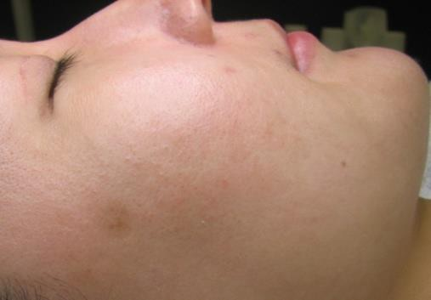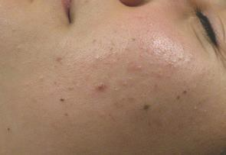

Moderate Non-inflamed Acne

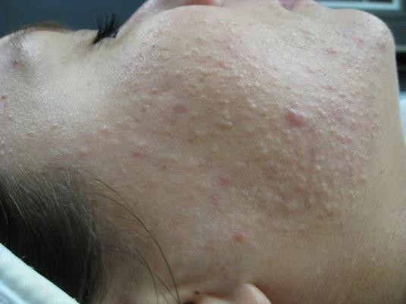

Severe Non-inflamed Acne

Characteristics of Non-inflamed acne:

• Dull and sluggish appearance

• Blackheads/whiteheads most predominant; few or no inflamed lesions

• Tissue congestion

• Skin is *usually* not sensitive or reactive to products

**Non-Inflamed Acne Guideline: Mild**

People with mild Non-inflamed acne have very few acne lesions – five or less on each side of the face—

and they ***never*** get any inflamed lesions. ***This type of acne will be very rare in your practice*.**

Most clients who have mild non-inflamed acne are 10-12 year old pre-teen girls. If left untreated this acne will progress into inflamed acne. The non-inflamed acne typically starts on the forehead first and works its way down the face becoming more severe if left untreated.

Mild Non-inflamed acne types are *usually* not very sensitive and need more exfoliation than antibacterial action. The chart below shows the typical lineup of products used for mild Non-inflamed acne for face and/or chest. If a client is more sensitive, opt for milder products. If a client is sensitive or allergic to

the Vitamin A serum, test the glycolic serums on them.

Note: it is important these clients are receiving Acne Peel and or Microdermabrasion with extractions.

If the client has fungal folliculitis and Non-inflamed acne, start with mandelic serum 5% or 8% and move them to Vitamin A when the folliculitis has cleared.

**Home care products for mild Non-inflamed acne:**

|  |  |  |  |  |  |
| --- | --- | --- | --- | --- | --- |
| **Skin Type** | **Cleanser** | **Toner** | **Exfoliating Serum** | **Sunscreen** | **Antibacterial** |
| **DRY** | Ultra Gentle Cleanser | Moisture  Balance Toner | Glycolic 5% | Daily SPF or Clove Hill | Acne Med 2.5 |
| **NORMAL** | Mandelic Scrub | AcneBeta-C Toner | Glycolic 5% | Daily SPF or Clove Hill | Acne Med 2.5 |
| **OILY** | Acne Scrub | AcneBeta-C Toner | Glycolic 5% | Daily SPF or Clove Hill | Acne Med 2.5 |
| **MATURE** | Ultra Gentle Cleanser | AcneBeta-C Toner | Glycolic 5% | Daily SPF or Clove Hill | Acne Med 2.5 |
| **FITZ 4+** | Mandelic  Scrub | AcneBeta-C Toner | Glycolic 5% | Daily SPF or Clove Hill | Acne Med 2.5 |

Consider Mandelic Scrub if the client has folliculitis, or brown hyperpigmentation from acne, provided their skin type can tolerate it.

*NOTE: Clients with mild Non-inflamed acne can be some of the most frustrating clients to treat because they expect perfection with their skin.*

**In-office Bi-weekly Regimen Changes – Mild Non-Inflamed Acne**

**Weeks 1-2**

**Morning Routine:** Mandelic Scrub, AcneBeta-C Toner, Glycolic 5% **every other day**, Balancing Lotion, Daily SPF or Clove Hill (Chemical) for normal/dry OR Clove Hill (Tinted or Non-tinted) SPF 40 (Chemical-free)

**Evening Routine:** Mandelic Scrub, AcneBeta-C Toner, Balancing Lotion

**Weeks 3-4**

**CHANGE: Increase serum to every day**

**Morning Routine:** Mandelic Scrub, AcneBeta-C Toner, Glycolic 5% **every day**, Balancing Lotion, Daily SPF or Clove Hill (Chemical) for normal/dry OR Clove Hill (Tinted or Non-tinted) SPF 40 (Chemical-free)

**Evening Routine:** Mandelic Scrub, AcneBeta-C Toner, Balancing Lotion

**Weeks 5-6**

**CHANGE: Add serum to PM, every other night**

**Morning Routine:** Mandelic Scrub, AcneBeta-C Toner, Glycolic 5% **every day**, Balancing Lotion, Daily SPF or Clove Hill (Chemical) for normal/dry OR Clove Hill (Tinted or Non-tinted) SPF 40 (Chemical-free)

**Evening Routine:** Mandelic Scrub, AcneBeta-C Toner, Vitamin A II **every other night**, Balancing Lotion

**Weeks 7-8**

**CHANGE: Increase serum to every night**

**Morning Routine:** Mandelic Scrub, AcneBeta-C Toner, Glycolic 5% **every day**, Balancing Lotion, Daily SPF or Clove Hill (Chemical) for normal/dry OR Clove Hill (Tinted or Non-tinted) SPF 40 (Chemical-free)

**Evening Routine:** Mandelic Scrub, AcneBeta-C Toner, Glycolic 5% **every night**, Balancing Lotion

*NOTE: If the client is nearly clear or is clear, there is no need to adjust the routine. If a client with mild Non-inflamed acne is not clear by this time, they will need benzoyl peroxide (Acne Med). If that is the case, go to Non-inflamed Acne Guideline: Moderate and Severe. You can keep them on their exfoliating serum in the morning and they will need to do the Benzoyl Peroxide Timed Schedule (see page 8) for two weeks.*

**Option for Brown Hyperpigmentation as a result of acne**

• Mandelic Scrub is the cleanser of choice for clients with hyperpigmentation.

**Non-Inflamed Acne Guideline: Moderate and Severe**

Moderate and severe Non-inflamed acne types are usually not very sensitive and need more exfoliation than antibacterial action. These clients ***never*** get inflamed lesions.

Severe Non-inflamed acne is the toughest type of acne you will deal with, so tell them it will take longer than three to four months to achieve clear skin. In some cases, it will take at least five or six months to achieve clear skin. Your client will have to be incredibly consistent with their home care regimen and in-office treatments in order to get clear. This type of acne usually calls for more aggressive home care and treatments. Clients with this type of acne are usually not very sensitive, but there are definitely exceptions.

Again, this type of acne usually needs a lot of exfoliation—the stronger the exfoliating serum, the better.

The chart below shows the typical lineup of products used for moderate and severe Non-inflamed acne for face and/or chest. If a client is more sensitive, opt for milder products. If a client is sensitive or allergic to Vitamin A serums, try the glycolic serums on them.

*NOTE: If the client has fungal folliculitis and Non-inflamed acne, start with Mandelic serum 8% and move them to Vitamin A when the folliculitis has cleared.*

Recommend that your client begin using benzoyl peroxide (Acne Med) in the evenings, following the timed schedule on page 8.

**Home care products for moderate and severe Non-inflamed acne**

|  |  |  |  |  |  |
| --- | --- | --- | --- | --- | --- |
| **Skin**  **Type** | **Cleanser** | **Toner** | **Exfoliating Serum** | **Sunscreen** | **Antibacterial** |
| **DRY** | Mandelic Cleanser | Mandelic Toner | Glycolic 5% | Daily SPF or Clove Hill | Acne Med 5% |
| **NORMAL** | Mandelic Scrub | Glycolic / Lactic Toner | Glycolic 5% | Daily SPF or Clove Hill | Acne Med 5% |
| **OILY** | Acne Scrub | Glycolic / Lactic Toner | Glycolic 5% | Daily SPF or Clove Hill | Acne Med 5% |
| **MATURE** | Mandelic Cleanser | Mandelic Toner | Glycolic 5% | Daily SPF or Clove Hill | Acne Med 5% |
| **FITZ 4+** | Mandelic  Scrub | AcneBeta-C Toner | Glycolic 5% | Daily SPF or Clove Hill | Acne Med 5% |

Consider Mandelic Scrub if the client has folliculitis, or brown hyperpigmentation from acne, provided their skin type can tolerate it.

If a client’s skin starts to get dehydrated from products, you can give them **HydraBalance**, a water- based emulsion that they can use under their Acne Med at night, once they are wearing it overnight. It will not interrupt the antibacterial action of benzoyl peroxide like other moisturizers can.

**In-office Bi-weekly Regimen Changes – Moderate and Severe Non-inflamed Acne**

**Weeks 1-2**

**Morning Routine:** Mandelic Scrub, Glycolic 5% **every other day**, Balancing Lotion, Daily SPF or Clove Hill (Chemical) for normal/dry OR Clove Hill (Tinted or Non-tinted) SPF 40 (Chemical-free)

**Evening Routine:** Mandelic Scrub, Acne Med 5% (timed schedule), Ultra Gentle Cleanser, Balancing Lotion

*if they are dry or irritated, start with Mandelic Wash

**Weeks 3-4**

**CHANGE: ADD TONER, ACNE MED ALL NIGHT & SERUM EVERY DAY**

**\*ADD SCRUB IF STARTED WITH A WASH**

**Morning Routine:** Mandelic Scrub, Glycolic 5% **every day**, Balancing Lotion, Daily SPF or Clove Hill (Chemical) for normal/dry OR Clove Hill (Tinted or Non-tinted) SPF 40 (Chemical-free)

**Evening Routine:** Mandelic Scrub, Glycolic/Lactic Toner **every other night**, HydraBalance (optional), Acne Med 5% all night

*refill Healthy Skin

*NOTE: It is normal for non-inflamed clients to start to get a few inflamed breakouts at this point. Should this happen, have them spot treat inflamed acne in the morning with Acne Med 5% and ice, this will subside in 2-3 weeks.*

**Weeks 5-6**

**CHANGE: INCREASE SERUM TO TWICE A DAY, EVERY OTHER NIGHT TO START**

**INCREASE TONER EVERY NIGHT**

**Morning Routine:** Mandelic Scrub, Glycolic 5% **every day**, Balancing Lotion, Daily SPF or Clove Hill (Chemical) for normal/dry OR Clove Hill (Tinted or Non-tinted) SPF 40 (Chemical-free)

**Evening Routine:** Mandelic Scrub, Glycolic/Lactic Toner **every night**, Glycolic 10% **every other night,** HydraBalance (optional), Acne Med 5% all night

*will need to refill Probiotics and Fish Oil

*NOTE: This is a good time to introduce Vitamin A II for any client that began with Mandelic serum for fungal folliculitis, if it has now cleared. Have them use this in place of the serum they have been using in the evening.*

**Weeks 7-8**

**CHANGE: INCREASE ACNE MED CONCENTRATION TO NEXT LEVEL**

**INCREASE SERUM TO TWICE A DAY**

**INCREASE TONER TO TWICE A DAY BUT ONLY EVERY OTHER DAY IN THE MORNING**

**Morning Routine:** Mandelic Scrub, Glycolic/Lactic Toner **every other day,** Glycolic 5% **every day**, Balancing Lotion, Daily SPF or Clove Hill (Chemical) for normal/dry OR Clove Hill (Tinted or Non-tinted) SPF 40 (Chemical-free)

**Evening Routine:** Mandelic Scrub, Glycolic/Lactic Toner **every night**, Glycolic 10% **every night**, HydraBalance (optional), Acne Med increase to 10% all night (alternate between lower and higher concentration for up to one week and no longer)

* will need to refill herbal formulas Vitex, Adrenal Formula, Saw Palmetto, etc. Remember Bowel Rejuv switches to Bowel Revitalizer f taking these)

* will need to refill Healthy Skin

**Weeks 9-10**

**CHANGE: INCREASE TONER TO TWICE A DAY**

**CHANGE MORNING EXFOLIANT TO GLYCOLIC SERUM 10% IF THEY ARE OUT OF OR ARE NOT CLEARING**

**Morning Routine:** Mandelic Scrub, Glycolic/Lactic Toner **every day**, Glycolic 5% OR Glycolic Serum 10% **every day**, Balancing Lotion, Daily SPF or Clove Hill (Chemical) for normal/dry OR Clove Hill (Tinted or Non-tinted) SPF 40 (Chemical-free)

**Evening Routine:** Mandelic Scrub, Glycolic/Lactic Toner **every night**, Glycolic 10% **every night**, HydraBalance (optional), Acne Med 10% all night

*Refill Probiotics and Fish Oil

**Weeks 11-12**

**CHANGE: INCREASE SERUM TO VITAMIN A III AT NIGHT IF NEEDED**

**Morning Routine:** Mandelic Scrub, Glycolic/Lactic Toner **every day**, Vitamin A II OR Glycolic Serum 10% **every day**, Balancing Lotion, Daily SPF or Clove Hill (Chemical) for normal/dry OR Clove Hill (Tinted or Non-tinted) SPF 40 (Chemical-free)

**Evening Routine:** Mandelic Scrub, Glycolic/Lactic Toner **every night**, Glycolic 5% or Vivant Vitamin A III **every night**, HydraBalance (optional), IF USING VITAMIN A WAIT 15 MINTUES to apply Acne Med 10%

*need to refill Healthy Skin

**Weeks 13-14**

If still breaking out, let them know they will need to continue receiving treatments. Have them continue the same regimen. If clear, book them for a follow-up treatment in one month, have them continue the same regimen and discuss maintenance then.

* will need to refill herbal formulas Vitex, Adrenal Formula, Saw Palmetto, etc. Remember Bowel Rejuv switches to Bowel Revitalizer if taking these)

*Refill Probiotics and Fish Oil

**\*\*Non-inflamed acne can take 3-6 months to clear. It is very realistic that they will need to continue coming in for peels every 2 weeks at this point**

**Additional Options for strengthening home care**

**(usually from Weeks 7 and beyond):**

• Generally, you will strengthen active products (serums and benzoyl peroxide) first before strengthening cleanser and toner.

• Bump up to a stronger Glycolic Serum or Vitamin A. Always alternate the two serums until the weaker one is gone. Then have the client use the stronger serum every day and/or night.

         • Bump up to a stronger toner.

• Advise clients to cleanse, tone, and use their exfoliating serum three times a day.

• Treatment: Consider deeper peels once a month if the client is still not clear after 12 weeks, along with strengthening their home care routine.

Chapter 5

Back Acne:

Non-inflamed and Inflamed

Non-inflamed

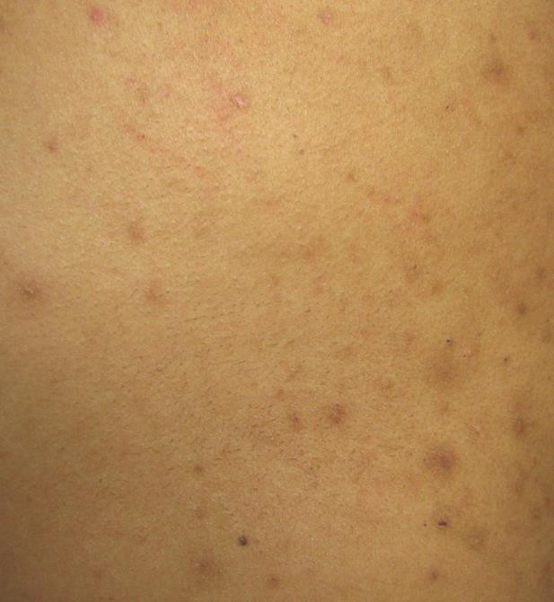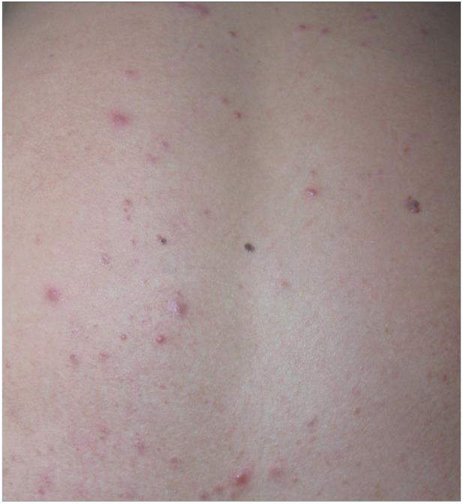

Inflamed

**Back & Shoulders Acne – Non-inflamed**

Back acne can be treated more aggressively because the skin on the back is thicker than on the face. The chart below shows the typical lineup of products used for Non-inflamed acne for the back. If a client is more sensitive or reactive, opt for milder products.

**Home care products for Non-inflamed back and shoulders acne:**

|  |  |  |  |
| --- | --- | --- | --- |
| **Skin Type** | **Cleanser** | **Exfoliating Serum** | **Antibacterial** |
| **DRY** | Mandelic Scrub | Mandelic 11% or 15% | Acne Med 5% w/ Sulfur |
| **NORMAL** | Acne Scrub | Mandelic 11% or 15% | Acne Med 5% w/ Sulfur |
| **OILY** | Acne Scrub | Mandelic 11% or 15% | Acne Med 5% w/ Sulfur |
| **MATURE** | Mandelic Scrub | Mandelic 11% or 15% | Acne Med 5% w/ Sulfur |
| **FITZ 4+** | Acne Scrub | Mandelic 11% or 15% | Acne Med 5% w/ Sulfur |

Consider Mandelic Scrub if the client has folliculitis, or brown hyperpigmentation from acne, provided their skin type can tolerate it.

The client can use Balancing Lotion in the morning if they become dry.

**In-office Bi-weekly Regimen Changes – Non-inflamed Back & Shoulders Acne**

**Weeks 1-2**

**Evening Routine:** Cleanser, Exfoliating Serum every other night, Acne Med all night

\**Make sure clients using Acne Med wear a white shirt to bed and use white sheets and towels. Acne Med bleaches fabric.*

**Weeks 3-4**

**Evening Routine:** Cleanser, Exfoliating Serum every night, Acne Med all night

**Weeks 5-6**

**Morning Routine:** Cleanser, Vivant’s Clear Body Therapy

**Evening Routine:** Cleanser, Exfoliating Serum, Acne Med all night

*\*Vivant’s Clear Body Therapy cannot be used in the evening if the client is wearing Acne Med. It contains oils that are noncomedogenic but they will interfere with the action of the benzoyl peroxide.*

**Weeks 7-8**

**Morning Routine:** Cleanser, Exfoliating Serum, Vivant’s Clear Body Therapy

**Evening Routine:** Cleanser, Exfoliating Serum, Acne Med all night

**Back & Shoulders Acne - Inflamed**

Back acne can be treated more aggressively because the skin on the back is thicker than on the face. The chart below shows the typical lineup of products used for inflamed acne for the back. If a client is more sensitive or reactive, opt for milder products. Test their back first with the Mandelic 15%. If too strong (over a 2 on a scale of 1 to 10) then go to Mandelic 11%. If they

are sensitive to mandelic, then test Salicylic Serum.

Recommend zinc monomethionine supplements and/or omega-3 fish oil supplements to reduce inflammation.

**Home care products for inflamed back & shoulders acne:**

|  |  |  |  |  |
| --- | --- | --- | --- | --- |
| **Skin Type** | **Cleanser** | **Exfoliating Serum** | **Antibacterial** | **Spot Treatment** |
| **DRY** | Mandelic Wash | Mandelic 11% | Acne Med 5% w/ Sulfur | Acne Med 10% With Sulfur |
| **NORMAL** | Acne Wash | Mandelic 11% | Acne Med 5% w/ Sulfur | Acne Med 10%  With Sulfur |
| **OILY** | Acne Wash | Mandelic 11% or 15% | Acne Med 5% w/ Sulfur | Acne Med 10%  With Sulfur |
| **MATURE** | Mandelic Wash | Mandelic 11% | Acne Med 5% w/ Sulfur | Acne Med 10%  With Sulfur |
| **FITZ 4+** | Acne Wash | Mandelic 11% or 15% | Acne Med 5% w/ Sulfur | Acne Med 10%  With Sulfur |

Consider Mandelic Wash if the client has folliculitis, or brown hyperpigmentation from acne, provided their skin type can tolerate it.

The client can use Balancing Lotion in the morning if they become dry.

**Bi-weekly Regimen Changes – Inflamed Back & Shoulders Acne**

**Weeks 1-2**

**Morning Routine:** Acne Wash if showering or leave on Acne Med from previous night

**Evening Routine:** Acne Wash, Mandelic 11% every other night, Acne Med 5% w/ Sulfur all night

\**Make sure clients using Acne Med wear a white shirt to bed and use white sheets and towels. Acne Med bleaches fabric.*

**Weeks 3-4**

**CHANGE: ADD GLYCOLIC/LACTIC TONER and INCREASE EXFOLIATING SERUM TO EVERY NIGHT**

**Morning Routine:** Acne Wash if showering or leave on Acne Med from previous night

**Evening Routine:** Acne Wash, Glycolic/Lactic Toner, Mandelic 11% every night, Acne Med 5% w/ Sulfur all night

**Weeks 5-6**

**CHANGE: ADD AM REGIMEN- CLEANSE and EXFOLIATING SERUM**

**Morning Routine:** Acne Wash, Mandelic 11% every other day, Balancing Lotion and SPF if needed

**Evening Routine:** Acne Wash, Glycolic/Lactic Toner, Mandelic 11% every night, Acne Med 5% w/ Sulfur all night

**Weeks 7-8**

**CHANGE: INCREASE ACNE MED TO NEXT LEVEL, ADD TONER TO AM**

**Morning Routine:** Acne Wash, Glycolic/Lactic Toner, Mandelic 11%, Balancing Lotion and SPF if needed

**Evening Routine:** Acne Wash, Glycolic/Lactic Toner, Mandelic 11% every night, Acne Med 10% w/ Sulfur all night

*NOTE: You can alternate Acne Med with and without sulfur at first to allow them to get used to the Acne Med with Sulfur. If you do put them on Acne Med with sulfur all over, warn them that they will get dry. Most people don’t mind dehydration on their back – they just want to get rid of their acne.*

**Weeks 9-10**

**CHANGE: INCREASE PM EXFOLIATING SERUM TO NEXT LEVEL**

**Morning Routine:** Acne Wash, Glycolic/Lactic Toner, Mandelic 11%, Balancing Lotion and SPF if needed

**Evening Routine:** Acne Wash, Glycolic/Lactic Toner, Mandelic 15% every night, Acne Med 10% w/ Sulfur all night

**Weeks 11-12**

**CHANGE: INCREASE AM EXFOLIATING SERUM TO NEXT LEVEL, FOR PIH ADD VITAMIN A CORRECTIVE II TO PM**

**Morning Routine:** Acne Wash, Glycolic/Lactic Toner, Mandelic 15%, Balancing Lotion and SPF if needed

**Evening Routine:** Acne Wash, Glycolic/Lactic Toner, Mandelic 15% every night, Vitamin A Corrective II, Acne Med 10% w/ Sulfur all night

**Weeks 13-14**

**CHANGE: ADD VITAMIN A CORRECTIVE II TO AM**

**Morning Routine:** Acne Wash, Glycolic/Lactic Toner, Mandelic 15%, Vitamin A Corrective II, Balancing Lotion and SPF if needed

**Evening Routine:** Acne Wash, Glycolic/Lactic Toner, Mandelic 15% every night, Vitamin A Corrective II, Acne Med 10% w/ Sulfur all night

**If they are clear, there are three objectives at this point:**

1. **Educated them on treatments for PIH and Scarring. For the back, IPL Photofacial treatments are best along with Vitamin A Corrective or Vitamin A Corrective II**
2. **Convert them to skincare, supplement and service maintenance**
3. **Request they write a review on Yelp or Google+**

**At the 6th treatment, if they are clear, have them continue the same regimen for 1 month and re-book them for follow-up Acne Peel or Pore Cleanse (one month out) and to discuss maintenance.**

Chapter 6

Troubleshooting

**Client allergic to benzoyl peroxide**

• Put benzoyl peroxide the size of a quarter on inside of arm for 3 days in a row. See if there is a reaction. If no reaction, they are not allergic (many people think they are when they are not). Have them start even more slowly in getting used to it if necessary)

• Use the Vitamin A Corrective serum for noninflamed acne

• Use Michele Corley oxygen emulsion in place of Acne Med (benzoyl peroxide)

**Client used prescription topical products prior to coming to see you**

• If their skin is red and irritated, have them use Ultra Gentle Cleanser, Balancing Lotion and SPF for 3-5 days before starting full regimen.

• If they show no signs of irritation, proceed as normal.

**Impatient Client - wants to be clear in two weeks**

• Remind your client that it takes three months, in most cases, to see significant clearing of their skin.

• It takes 30 to 90 days for a microcomedone to surface and that acne will come up in the three months you are treating them.

• Be a cheerleader. Let them know that they are doing great and the benefits will start to pay off soon!

**Dryness and peeling**

Tell them from the outset that they will most likely have temporary dryness and peeling on their way to getting clear. I say that any product that is strong enough to get acne under control is inherently drying. So, tell them to please be patient with a bit of dry skin, but if it gets uncomfortably dry to please contact you.

• **Use petroleum jelly** - A very common symptom of using benzoyl peroxide is dryness around the mouth and chin area. When that happens, tell them to put a thin layer of petroleum jelly on the dry area before they put the Acne Med on.

They will do this for just a few days and then resume the Acne Med there again. Reassure your client that Vaseline will not break them out.

• **Tell them they can use Balancing Lotion** in the morning (if not using Acne Med) and/or

**Hydrabalance** at night after the serum and before the Acne Med.

Inconsistent or Improper Product Usage

If a client is not getting clear or staying clear, the first thing to check is check *how* they are doing their home care:

• Make sure they are putting their serum on with their hands, not a cotton ball or cotton round

• Make sure they are putting Acne Med all over their face and not just spot treating

• Make sure they are putting products on in the right order

• Make sure they are putting enough product on

If that checks out, the next step is to check their product purchase history. 90% of the time the clients are using their home care products inconsistently. Check their Acne Med purchases first, and exfoliating serum purchases next. Compare their purchase history to the Normal Product Usage Timetable.

|  |  |  |
| --- | --- | --- |
| **Product** | **Usage – 1x per day** | **Usage – 2x per day** |
| 1 oz Acne Med  **\*dime to nickel-size** | 4 -6 weeks | 2-3 weeks |
| 1 oz Mandelic Serums  **\*3 pumps** | 18 weeks | 9 weeks |
| 1 oz Glycolic and Salicylic Serums  **\*2 pumps** | 20 weeks | 10 weeks |
| 1 oz Vitamin A Corrective Serum  **\*3 pumps**  1 oz Vitamin A Corrective II Serum  **\*1 pump** | 12 weeks | 6 weeks |
| 6 oz Cleanser |  | 8-10 weeks |
| 6 oz Toner |  | 8-10 weeks |
| 2 oz Sunscreen or Moisturizer | 12-15 weeks | 6-8 weeks |

If their purchase history and the Normal Product Usage Timetable show that the client is being inconsistent with the home care product usage, explain why consistency is crucial. Next, find out why the client isn’t being consistent. It could be:

1. Skipping home care because of dryness/dehydration/products stinging

2. Skipping home care because of budget

3. Skipping home care because of schedule

**1. Skipping Home Care due to Dryness, Dehydration, or Stinging Products**

**Ideally, the client needs to be able to use their exfoliating serum twice a day and Acne Med once a day, to get clear and stay clear. You will need to find a home care routine that will allow for this.**

a. Ask if any of their products are stinging or burning. If so, change that product. Sometimes it can be a mild non-active (like toner or sunscreen) that is the problem.

b. Ask if they are skipping products when they get dry. If so, the home care routine is too strong. i. Make sure they are using **Balancing Lotion** in the morning (if not using Acne Med) and

**Hydrabalance** at night.

ii. Consider giving them a milder cleanser and/or toner.

iii. Adjust down active products after non-actives – Acne Med and serums. If their product is not stinging or burning, they do not need to return the product. They can use it later, when their skin has adjusted and is no longer as dry (even once or twice a week as a booster).

*Remember when the weather gets colder, skin becomes drier and cannot always tolerate the same products.*

**2. Skipping Home Care due to Budget or Money Issues**

If a client is having consistency issues because of cost, we can make the following suggestions:

a. Always spend the money on products before treatments.

b. They should check in via email for an updated routine if they will be stretching the time between appointments past 2 weeks.

c. If they can’t afford to come in at all, offer our Online Acne Program.

d. Make sure they are not using any non-Face Reality products that might contain pore clogging ingredients (cleansers, benzoyl peroxide, sunscreen).

e. Take the toner out of their routine temporarily as a last resort.

**3. Skipping Home Care due to Schedule**

If a client is having consistency issues because of their schedule, find out what is getting in the way. Brainstorm with the client to find a way around the issue.

a. If they absolutely cannot use Acne Med consistently at night, move it to their morning routine.

Advise the client to wait 15 minutes after applying the Acne Med to apply sunscreen.

b. If they are not able to do a multi-step routine in the morning, advise them to just use their actives at night. Remind them it may take longer to get clear without using actives twice a day.

**What if you are not sure if they are being consistent?**

Give them a home care routine that will make them dry. (You can warn them that this is a test, or choose not to depending on the client.) Ask them to return in 2 or 3 weeks. If they are not dry when they return, they are not being consistent.

Client Not Clearing After Treatment 3

If your client is using their home care products consistently and still are not getting clear, it is time to review lifestyle choices. Even if a client initially was on a safe makeup or safe form of birth control, they may have changed that since they were last asked. Here are some reasons a client may not be clearing if it is not due to inconsistent product usage:

• Do they check in with you to adjust their routine at two-week intervals?

• Did they change their routine on their own without consulting you first?

• Are they using non-Face Reality products?

• Are they using comedogenic makeup?

• Are they using comedogenic hair care?

• Are they taking the supplements recommended by their Acne Specialist?

• Are they using fabric softener or dryer sheets in the washer and/or the dryer?

• Are they consuming dairy/soy products: milk, cheese, and/or yogurt?

• Are they consuming protein shakes or protein bars made from whey or soy that contain iodine?

• Are they consuming sushi, seaweed, iodized salt, spirulina, or chlorella?

• Are they consuming high androgen foods like peanuts, peanut butter, shellfish, or organ meat?

• Are they taking vitamins or supplements that may contain iodides and/or biotin?

• Are they taking any medications or drugs or have any medical condition that they haven’t yet disclosed

to you?

• Are they smoking marijuana?

• Do they regularly wear hats, helmets, or shoulder pads?

• Are they under more stress than usual and/or getting enough sleep?

• Are they on birth control pills or other form of birth control?

• Are they using water softener water to cleanse their face?

If not being compliant with lifestyle issues is keeping the client from getting clear or staying clear, give them a copy of the **Getting Clear and Staying Clear** document. Highlight which lifestyle issues need addressing. If inconsistent product usage is also an issue, highlight that on the document as well. Inconsistent clients should also receive a copy of the **Normal Product Usage Timetable** with their purchase history written on

it. Write which documents are given in their acne treatment notes. If you have to give them these documents too many times, it may be time to tactfully end your relationship with them.

Handling a Minor that is Not Clearing

1. If you have a minor that is not clearing due to inconsistent product use and/or lifestyle issues, ask what is keeping them from being consistent. Find out if there is an issue you can help them work around.

2. If the parent is not in the room, speak with the parent after the appointment to let them know what the issues are.

a. They often believe the minor is being compliant. Inform them about inconsistent product usage or lifestyle issues that are causing problems.

b. If the parent is not with the minor for the appointment, send an email letting them know

what the issues are.

c. If the situation can’t be changed, suggest they bring the minor back when they are ready to

be consistent.

LED’s

If a client has inflamed acne that is not clearing after 6-weeks AND they have been compliant with their home care, you can recommend the LED light mask. It can really help to reduce inflammation. See the handout in the consultation forms for instructions (the client takes home) on how they will use it.

Chapter 7 Pregnancy/Nursing

This is what we tell our pregnant and nursing clients and is in our handout:

During this time, as well as postpartum, your skin may experience changes. Here are some things you should be aware of:

• Your acne may improve during your pregnancy, or it may get worse due to hormonal changes

• Strictly adhering to all lifestyle recommendations is important

• If your doctor approves, strictly adhering to your home care regimen is important

• Most pre-natal vitamins contain iodides and/or biotin which can cause acne

We would like to recommend certain products that we feel would be safe during your pregnancy. Included below is an ingredient deck of all possible products that could be recommended for your doctor to review.

We recommend discontinuing use of Salicylic, Vitamin A or TCA during pregnancy and nursing. Please

confer with your doctor to see if there are any additional ingredients or products that they may discourage.

**If you are unable or unwilling to use any active products during your pregnancy, we will not be able to see you for treatments or extractions. Active products are what assist in clearing your acne and also assist us in being able to extract your acne lesions. Thank you for your cooperation.**

We have them fill out a release form and tell them that: “We cannot perform treatments or sell you active products without having a signed copy of the release on file.” The release form lists all of the Face Reality products and ingredient decks, plus all of the products that have any form of vitamin a and/or salicylic acid.

Treatments

We do not do any type of peel on pregnant or nursing clients. All the Face Reality brand peels contain TCA. Instead, we follow the Acne Facial Protocol. This treatment uses the Hydrating Treatment Enzyme Mask.

Chapter 8

Acne Rosacea: Subtype 2

Subtype 2 Acne Rosacea

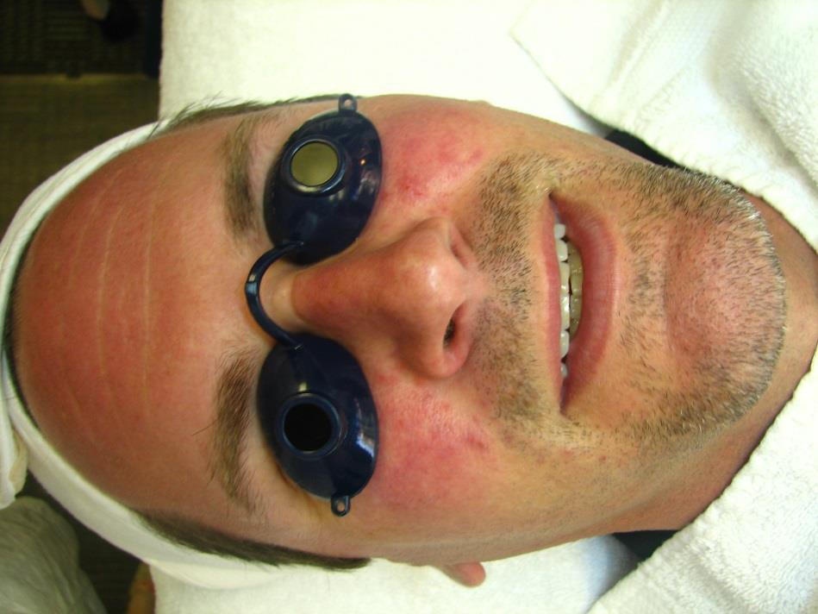

Characteristics of Acne Rosacea:

• Persistent facial erythema

• Resembles acne, except that comedones are absent

• Papules and pustules are mainly found on the cheeks, nose and forehead

**Acne Rosacea**

Rosacea is a chronic, but treatable bacterial condition, (it is not considered acne) that primarily affects the central face, and is often characterized by flare-ups and remissions. It typically begins any time after age 30 as a flushing or redness on the cheeks, nose, chin or forehead that may come and go. Over time, the redness tends to become ruddier and more persistent, and visible blood vessels may appear. Left untreated, bumps and pimples often develop, and in severe cases - particularly in men - the nose may grow swollen and bumpy from excess tissue. In many people the eyes are also affected, feeling irritated and appearing watery or bloodshot.

**Types of Rosacea**

**1. Subtype I: Erythematotelangiectatic Rosacea**

This subtype is characterized by flushing and persistent central facial erythema. Telangiectases are common but not essential for the diagnosis.

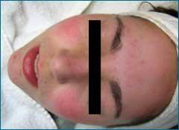

**2. Subtype 2: Papulopustular Rosacea (CAN TREAT)**

This subtype includes persistent central facial erythema with transient papules, pustules, or both in a central facial distribution. Burning and stinging may also be reported.

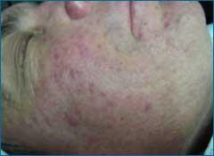

**3. Subtype 3: Phymatous Rosacea**

This subtype may include thickening skin, irregular surface nodularities, and enlargement. Phymatous rosacea occurs most commonly as rhinophyma but may appear elsewhere, including the chin, forehead, cheeks, and ears. Patulous, expressive follicles may appear in the phymatous area, and telangiectases may be present.

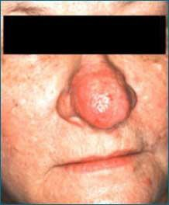

**4. Subtype 4: Ocular Rosacea**

This subtype may include watery eyes or bloodshot appearance, telangiectasia of conjunctiva and lid margin, or lid and periocular erythema. Blepharitis, conjunctivitis, and irregularity of eyelid margins also may occur.

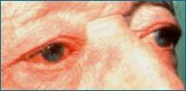

**Rosacea Triggers**

Rosacea Triggers include:

1. the sun

2. stress

3. hot weather

4. wind

5. exercise

6. alcohol

7. hot baths

8. cold weather

9. spicy foods

10. humidity

11. indoor heat

12. irritating skin products

**13.** heated beverages

If in doubt about whether a client has rosacea, ask them about any of these triggers and whether any of these affect their skin. If they have rosacea, they will answer with an affirmative yes!

**Analyzing and Treating Acne Rosacea**

• It can mimic acne however pustules do not extract like a normal acne pustule. There is no core and usually the material is watery. It does not start as a comedone.

• This protocol works well for Subtype 2, not very successful with Subtype 1.

The pustules clear quickly, usually in 6 to 8 weeks. **Sometimes, the overall redness does not improve, so set client expectations correctly*.***

• Surprisingly, Rosacea skin may not be that sensitive in general when you do a Skin

Sensitivity Test. *Rosacea skin is sensitive to triggers not necessarily to products*.

• Use a mild peel during the treatment. Avoid steaming for more than 5 minutes (try to avoid steaming at all).

The chart below shows the typical lineup of products used for acne rosacea. Acne rosacea responds well to products that contain salicylic or mandelic acid. If a client is sensitive or allergic to the Salicylic Gel serum, test the mandelic serums.

Clients with rosacea should not wear chemical-based sunscreens. Always recommend Ultimate

Protection SPF 28 (zinc sunscreen).

Recommend that your client begin using benzoyl peroxide (Acne Med) in the evenings, following the timed schedule on page 8.

**Home care products for mild and acne rosacea:**

|  |  |  |  |  |  |
| --- | --- | --- | --- | --- | --- |
| **Skin Type** | **Cleanser** | **Toner** | **Exfoliating Serum** | **Sunscreen** | **Antibacterial** |
| **DRY** | Ultra Gentle  Cleanser | AcneBeta-C Toner | Salicylic Gel Serum  or  Mandelic Serum | Ultimate SPF 28 | Acne Med 2.5% |
| **NORMAL** | Ultra Gentle  Cleanser | AcneBeta-C Toner | Salicylic Gel Serum  or  Mandelic Serum | Ultimate SPF 28 | Acne Med 2.5% |
| **OILY** | Ultra Gentle  Cleanser | AcneBeta-C Toner | Salicylic Gel Serum  or  Mandelic Serum | Ultimate SPF 28 | Acne Med 2.5% |
| **MATURE** | Ultra Gentle  Cleanser | AcneBeta-C Toner | Salicylic Gel Serum  or  Mandelic Serum | Ultimate SPF 28 | Acne Med 2.5% |
| **FITZ 4+** | Ultra Gentle  Cleanser | AcneBeta-C Toner | Salicylic Gel Serum  or  Mandelic Serum | Ultimate SPF 28 | Acne Med 2.5% |

If a client’s skin starts to get dehydrated from products, you can give them **HydraBalance**, a water-based emulsion that they can use under their Acne Med at night, once they are

wearing it overnight. It will not interrupt the antibacterial action of benzoyl peroxide like other

moisturizers can.

For mature and/or dry skin types, you can start much more slowly with the Acne Med. If they seem to dry or sensitive for the 15 minutes for the first 3 nights, instruct them to put it on for just 5 minutes a night and add 5 minutes per night.

You can also have them just “area treat” instead of applying it all over the face.

**Bi-weekly Regimen Changes – Acne Rosacea Subtype 2**

**Weeks 1-2**

**Morning Routine:** Cleanser, Toner, Exfoliating Serum **every other day**, Balancing Lotion

(optional), Sunscreen

**Evening Routine:** Cleanser, Acne Med using timed schedule, Cleanser, Toner, Balancing Lotion

*Note: If the client is dry/irritated from Acne Med use, have them take a break from their active products for one to three days (just cleanse, tone, moisturize, spf), then resume the routine.*

**Weeks 3-4**

**Morning Routine:** Cleanser, Toner, Exfoliating Serum **every day**, (HydraBalance or

Balancing Lotion - optional), Sunscreen

**Evening Routine:** Cleanser, Toner, HydraBalance (optional), Acne Med all night

*Note: Clients can use Balancing Lotion in the morning if their skin feels dry, but not in the evening – it will interfere with the antibacterial action of Acne Med.*

**Weeks 5-6**

**Morning Routine:** Cleanser, Toner, Exfoliating Serum, Balancing Lotion (optional), Sunscreen **Evening Routine:** Cleanser, Toner, Exfoliating Serum (**begin using twice a day**), HydraBalance (optional), Acne Med

*NOTE: If a client spot treats with Acne Med in the morning, they will not be able to use the Balancing Lotion on top of it for moisture. If they need hydrating, they can use the HydraBalance underneath the Acne Med. If the client is not spot treating with Acne Med in the morning, they can use either the Balancing Lotion or HydraBalance with no problems.*

*NOTE: The protocol given for the next six weeks is a guideline only. Most clients with acne rosacea are clear by this time. The following information explains how to strengthen the home care if the client is not clearing. If they are clearing or are clear, there is no need to adjust the routine.*

**Weeks 7-8**

**Morning Routine:** Cleanser, Toner, Exfoliating Serum, Balancing Lotion (optional), Sunscreen

**Evening Routine:** Cleanser, Toner, Exfoliating Serum, HydraBalance (optional), Acne Med

*NOTE: This is a good time to boost the exfoliating serum. If the client is using Mandelic 5% Serum, test them for Mandelic 8% Serum and bump them up if they feel a 2 or less on a 1 to 10 scale of tingling, stinging, and/or burning. Always alternate the two serums until the weaker one is gone and then have the client use the stronger serum every day and/or night. If the client is using Salicylic Serum Gel, consider adding a mandelic serum (test first) once a day. Have the client continue using the Salicylic Serum Gel once a day.*

**Weeks 9-10**

**Morning Routine:** Cleanser, Toner, Exfoliating Serum, Balancing Lotion (optional), Sunscreen

**Evening Routine:** Cleanser, Toner, Exfoliating Serum, HydraBalance (optional), Acne Med

*NOTE: If the client is too dehydrated or dry to wear Acne Med all over in the morning, consider giving them Aura Research AO2 Cream (oxygen emulsion cream) in the morning instead. It provides antibacterial action like benzoyl peroxide, but moisturizes at the same time. Only consider Acne Med or AO2 all over in the morning if the client still has inflamed lesions.*

**Weeks 11-12**

**Morning Routine:** Cleanser, Toner, Exfoliating Serum, Acne Med or AO2 all over to treat inflamed lesions (optional), Balancing Lotion (optional), Sunscreen

**Evening Routine:** Cleanser, Toner, Exfoliating Serum, HydraBalance (optional), Acne med with Sulfur all over (optional)

**Options for strengthening home care**

• Generally, you will strengthen active products (serums and benzoyl peroxide) first before strengthening cleanser and toner.

• Bump up to a stronger serum. (Always test serums on the client’s skin before giving it to them. Only bump up the serum if they feel a 2 or less on a 1 to 10 scale of tingling, stinging, and/or burning. Always alternate the two serums until the weaker one is gone and then have the client use the stronger serum every day and/or night.)

• Bump up to a stronger Acne Med.

**NOTES**