How to Reset ABS Password
- Launch the Nixon Apps icon on your desktop.
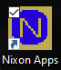

- Click the ABS Password Reset button.
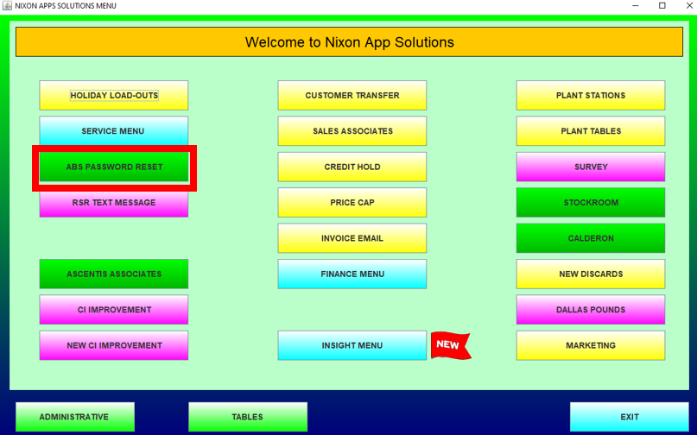

- Enter your username (lastnamefirstinistial) and click login
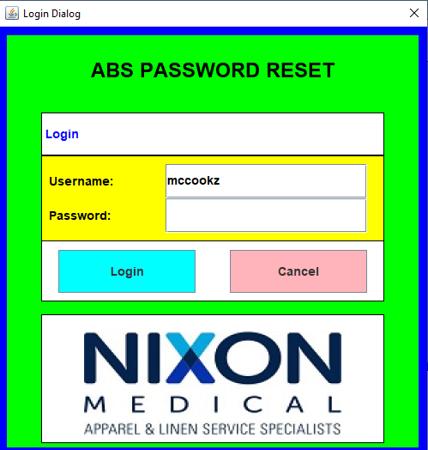

- Verify your username is correct and select the Reset ABS Password button.
