NIXON MEDICAL
ALL ABOUT SERVICE

COMPLETE CURTAIN PLANT PROCESS GUIDE
Ordering and ID Tape Creation | Plant Processing and Fulfillment

One complete instructional guide from initial curtain quantity determination through route staging.
MARRY C STAGE
FOLD / PACKAGE
WASH / DRY
RECEIVE C ID
ORDER

Every curtain must have a unique ID tape and must be married to the correct customer before leaving the plant.

COMPLETE PROCESS OVERVIEW
How to Use This Guide
Complete Section 1 first. Section 2 covers all plant processing and fulfillment steps after curtains are available and identified.

END-TO-END FLOW
- Determine quantity and create the ABS Cloud work order
- Order, receive, issue stock, print labels, and attach one ID tape to each curtain
- Retrieve dirty curtains and process through the 275 Washer and designated IPSO dryers
- Fold immediately, package one curtain per Felins package, and store in the designated location
- Check Put Up Requests, marry each curtain in ABS Cloud, verify quantities, and stage in the correct route cubbie

SECTION 1 - ORDERING C ID TAPE CREATION
Pages from the New Curtain Ordering S ID Tape Guide. Follow these steps to create the work order, receive and issue the curtains, generate unique ID tapes, and attach one tape to every curtain.
SECTION 2 - PLANT PROCESSING C FULFILLMENT
Pages from Curtain Steps at the Plant. Follow these steps for washing, drying, immediate folding, Felins packaging, storage, Put Up fulfillment, ABS Cloud curtain marriage, and route staging.
CONTROL POINTS
Use product code CSCURTBM66 - Blue Moon Curtain. Use Reason Code 8-FWO. Select Code Uniquely. New vendor curtains must be Grade N - New. One curtain equals one unique ID tape and one Felins package.
FINAL RELEASE REQUIREMENT
Do not place a curtain into service or stage it for route delivery unless the ID tape is attached, the barcode was scanned individually, Ordered equals Delivered, Balance equals 0, and the Delivery Note is attached to the package.

Follow every step. Protect the product. Deliver the best service.

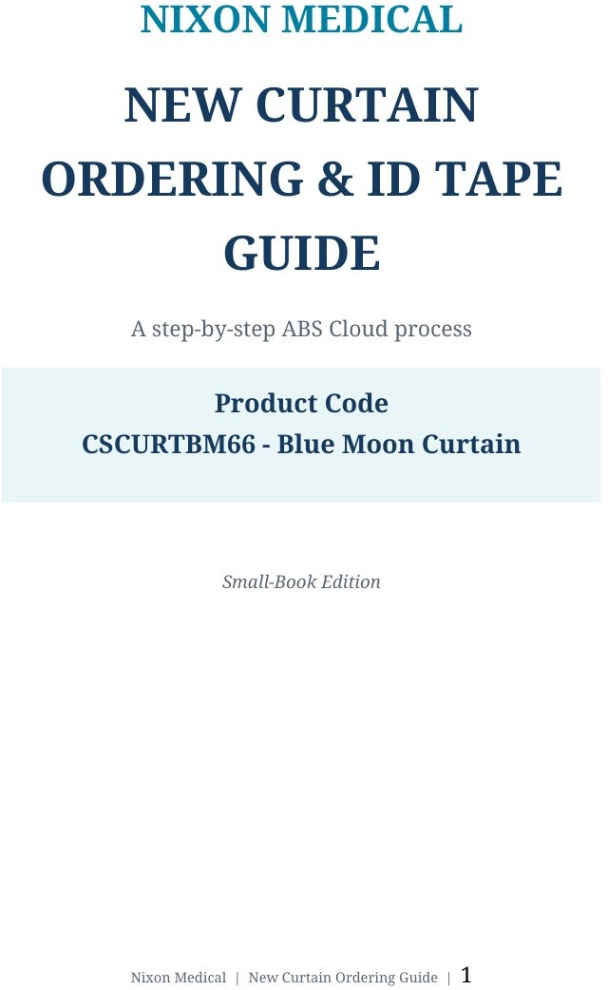

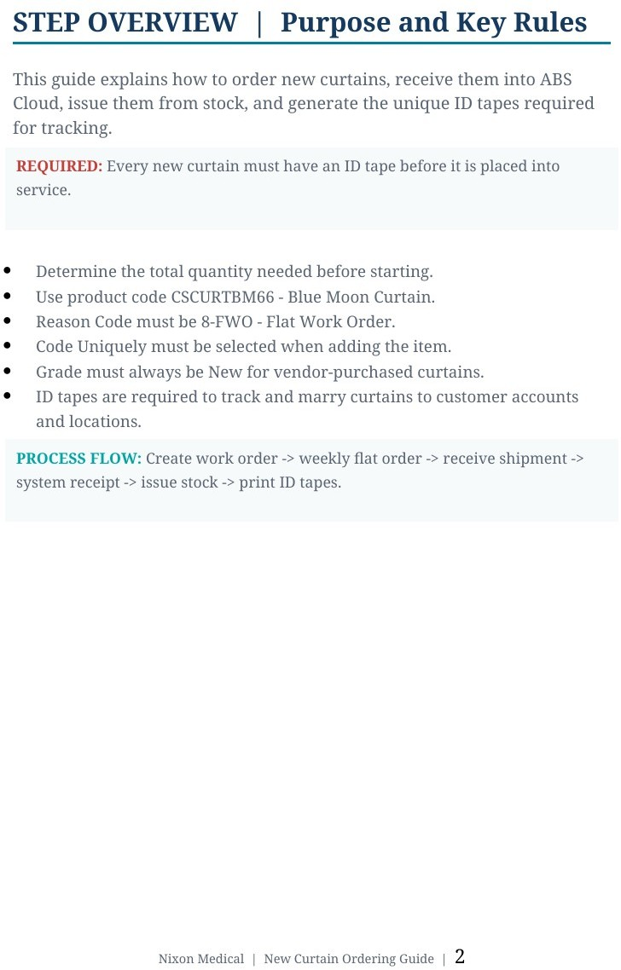

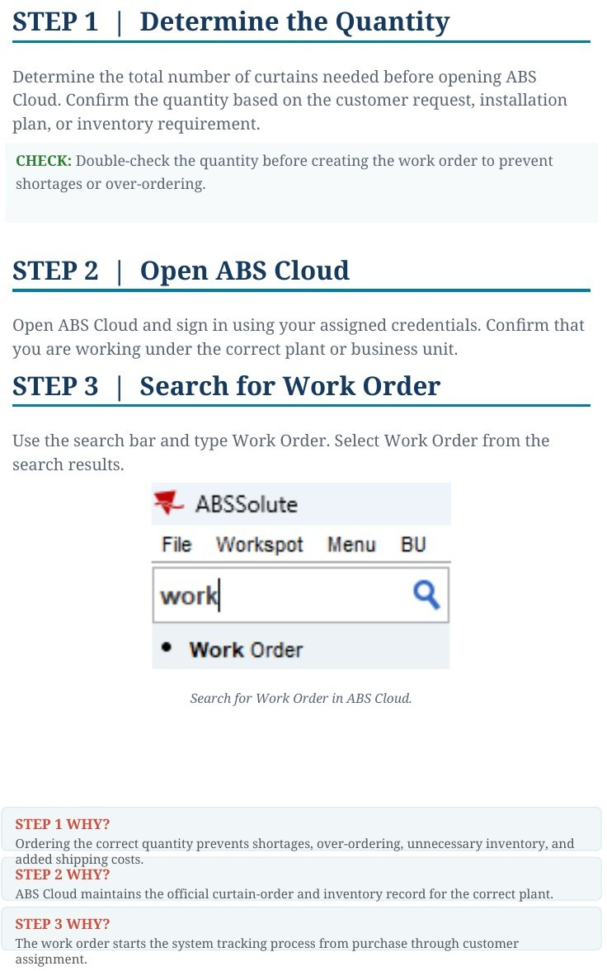

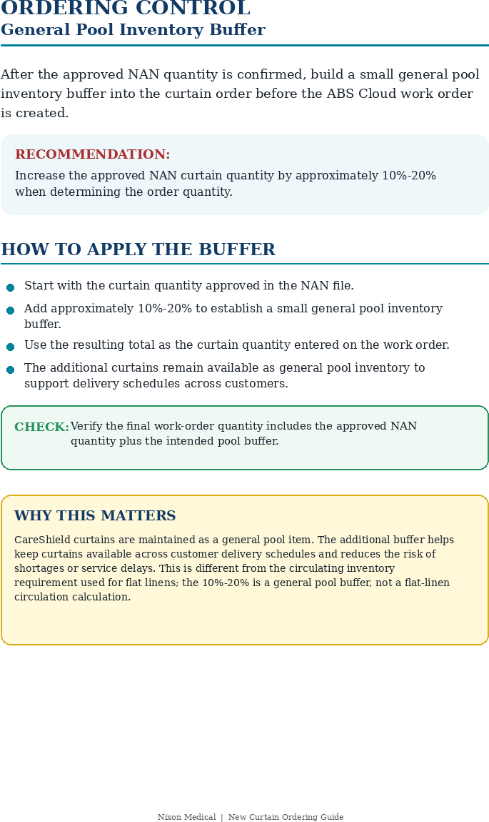

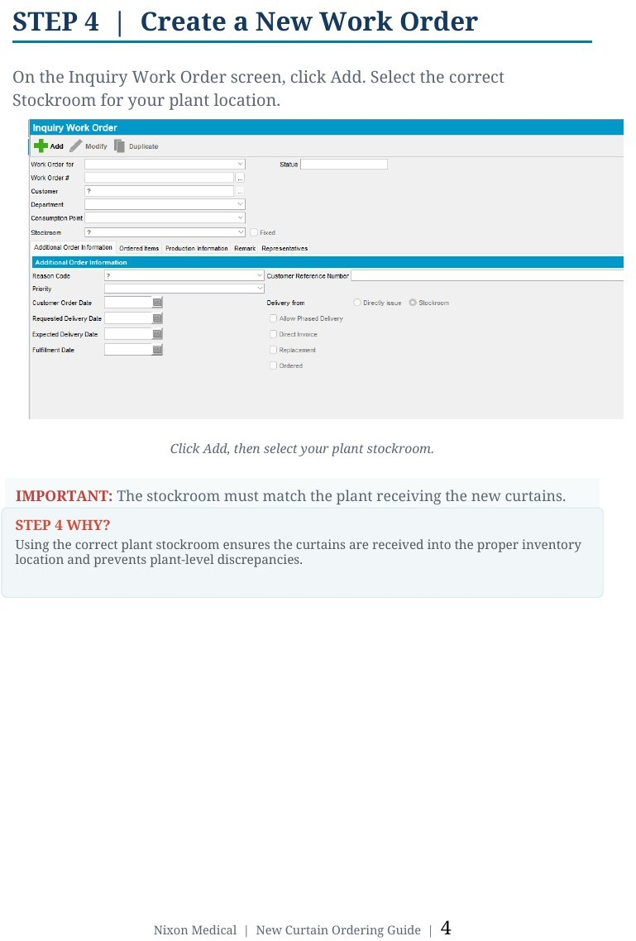

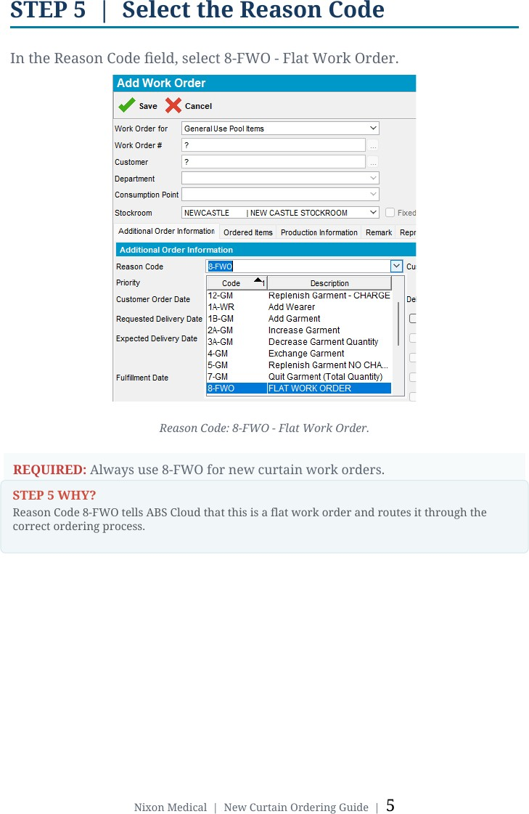

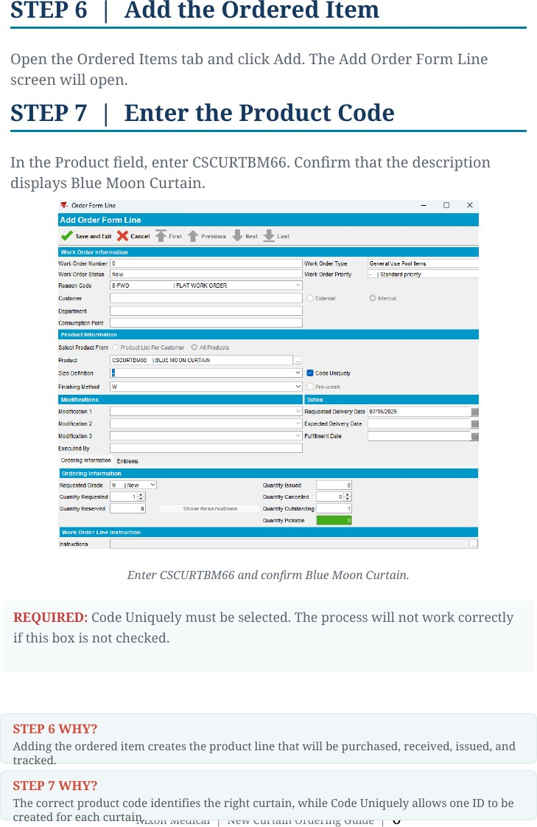

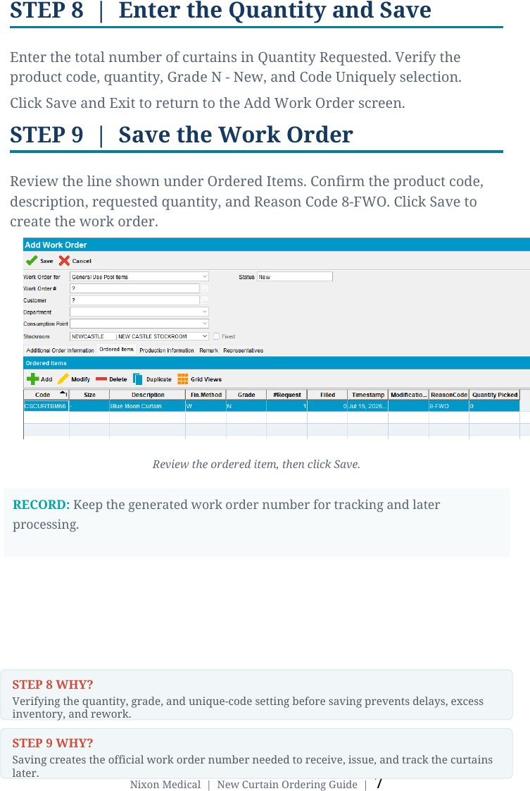

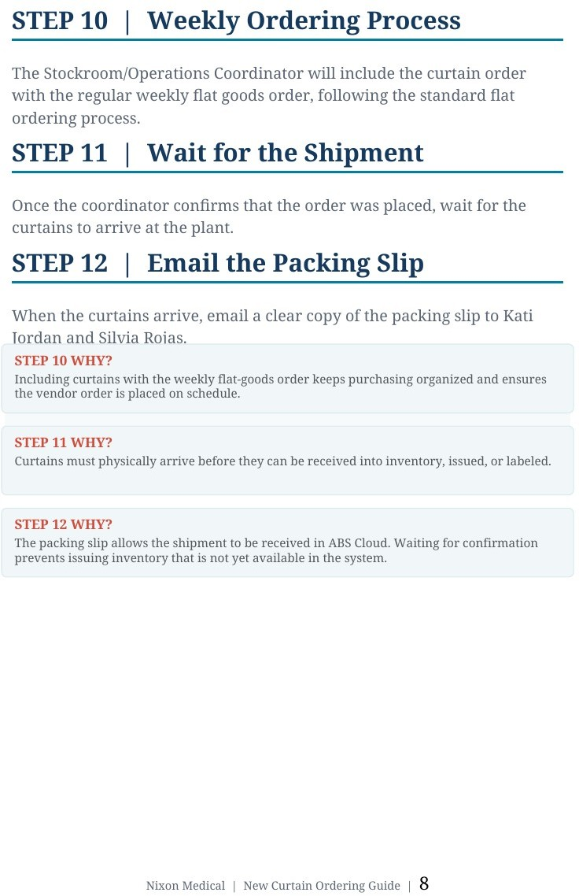

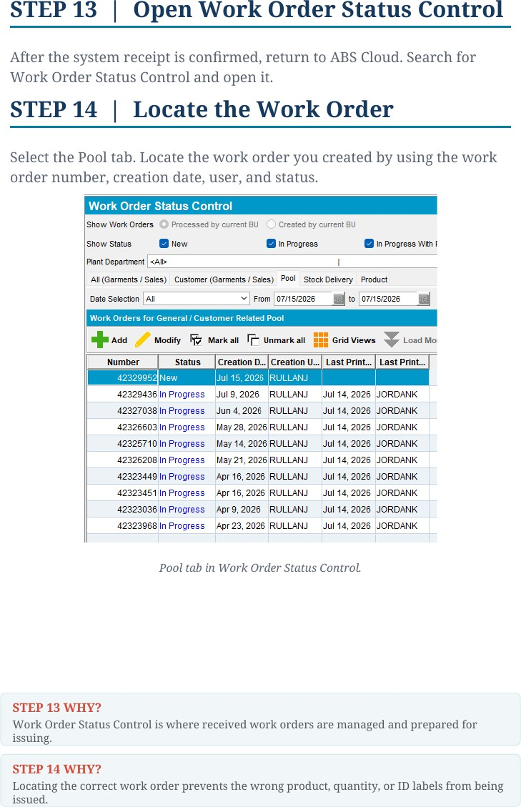

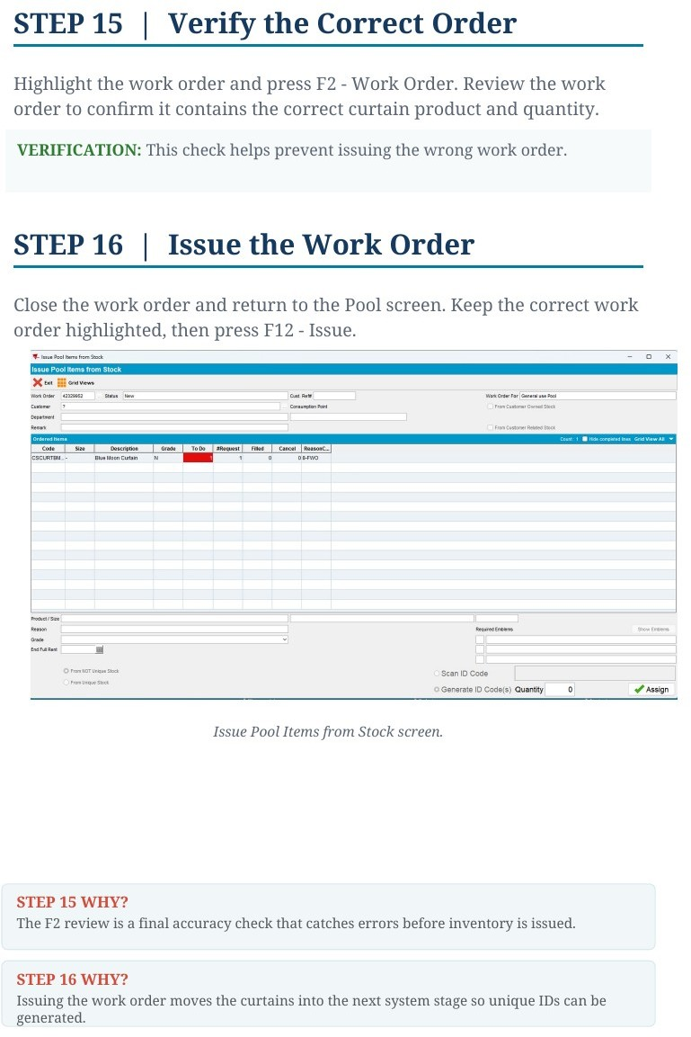

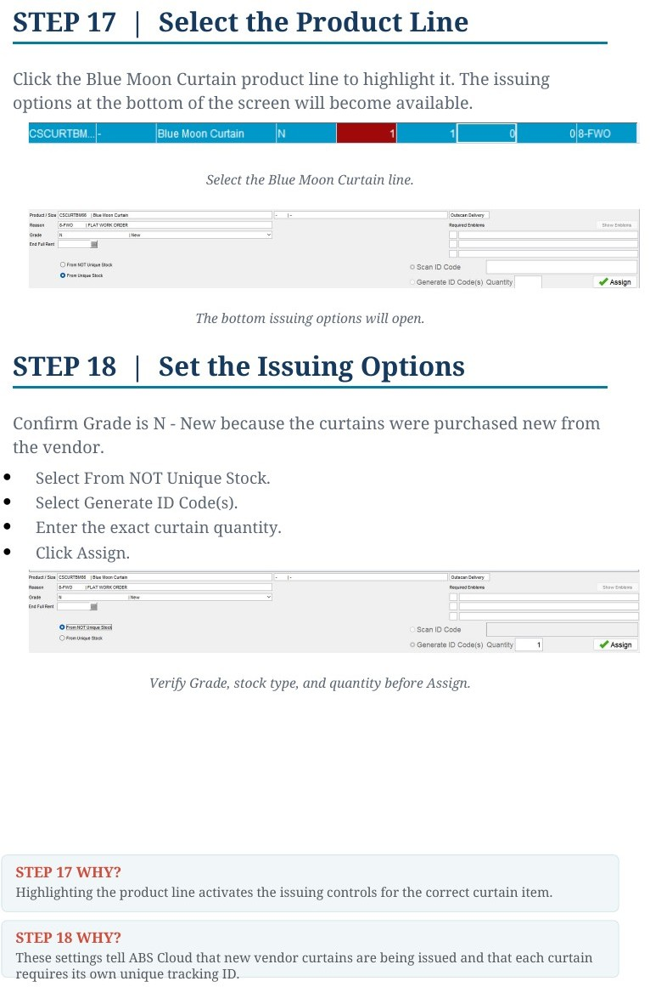

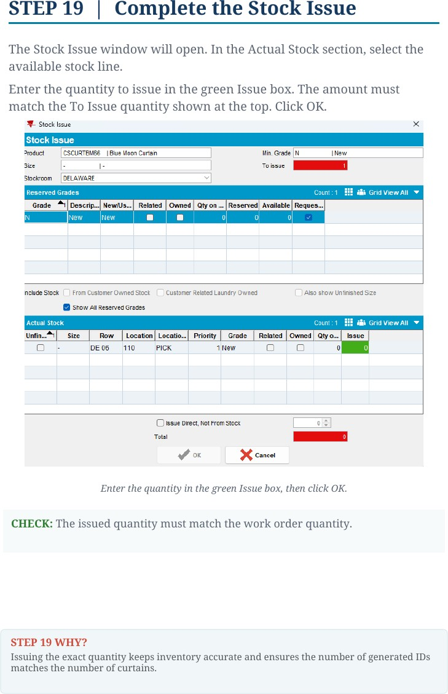

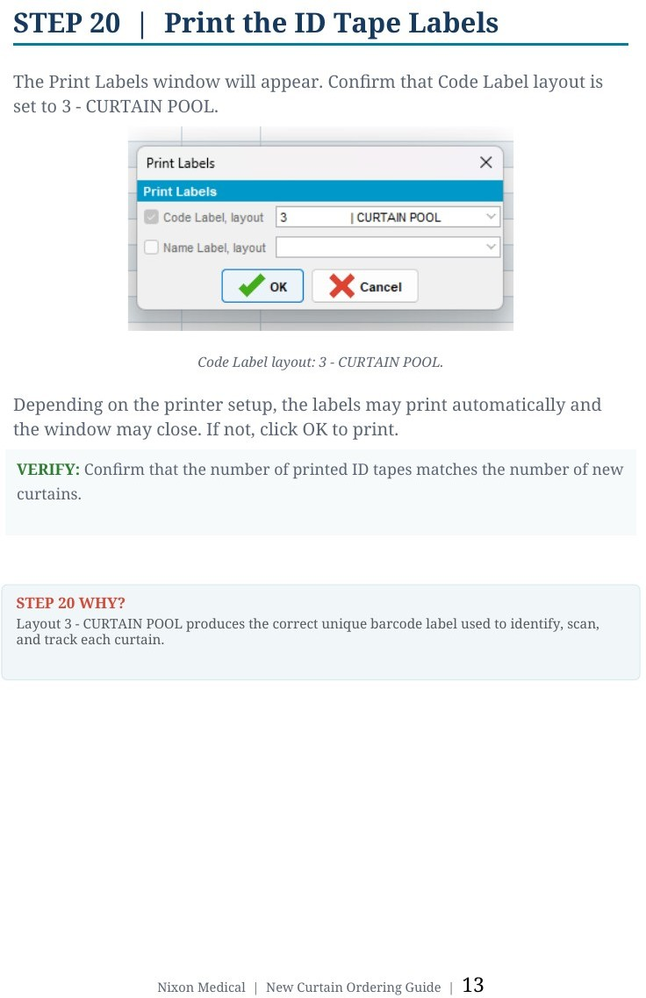

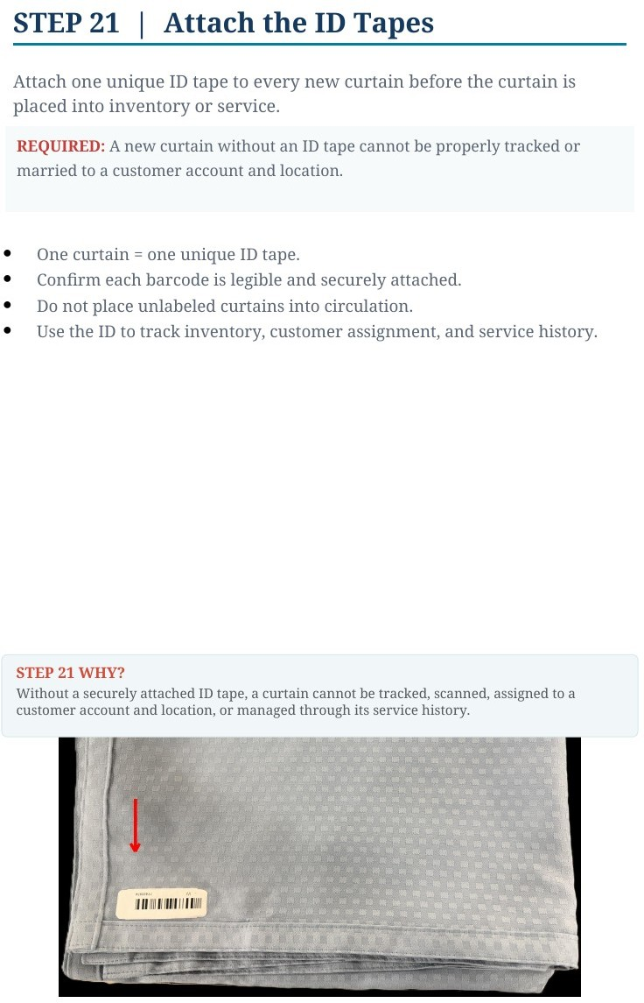

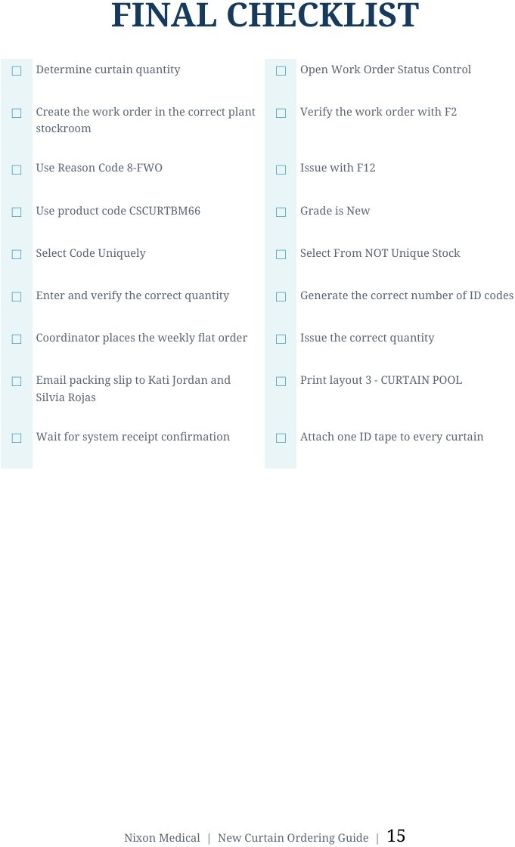

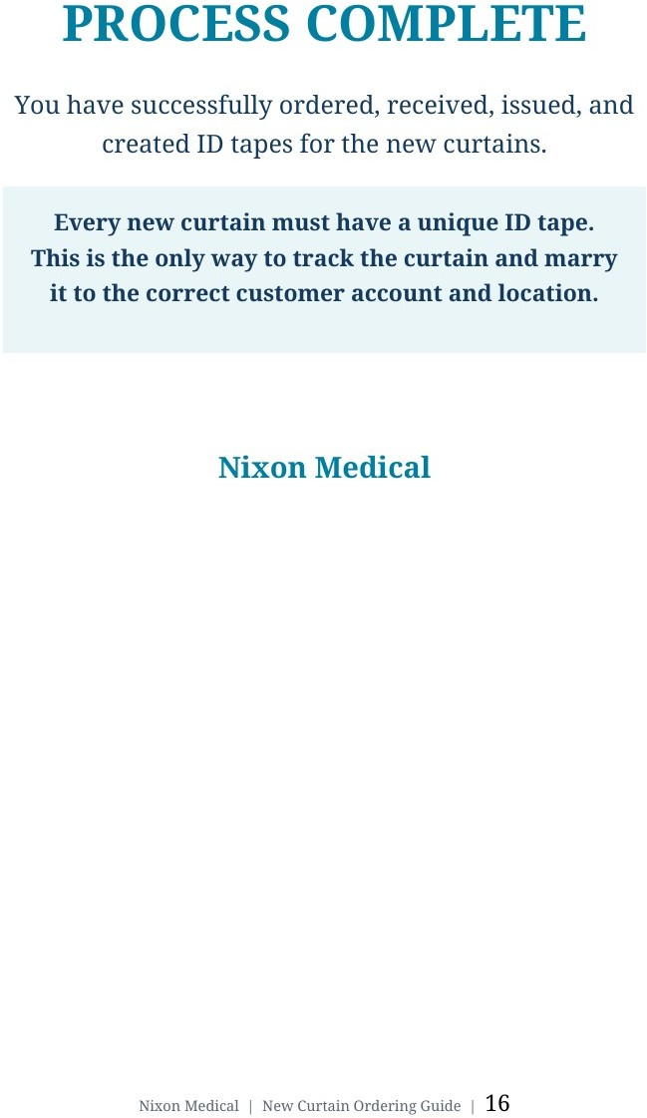

SECTION 2

PLANT PROCESSING C FULFILLMENT
Wash - Dry - Fold - Package - Store - Fulfill Put Up - Marry - Stage

Every curtain must be processed, scanned, and staged exactly as shown.

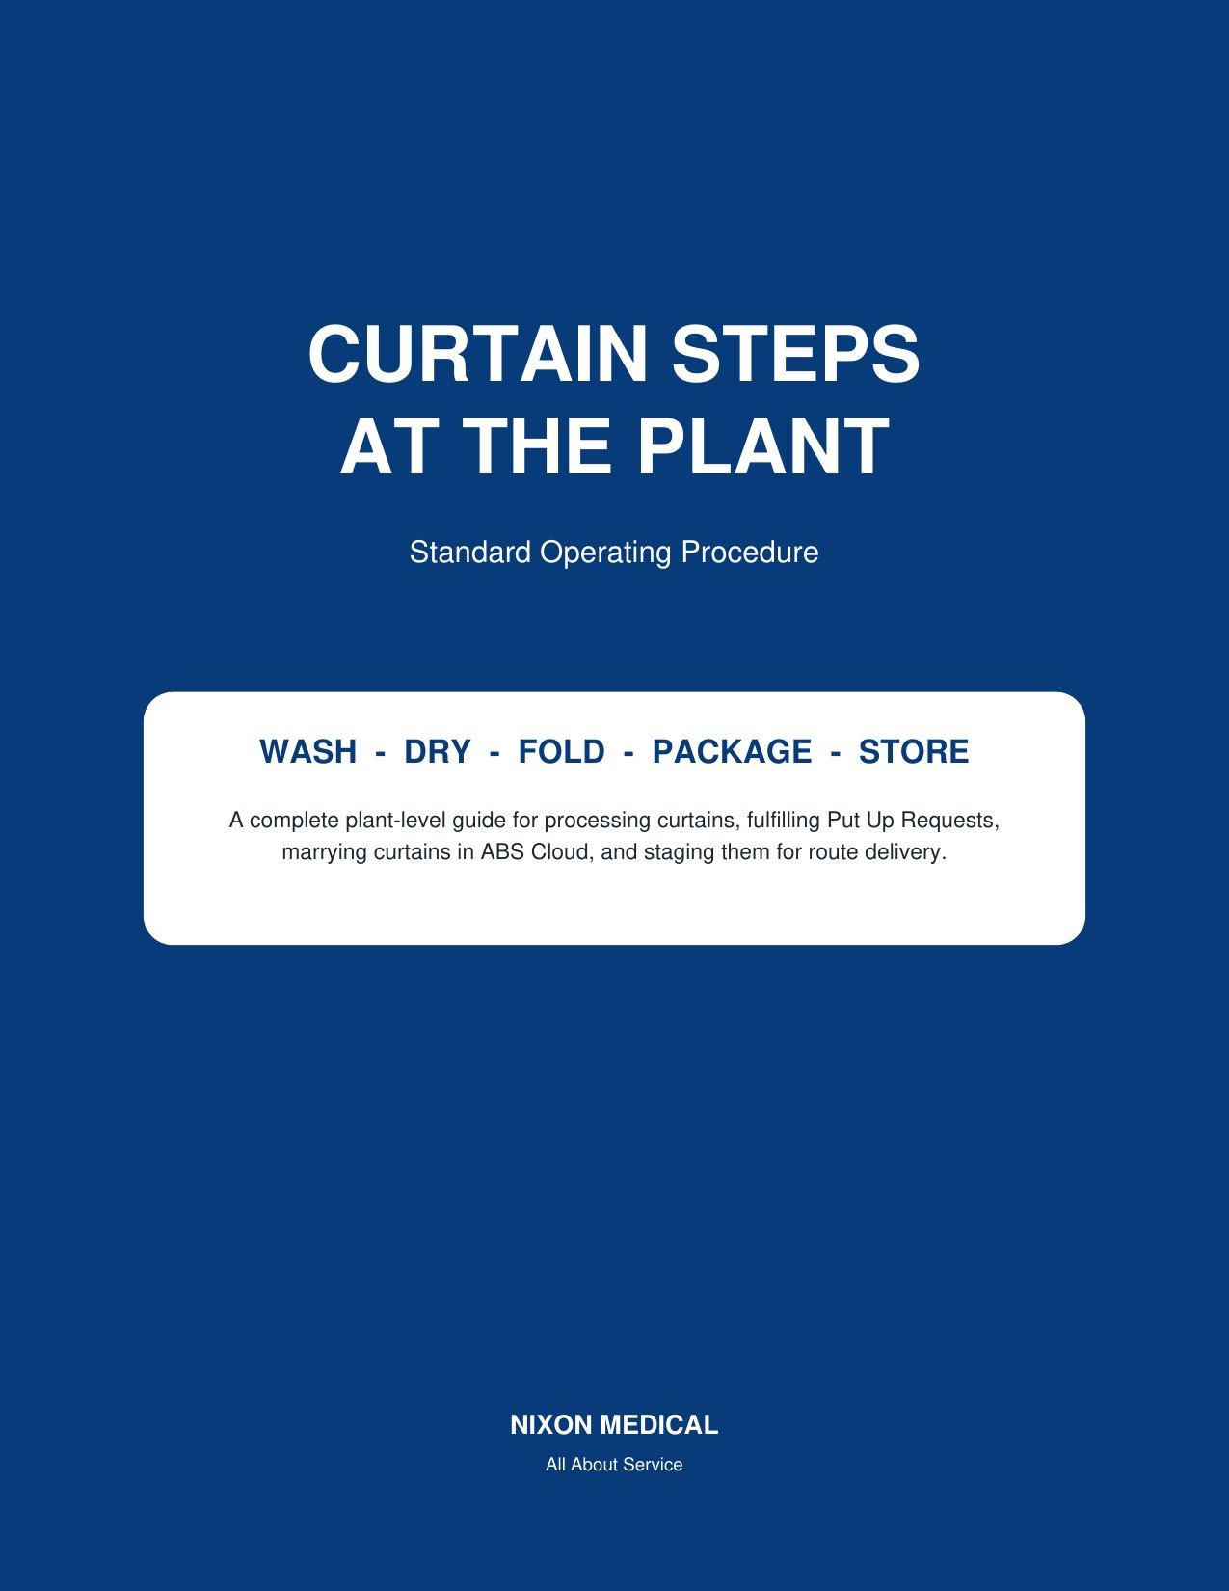

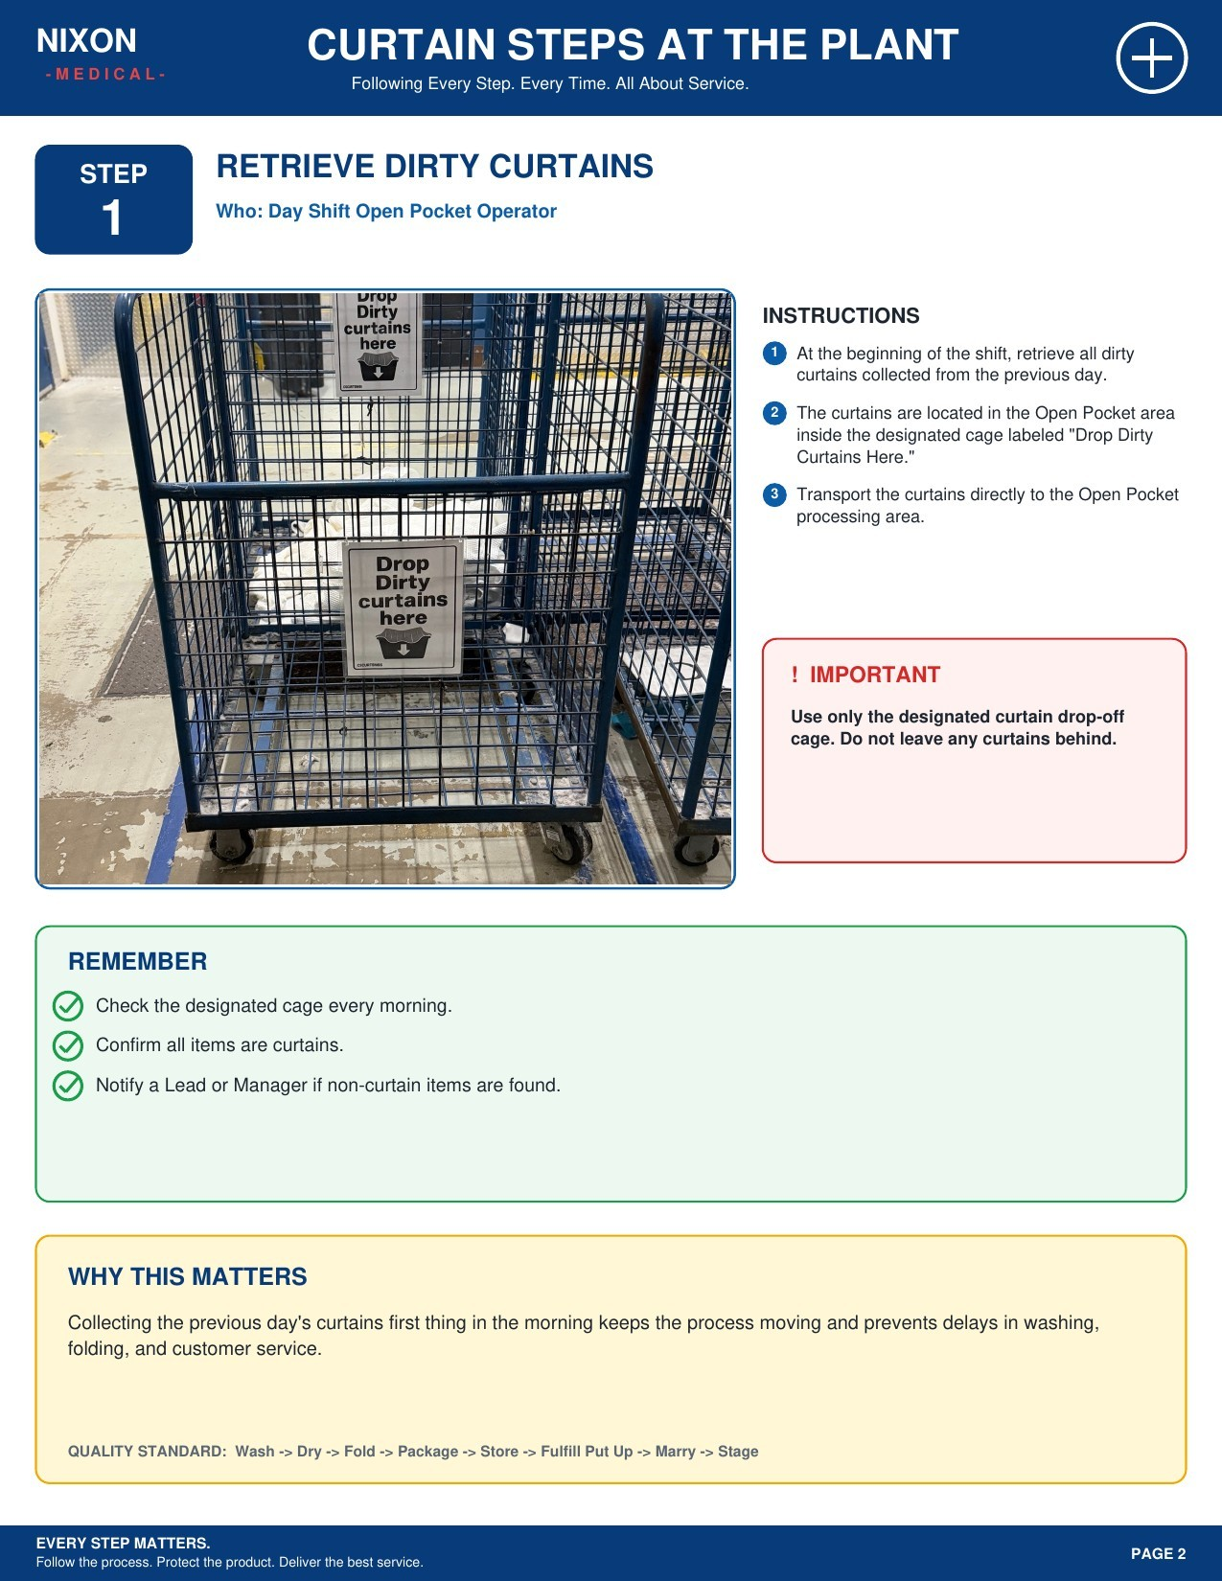

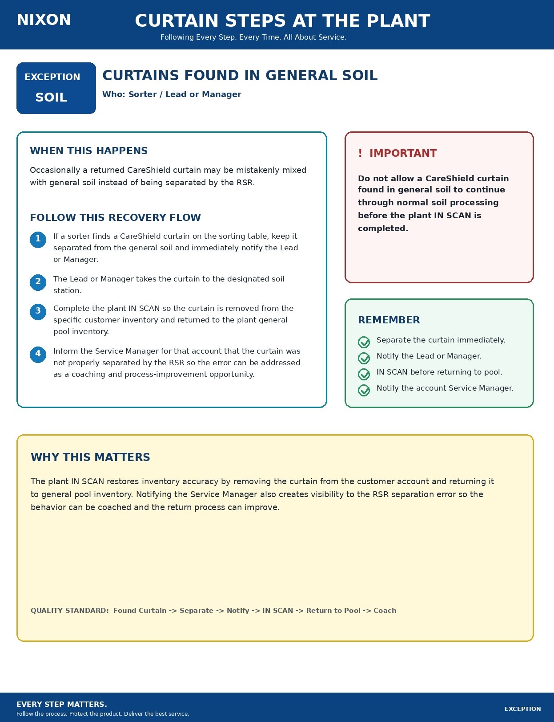

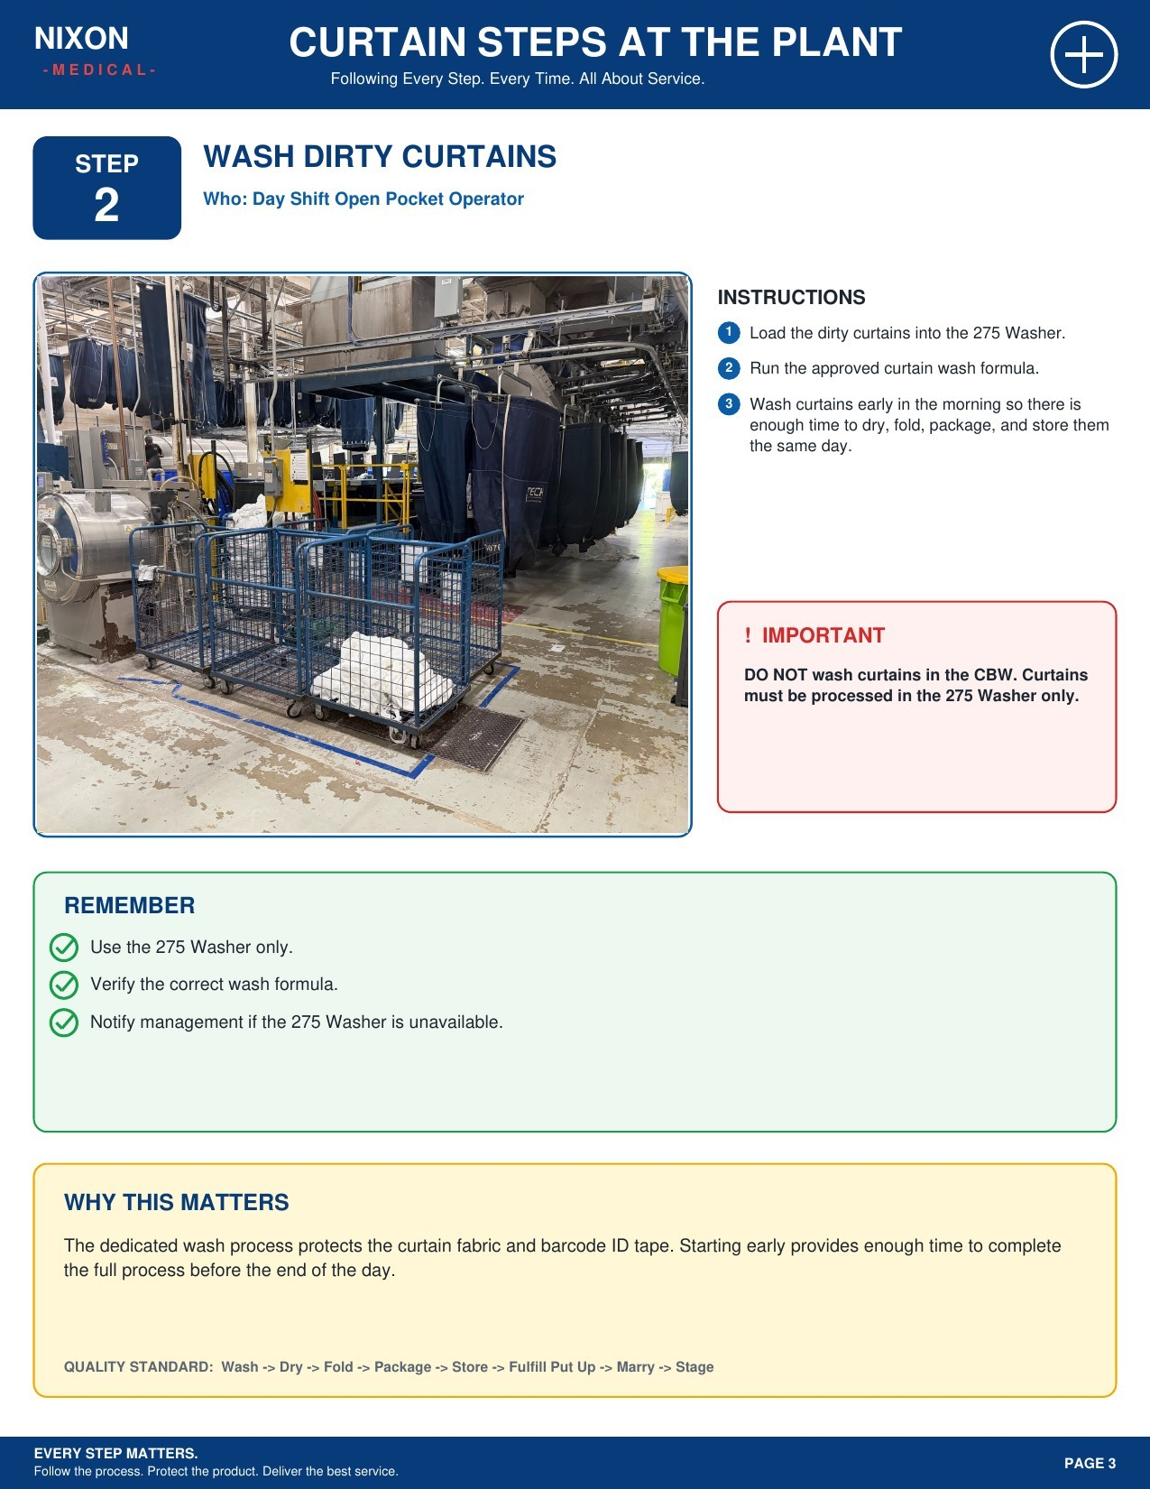

NIXON MEDICAL
CURTAIN STEPS AT THE PLANT
Following Every Step. Every Time. All About Service.
EVERY STEP MATTERS.
Follow the process. Protect the product. Deliver the best service.
WASH FORMULA REFERENCE

CARESHIELD WASH FORMULA REFERENCE
FORMULA
REF
Who: Open Pocket Washer Operator

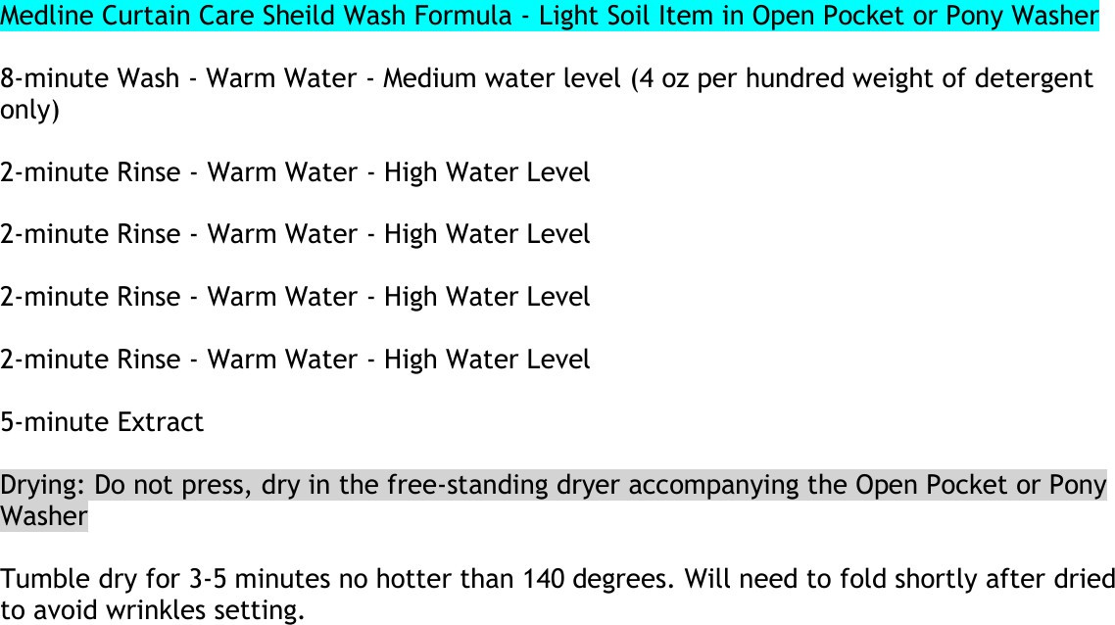INSTRUCTIONS

Each plant must create this CareShield wash formula as an available option on the washer used for curtain processing.
1

Select and verify the CareShield formula before starting every curtain load.
Use the formula shown at left as the standard
3 reference for wash, rinse, extract, and drying settings.
! IMPORTANT
The wash formula must be created as a selectable washer option at each plant. Do not rely on memory or substitute a different formula.
3 Use the formula shown at left as the standard reference for wash, rinse, extract, and drying settings.
! IMPORTANT

The wash formula must be created as a selectable washer option at each plant. Do not rely on memory or substitute a different formula.
2

REMEMBER
Wash: 8 minutes, warm water, medium level; detergent only at 4 oz per hundredweight. Rinse: four 2-minute warm-water rinses at high water level; then 5-minute extract.
Dry in the free-standing dryer for 3-5 minutes at no more than 140 degrees; fold shortly after drying.

WHY THIS MATTERS
Using one defined formula across plants creates a consistent curtain-care process and gives operators a clear, repeatable washer setting to follow.

REFERENCE: Medline Curtain CareShield Wash Formula

