Leveraging LoanBeam NQM™ to Process Bank Statements for Non-QM Income

  - User Guide
Version 3

November 6, 2025



Contents
Contents 2
Change History 2
Overview 3
NQM Template Group Access – For Admin User only 3
Configure individual user with access to NQM Income Calculation 3
Configure multiple users with access to NQM Income Calculation 5
Creating an Application 8
Using the LoanBeam NonQM™ Result 13
General Functionality 14
Findings Tab 15
Borrower Summary Tab 16
Biz-Entity Income Tab 20
Monthly Qualifying Income (MQI) Details 21
Additional Findings 24
Notes 25
Statement Details 25
Deposits Detail Tab 26

Change History
Date | Change | Author
9-12-2025 | Initial creation | Drew Needs
9-18-2025 | Copy and content updates. | Roby Robertson
11-6-2025 | Updates related to November 2025 release  Configuration of users to NQM Template group  New findings tab in workbook  Removed findings from Borrower summary  Updates to Biz Entity tab | Shannon Redican

Overview
LoanBeam automates income calculation and file review, dramatically reducing the time and effort spent extracting, inputting, and validating data for borrowers.
This document is intended to explain the steps required to process a LoanBeam NQM™ application via the LoanBeam web portal (secure.loanbeam.com), aka “LoanBeam Dashboard.”

NQM Template Group Access – For Admin User only
Users who upload bank statements for NQM Income calculation will require configuration by their LoanBeam administrator to be included in the NQM Template Group.
This section will provide the steps for the LoanBeam administrator to provide access to users who will use LoanBeam for NQM Income calculation.

Configure individual user with access to NQM Income Calculation
Please follow the steps below to configure a single user with access to NQM Income Calculation.
- Admin users click Admin from dropdown located in top right corner of LoanBeam Dashboard screen to navigate to User tab of the Admin screens.
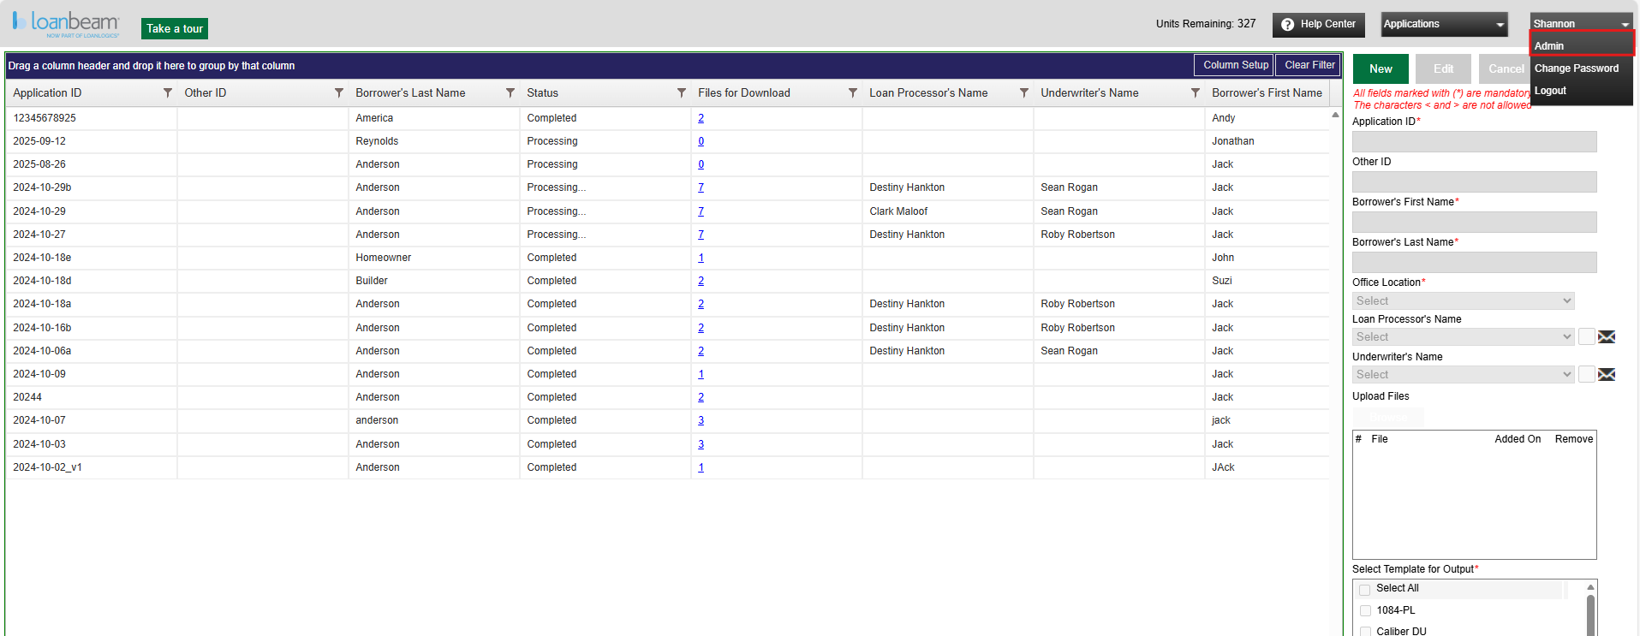

- Click on the line with the selected user’s name to add NQM Income Calculation and choose “Edit” in top line of right panel.
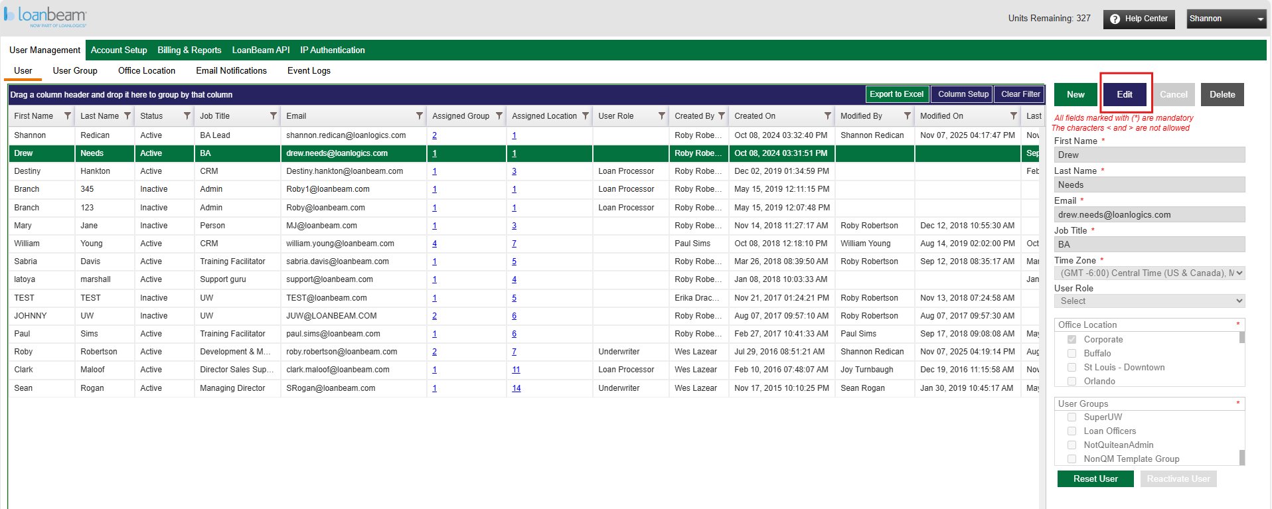
- Click on box labeled “NonQm Template Group” under “User Groups” and click “Update” in top line of right panel.
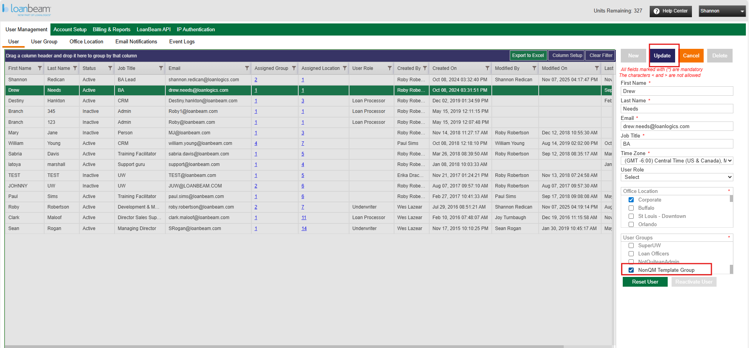

- When complete you will see message below “LoanBeam: The user is successfully updated.”
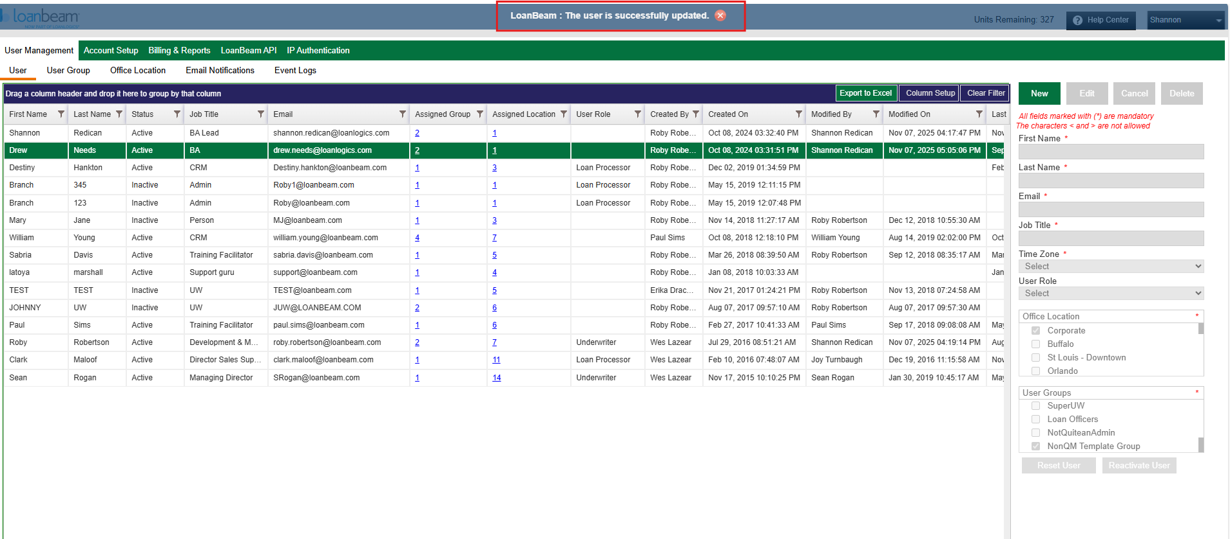

Configure multiple users with access to NQM Income Calculation
Please follow the steps below to configure multiple users with access to NQM Income Calculation.
- Admin users click Admin from dropdown located in top right corner of LoanBeam Dashboard screen to navigate to User tab of the Admin screens.
- Click on the “User Group” tab in the second row of the top left line to navigate to the User Group tab.
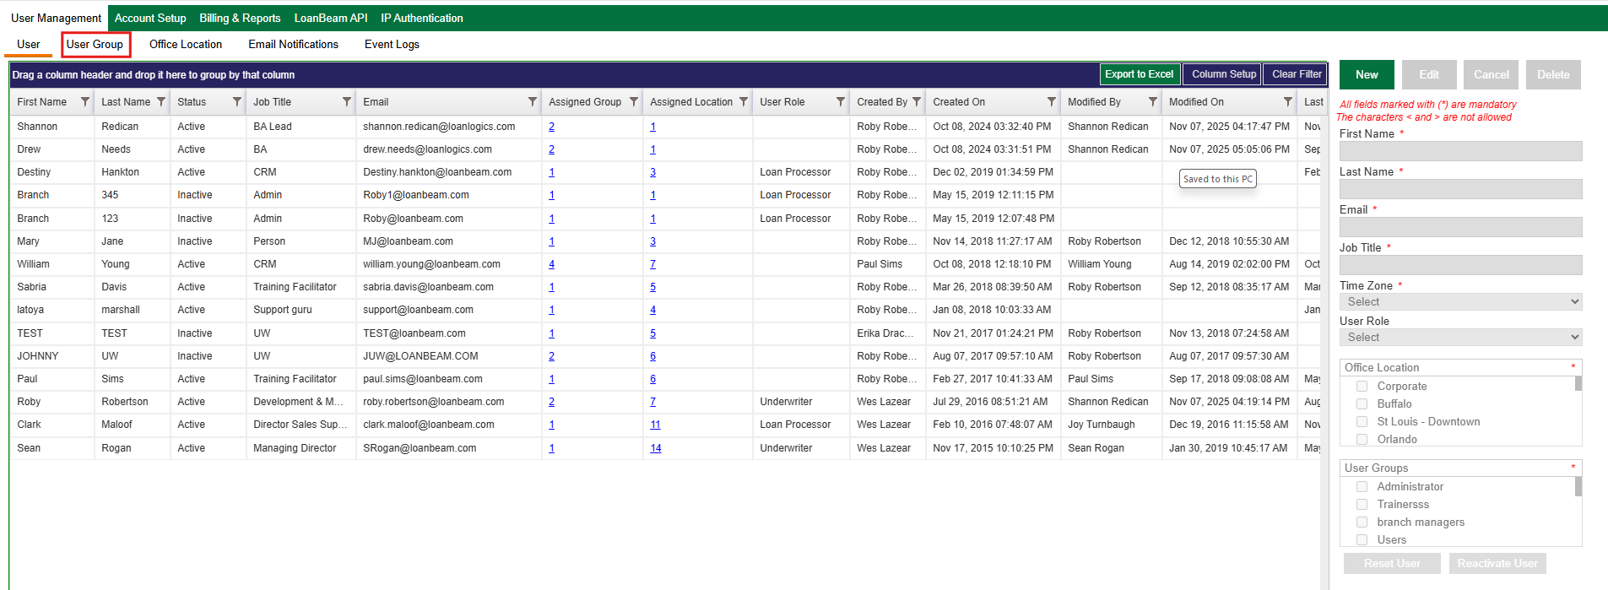

- Click on “NonQm Template Group” in the Group Name column and choose “Edit” on the top line of the right panel.
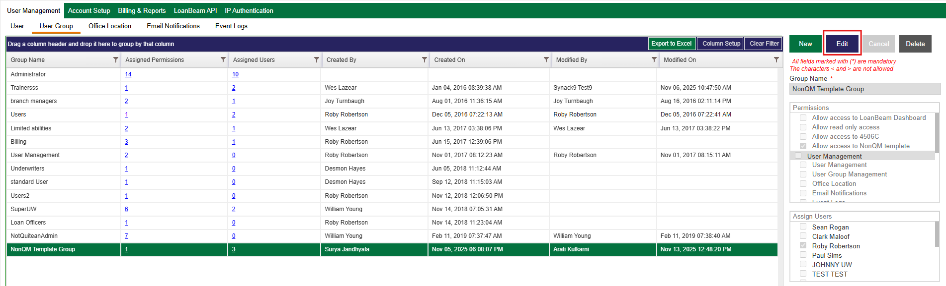

- Click on check box next to the user(s) names in assign users list that need to be added to the “NQM Template Group” and choose “Update” to save the change.
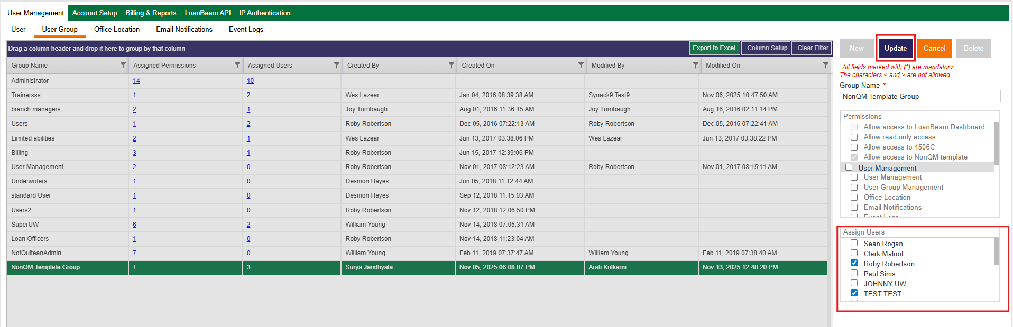
- When complete you will see message below “LoanBeam: The group permissions are successfully updated.”
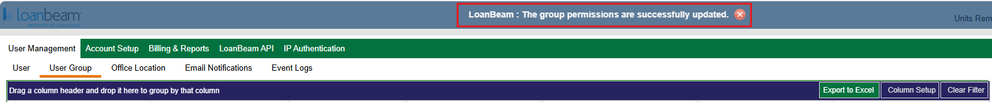
(The remainder of this page was intentionally left blank.)

Creating an Application
To create an application with LoanBeam NQM™ using the LoanBeam® web portal (“Dashboard”), complete the following steps.
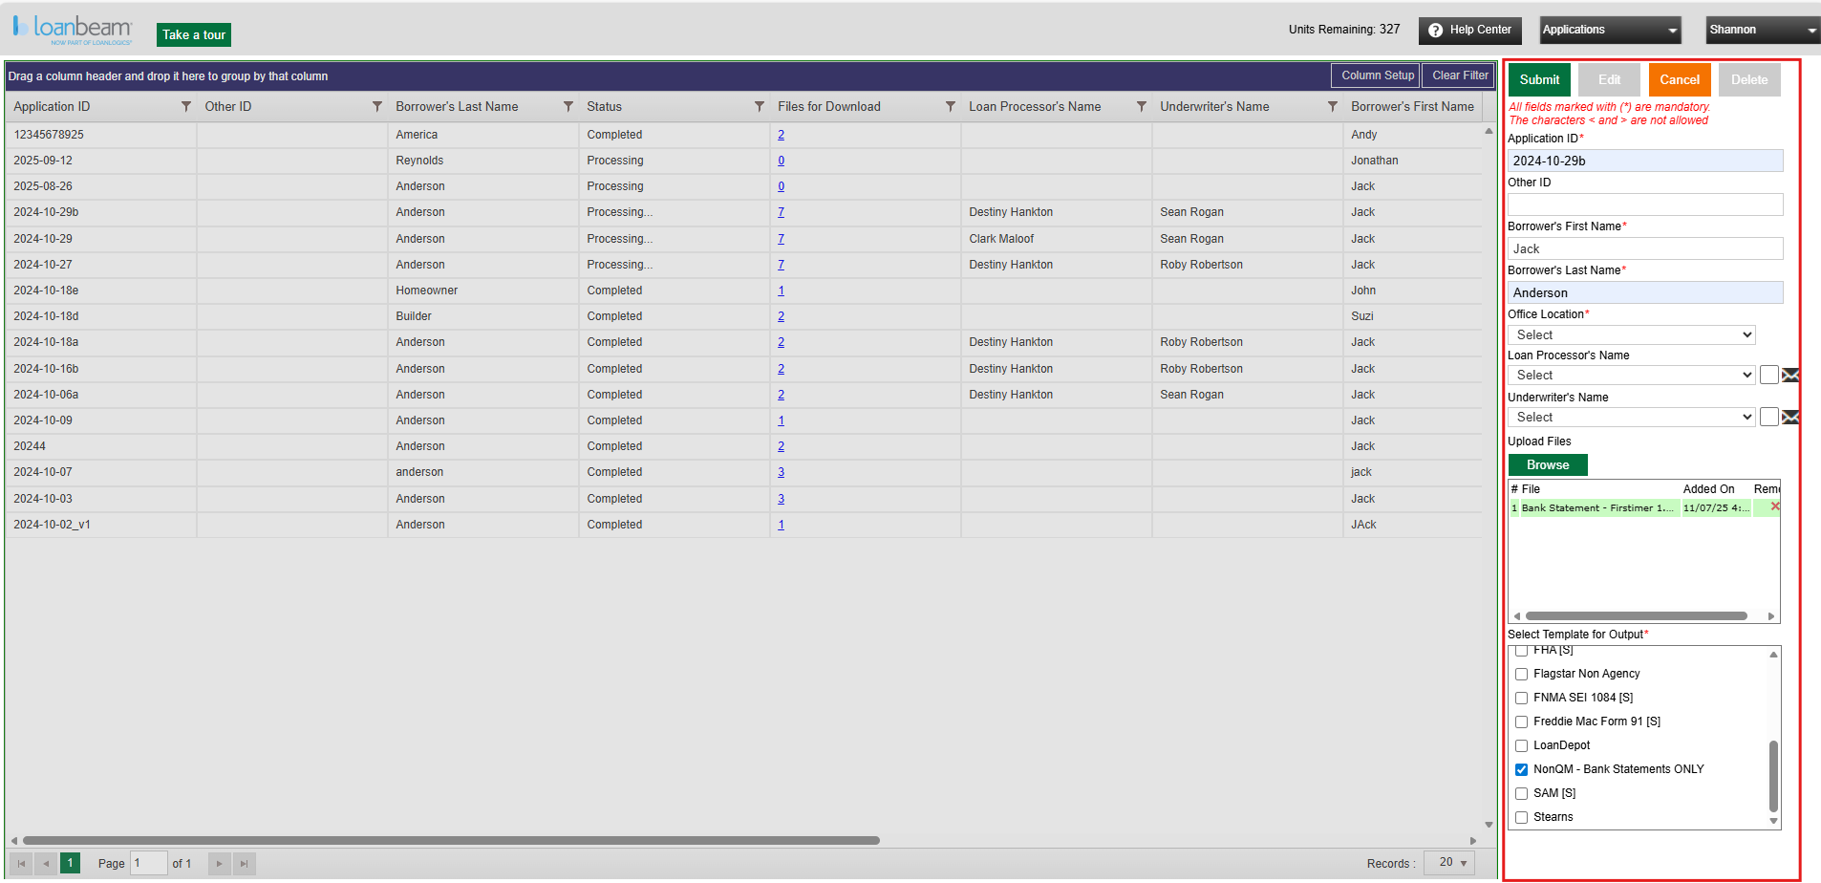

- Using the panel to the right of the home screen, click the green “New” button.
- Enter borrower and loan data. Fields marked with * are required.
  - Application ID*: - Typically the loan number
  - Other ID: Use for other ID needs.
  - Borrower Name (First and Last) *: Typically, the name of the primary borrower. Useful information for finding your application later.
  - Office Location*: Select the office location for this application. All users assigned to this office will have viewing access.
  - Loan Processors Name: Name of a processor that is working on the file.
    - Email checkbox: Use if you want the processor to get an email alert.
  - Loan Underwriters Name: Name of an underwriter that is working on the file.
    - Email checkbox: Use if you want the Underwriter to get an email alert.

- Attach Bank Statements
  - Click Green Browse button to find and attach your bank statements.
  - Use the attachments window to confirm you’ve attached the correct file.
  - Use the red “X” in the row to remove a file you wish to remove.

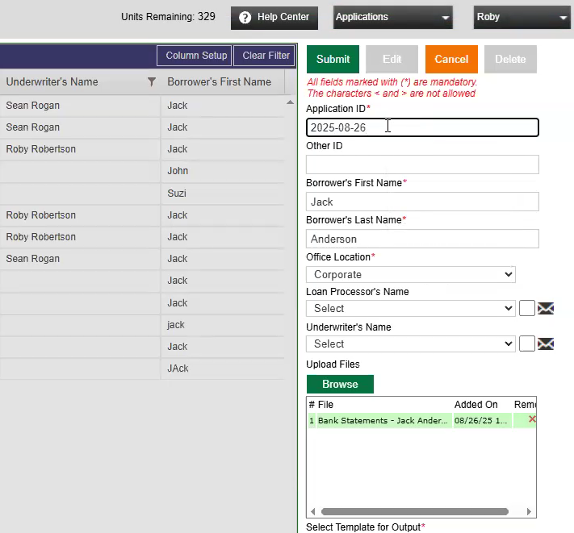

- Calculation Selection
  - In the list of calculation methods (“Templates”), select “NonQM Calculation-Bank Statements ONLY”.
    - IMPORTANT NOTE! Selecting this calculation method will disable the other options. NonQM is only used for bank statements – any other documents will be ignored. For tax returns, paystubs, W2s, use the other options.

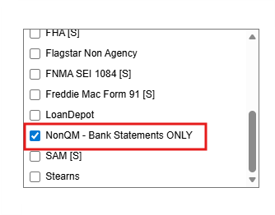

- Click Submit

When the loan has been submitted successfully, a confirmation message will be displayed at the top of the screen.
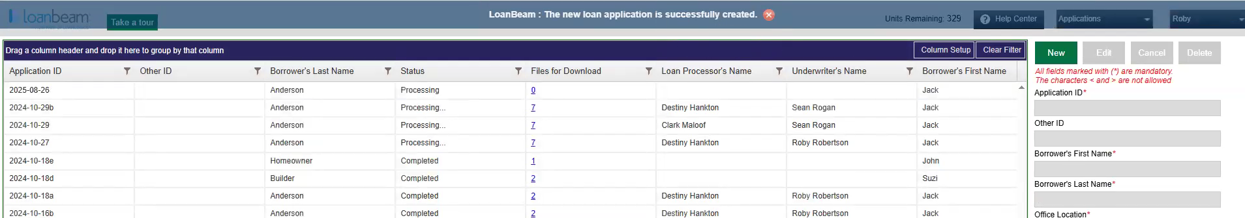

6. Download workbook
- Locate the loan in the Dashboard.
- Click on the corresponding link in the “Files To Download” column.
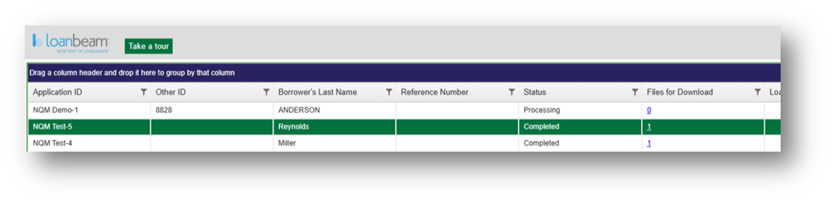

c. Download workbook by clicking on NonQM Calculation file.
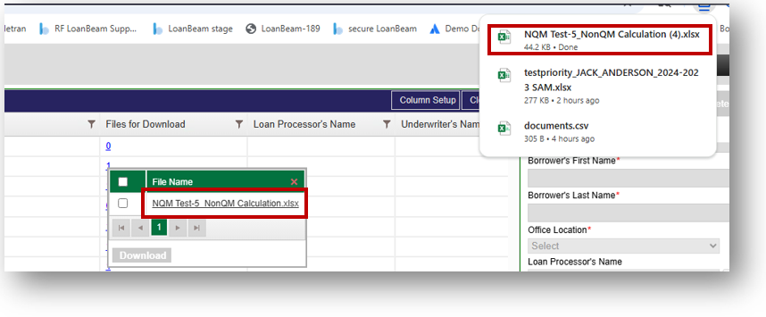

(The remainder of this page was intentionally left blank.)

Using the LoanBeam NonQM™ Result
The workbook contains four tabs. Arranged from left to right across the bottom of the workbook, they are:
- Findings
- Borrower Summary
- Biz-Entity Income
- Deposits Detail

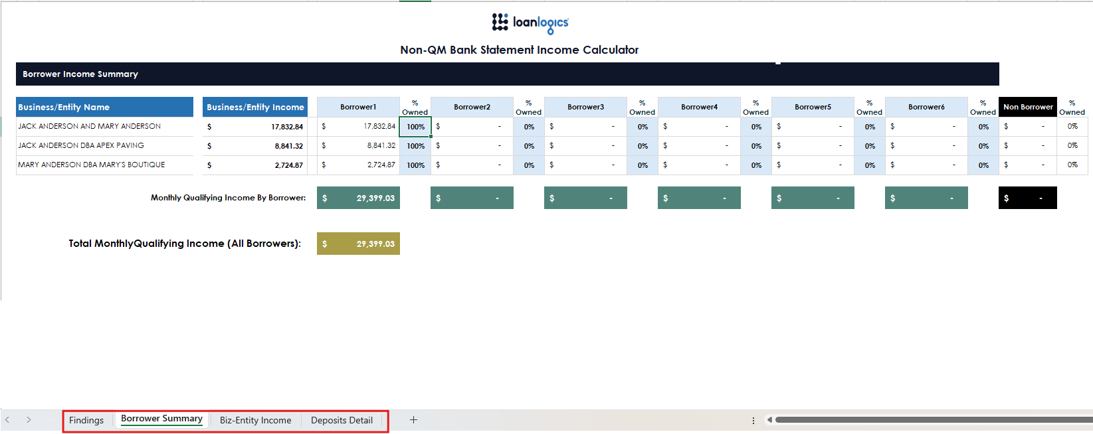

General Functionality
Used throughout the workbook, there are several features that control some basic functions. They are:
- Drop downs
- Editable override fields
Drop Downs
These fields are used to make a selection from a set of data programmed into the workbook. This allows users to make swift updates to the data.
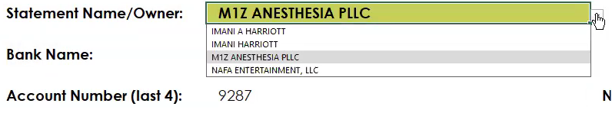
Editable Override Fields
Light blue fields are editable. Which means any default values entered by the system may be changed.
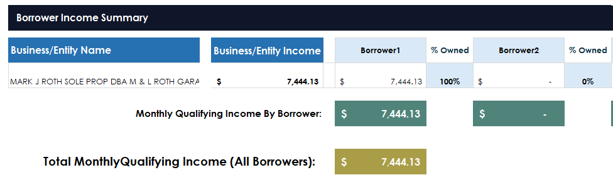

Findings Tab
This tab has been provided for the purpose of showing issues detected with the submission, such as missing statements. This tab will also supply the ability to show if the findings are being ignored and a place to write notes relating to the finding(s). 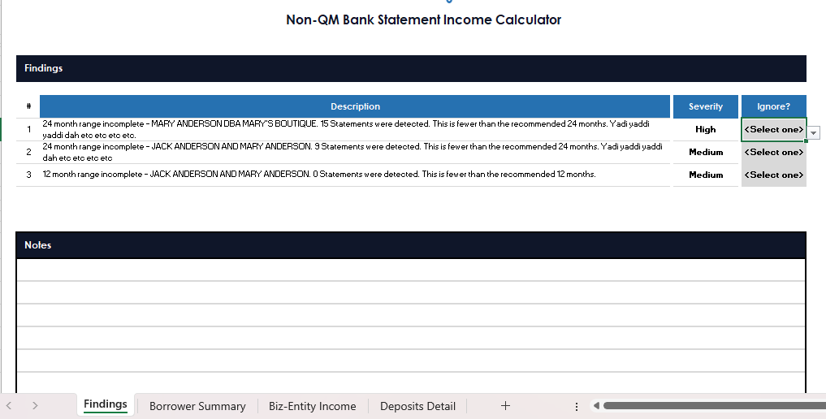

Findings can be grouped into two categories:
- Missing statements – Based on the “start date”, i.e., the first month chronologically, and the “end date”, i.e., the date the application was processed, the system determines if there are any missing statements.
  - An example of when the finding would fire:
    - Application submitted July 2025.
    - First statement chronologically that was uploaded was July 2023.
    - The file is missing in September 2024.
- Statement Range Alert – Based on logical rules, this finding alerts a user as to the following:
  - 12/24 Month Consistency – If the application does not have at least 12 or 24 consecutive months of data.
    - Important note! 12 and 24 month alerts are based on the current month (CM) of the application.

Borrower Summary Tab
This tab is a central location to show income calculations for each Business/Entity shown on the submitted bank statements. There will be the ability to assign percentages of income to specific people, so the income representation is accurate.
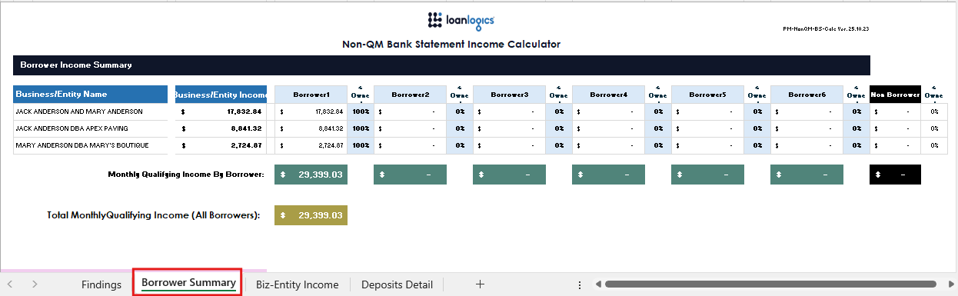

(The remainder of this page was intentionally left blank.)

Borrower Income Summary
Overview
This section is used to assign percentages of business/entity income to the borrowers. Income may be split between up to six borrowers.

Borrower Name Field
The light blue Borrower Name field may be used to enter in the borrower(s) name(s) for record keeping. This value is not completed by the system as the borrower's name is often not present on bank statements for businesses.

% Owned Fields
The light blue % Owned fields to the right of the borrower’s column are used to allocate income to your borrower(s). Note! All income is assigned to “Borrower1” by default.

Non-Borrower Column
To the right of all borrower columns, is a Non-Borrower column which captures any income that does not belong to your borrowers. The income is calculated automatically based on the remaining percentage after all borrower percentages have been accounted for.
For example: If Borrower1 = 40% and Borrower2 = 40%, then the Non-Borrower column would reflect the remaining 20% (100%-40%-40%=20%).
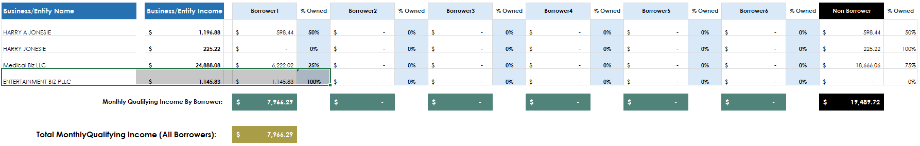

Total Monthly Qualifying Income
Total monthly income is separated into:
- Borrower Income – This is the total income for the borrower after percentages.
- Total Monthly Qualifying Income (All Borrowers) – This is the total monthly qualifying income for the entire application that belongs to borrowers. Note! This excludes any income in the Non Borrower column.

(The remainder of this page is intentionally left blank.)

Biz-Entity Income Tab
The Biz-Entity Income tab is used to calculate income by business/entity/statement owner using the data contained in the Deposits Detail tab. Each business/entity/statement owner is represented in its own separate group.
Each group is separated into four sections.
- Monthly Qualifying Income (MQI) Details
- Additional Findings
- Notes
- Statement Details
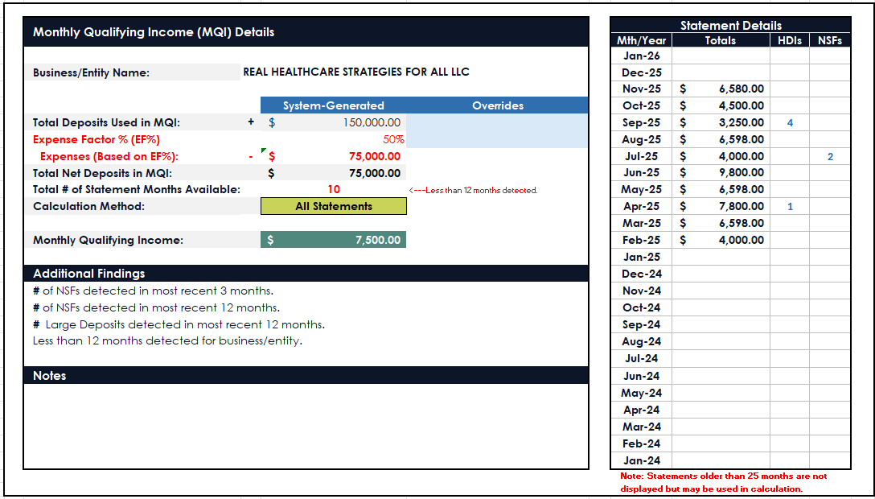

Monthly Qualifying Income (MQI) Details
The Monthly Qualifying Income (MQI) Details section converts statement details into an income calculation. The section calculates Monthly Qualifying Income based on the values from detected statements. The income calculation provides the option to override the values for Total Deposits and Expense Factor %. The following is a breakdown of the information in this section and functionality.
Business/Entity Name
Name listed on statement. Note! This is not editable.
Total Deposits Used in MQI
Total amount of deposits used to calculate MQI for the business/entity/statement owner based on selection of calculation method.
- Value in the System-Generated column will be calculated value from statements. The statements used in this calculation will depend on the value chosen in the Calculation Method field.
- When value in Overrides column is populated, it will be used instead of System-Generated value to calculate expenses, net deposits and monthly qualifying income.
Expense Factor % (EF%)
Percentage of Qualified Deposit Total assigned to expenses.
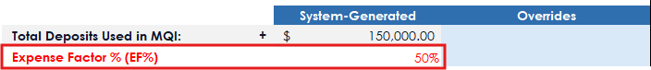

- System-Generated value defaults to 50%.
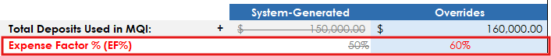
- When value in Overrides column is populated, it will be used instead of System-Generated value to calculate expenses, net deposits and monthly qualifying income.
Expenses (Based on EF%)
Expenses displayed as dollar value. This field will default to use values in System-Generated column unless values are input in the Overrides column for Total Deposits Used in MQI or Expense Factor %.
Below is an example of expenses using System-Generated value for Total Deposits Used in MQI and default value of 50% in Expense Factor.
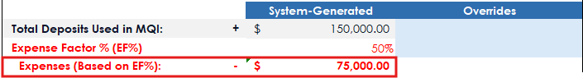
Below is an example of expenses using Overrides valued for Total Deposits Used in MQI and Overrides value of 50% in Expense factor.
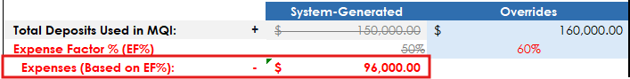

Total Net Deposits in MQI
Figure when Expenses are subtracted from Total Deposits Used in MQI.

Total # of Statement Months Available
Indicates the total number of statement months identified.

Calculation Method
The Calculation Method is a dropdown field which allows you to choose the number of statements used to calculate Monthly Qualifying Income. The selection for this field will be used to calculate the Total Deposits in MQI and Monthly Qualifying Income Calculation fields.
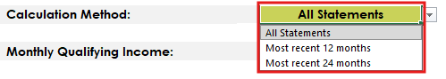
- All Statements – Total Net Deposits in MQI/ Total # of months where statements are available. This is the default value.
- Most recent 12 Months – Total Deposits for the most recent 12 months of statements found.
- Most recent 24 Months – Total Deposits for the most recent 24 months of statements found.
(The remainder of this page was intentionally left blank.)

Monthly Qualifying Income Calculation
The Monthly Qualifying Income for the business entity is calculated by dividing the Total Net Deposits in NQM by the number of statements used in the Calculation Method selected.
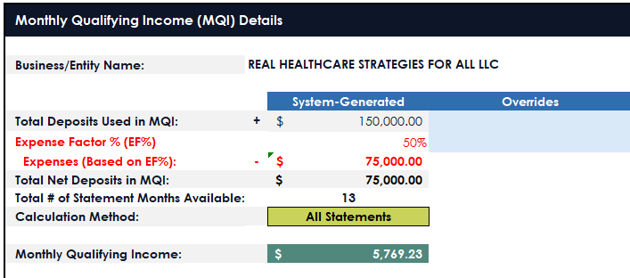

Additional Findings
The values in this section are for information purposes only and are static. No changes can be made. This section will show the number of NSFs detected in the past 3 months and 12 months, along with the number of large deposits within the last 12 months.
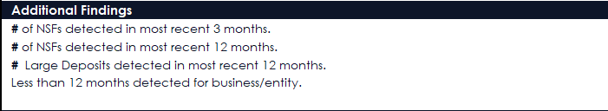

Notes
A notes section has been supplied at the bottom of each Business/Entity snapshot. This can be utilized for things such as underwriter notes.


Statement Details
The summary details table contains a summary of all monthly statements detected. The table has 25 rows beginning with the current month. Each row provides a summary for each statement provided for the business entity.
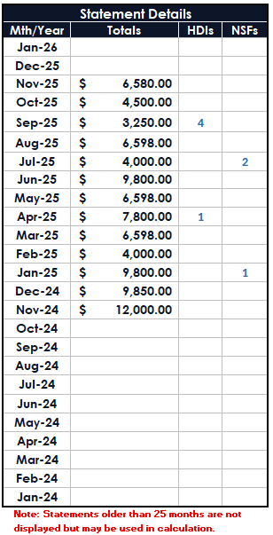

Below are the column names and descriptions in the Statement Details table.
Column Name | Column Description
Month/Year | Provides Month/Year of the statement
Deposit totals | Gross Deposit amount for the month of statement
HDI | Count of HDI for the statement month
NSF | Count of NSF for the statement month

Deposits Detail Tab
The Deposits Detail tab contains data directly from uploaded bank statements organized by statement. Each statement is separated into groups containing important owner, bank, account, issuance, and deposit details for determining qualifying deposits.
Each statement is separated into three sections:
- Header
- Deposits Detail
- Notes

Header
The header section contains statement information, including Statement Name/Owner, Bank Name, Last 4 digits of the Account, Statement Year, Statement Month, and a count of NSFs contained within the statement.
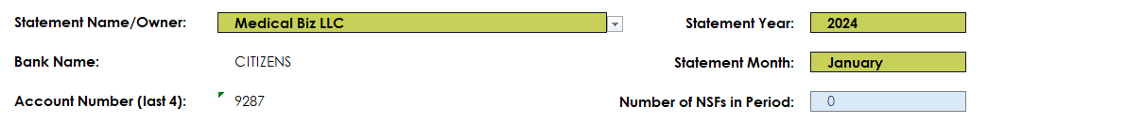
- Statement Name/Owner - Name extracted from the supplied statement. A dropdown has been supplied so the name the statement belongs to is used. Changes made will not be carried to other statements listed in the Deposit Details tab. If modifications are necessary, they will need to be made for each statement. If the wrong values are selected or statements are missing, this may result in broken income calculation.


- Bank Name – Name of the bank extracted from the supplied statement.
- Account Number – Last 4 digits of the Account number extracted from the supplied statement.
- Statement Year – The year listed on the supplied statement.
- Statement Month – The month listed on the supplied statement.
- Number of NSFs in Period – A count of all NSF transactions for each statement period.
Please note, if any value in the header section is deleted and left blank, the deposits for that month will not be included in the income calculations.

Deposits Detail
The Deposits Detail tab contains detailed information for deposits as they appeared on the statement. Each deposit is separated into rows.
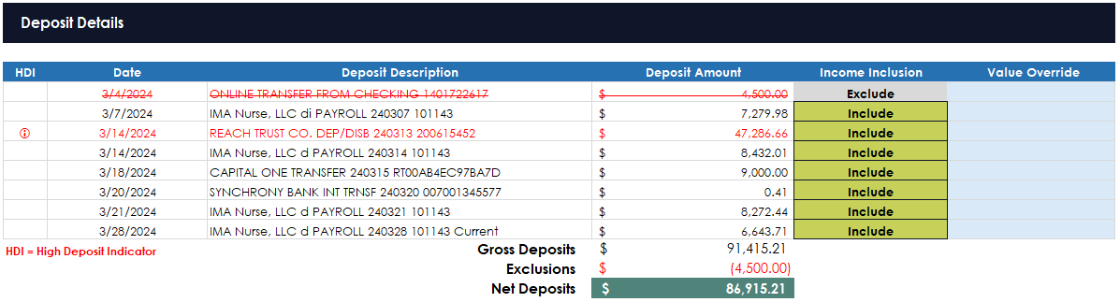
Included in this section are helpful automations, alerts, and functionality which speed up your data review. The following is a detailed breakdown of those functions.
- HDI - The High Deposit Indicator (HDI) flags any deposits that are greater than 50% of the Total Monthly Qualifying Income monthly income found on the Borrower Summary. Note! This flag is dynamic. Changes in the Total Qualifying Income may impact this flag.
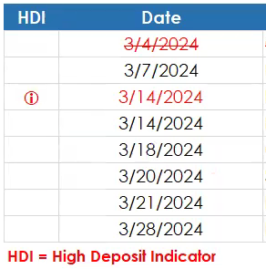
- Date - The date field is the date listed on the statement for the transaction.
- Deposit Description - The description is pulled from the transaction description as listed on the supplied statements.
(The remainder of this page was intentionally left blank.)

- Income Inclusion - The Income Inclusion field gives the option to include or exclude deposits from income calculations. Default values have been established and programmed into the workbook. The values can be overridden by clicking in the field and selecting the desired value.
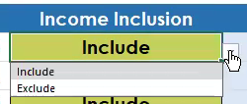
- Value Override – To modify/change a value extracted by the system, use the light blue cells to the right of the value. Note! Deposits flagged as High Deposits will not change in font style (they stay red), but the value will update in the calculations.
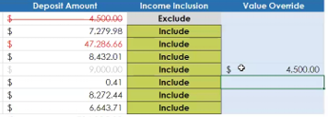

Calculations Section
Calculations of the Gross Deposits, Exclusions, and Net Deposits will be listed at the bottom of each Deposit Details section.
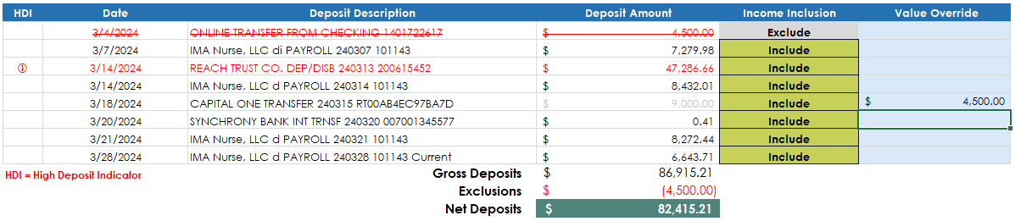

Notes section
A notes section has been provided at the bottom of each statement grouping. This can be utilized for things such as underwriter notes.
