Asus C302C Chromebook

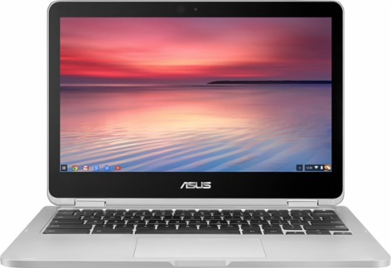

Tutorial

Pemberton Twp. School District

Technology Dept.

148 Arney’s Mount Road

Pemberton,NJ 08068

Table of Contents
Welcome 3
What Are Chromebooks? 4
Signing In To Your Chromebook 5
Connecting Your Chromebook to Wi-Fi at Home 6
Accessing Apps & Extensions 7
Connecting Your Printer to Your Chromebook at Home 9
Setting Up Classic Printing on Chromebook 10
Setting Up Google Cloud Printing on Chromebook 11
Managing Files on the Chromebook 12
Find and open a file 12
Save a file 12
Managing Files on the Chromebook Video Tutorial 13
Chromebook Shortcuts Reference Sheet 14
Issues You May Experience with the Chromebook 18
Care of the Chromebook 19
Specifics on the Chromebook 20
FAQ’S 21

Welcome

Welcome to PTHS. You’ve just been issued a Asus Chromebook by the Pemberton Twp. School District & Pemberton Twp. Technology Dept. This tutorial will help you on how to use the Chromebook. The equipment that you’ve been issued are as follows:
- Asus Chromebook
- Charger
- Belkin Laptop Sleeve

If you have any questions, please stop by the Tech Office at PTHS in Rm 201.

What Are Chromebooks?

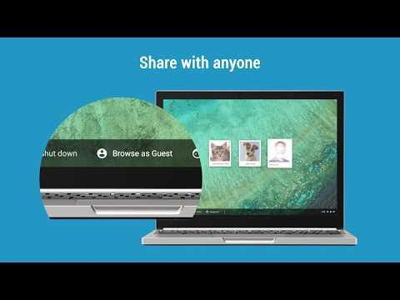

Signing In To Your Chromebook

Every student in PTSD has a Google Account which was created by the PTSD Technology Dept. Each student will log into their Chromebook with their student Google Account. When the Chromebook is turned on in school, it automatically connects to the PTHS Wi-Fi Network. The instructions for logging into the Chromebook are as follows:

- In the Username window, enter username@pemb.org. Example, if your name is Pemberton Hornet, you will enter phornet@pemb.org
- In the Password window, enter your password. The password is the same
password you use to log into any computer in PTSD.

The Sign-In Window looks the image below

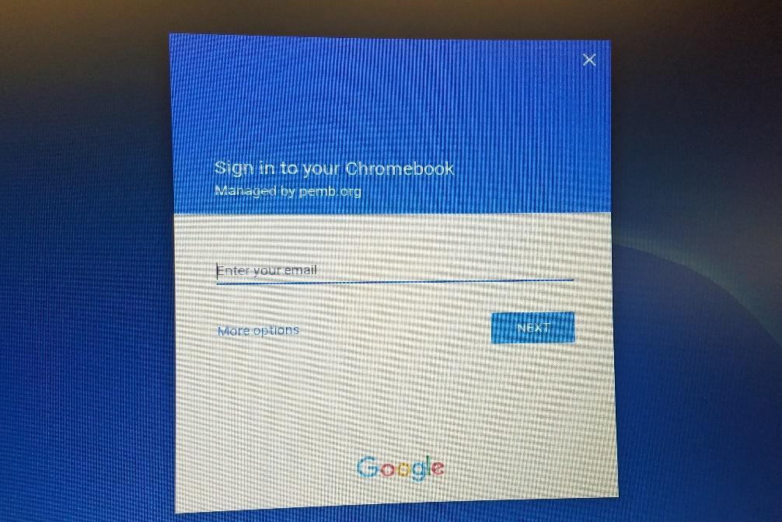

If you forgot your password to log into your Google Account, contact the PTHS Technology Dept. to get your password reset. Once the your password is reset, you’ll be prompted to change their password. The password will be reset to Pemberton with a capital P. The new password that you create must be at least 8 characters long & the new password can’t be a password that was previously used. You’ll be prompted to change the password to something that you’ll remember. Once your password has been changed, keep your password in a safe place & DON’T share your password with anyone.

Connecting Your Chromebook to Wi-Fi at Home

When the Chromebook is turned on in school, it automatically connects to the PTHS Wi-Fi Network but when you turn on your Chromebook at home, you must connect your Chromebook to your Home Wi-Fi Network. In order to connect the Chromebook to your Wi-Fi Network at home, the instructions are as follows:

- Turn on your Chromebook.
- Click on your Account Photo.
- Click No Network.
- To turn on Wi-Fi, click on switch.
- Your Chromebook will automatically look for available networks and show them to you in a list.
- Click on your Wi-Fi Network & enter the password to access Wi-Fi- Network
- Click Connect

*This process only has to be done once. Once the Chromebook connects to the Wi-Fi Network at home, it’ll connect automatically every time you turn the Chromebook.

Accessing Apps & Extensions

The Pemberton Twp. School District installed Apps & Extensions for Chrome on the Chromebook. In order to access the apps & extensions, follow the steps below:

- Log into the Chromebook with your username & password.
- Once you’ve logged into the Chromebook, click on the Launcher icon that looks like a Black circle with a small white circle inside it. It’s located in the lower left hand corner. The icon looks like the image below:

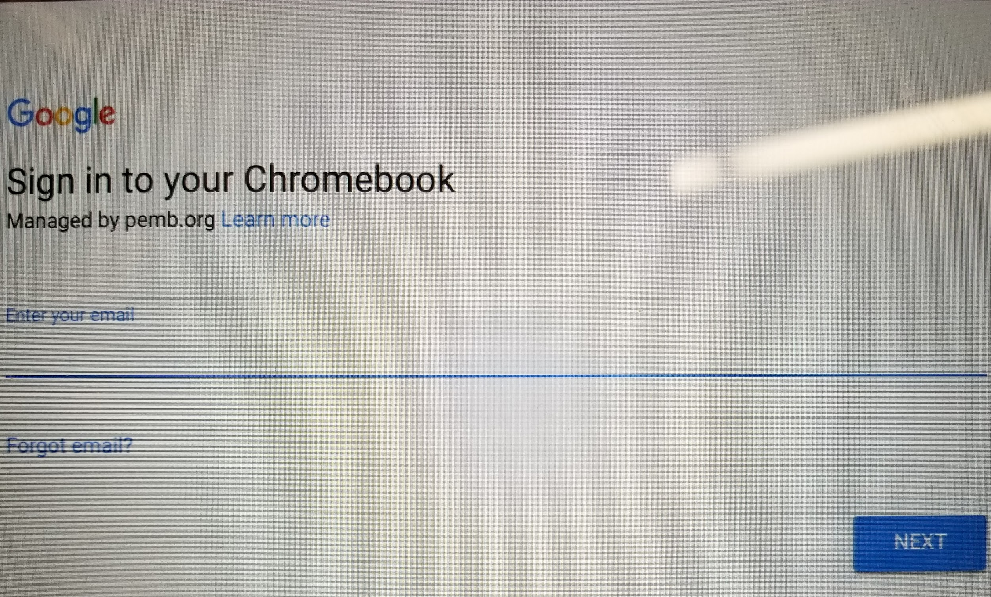

- Once you click on the icon, the window (image below) will appear.

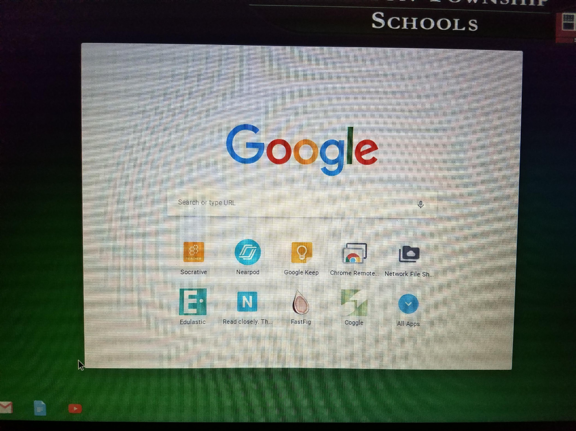

- Click on the icon “ALL APPS” & you will see all of the apps & extensions installed on your Chromebook.
- When you open up Chrome on your Chromebook there will be a folder of important links located on your bookmark bar (School Links). This folder will contain links pushed down from the tech department as needed (Outlook Web Access) etc.

Connecting Your Printer to Your Chromebook at Home

At home, you have the ability to connect your Chromebook to your printer. There are two ways to connect your Chromebook to your printer. The two methods of installing a printer to the Chromebook is Classic Printing & Google Cloud Printing. If you’re going to use Google Cloud Printing, your printer has Google Cloud compatible. If you don’t know if your printer is Google Cloud compatible, visit https://www.google.com/cloudprint/learn/ & click on the link Cloud-Ready Printers & you can see if your printer is Google Cloud compatible. Follow the steps listed below & if you have any issues connecting the printer to the Chromebook, feel free to watch the videos, which will walk you through on connecting your printer to the Chromebook.
- Click your account photo.
- Click Settings .
- At the bottom, click Advanced.
- In the "Printing" section, click Printers.
- Click Add Printer.
- Enter your printer information:
  - Name: Type any name.
  - Address: Type your printer’s IP address.
  - Protocol: For most printers, the supported connection protocol is IPP.
  - Queue: For most printers, the queue is IPP/Print.
- Click Add.
- In the box that appears, choose your printer manufacturer and model.
  - To find this info, look at the label on your printer.
  - If you don’t see your printer in the list, check your printer info for its "printer language" or "emulation." Then choose the "Generic" option that looks similar.
  - If you have your printer driver, click Browse to upload it. The file must be 250 kb or smaller.
- Click Add.

Setting Up Classic Printing on Chromebook

Setting Up Classic Printing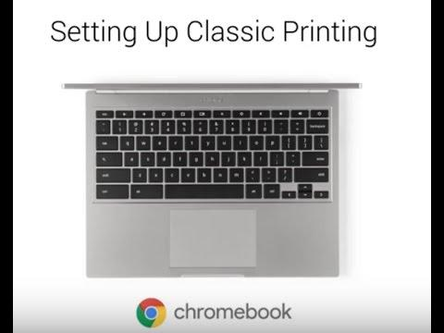

Setting Up Google Cloud Printing on Chromebook

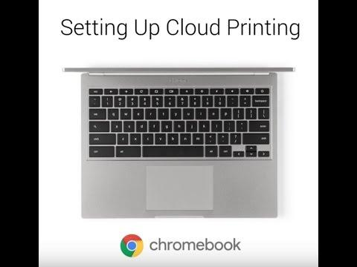

Managing Files on the Chromebook
When you used the computers in your respective school, you saved your files locally on the computer or your H drive. You will have the option of saving your files on the H drive by using the Network File Sharing app installed on the Chromebook. Faculty can access their H drive when they’re in school but they’re not able to access the H drive when they out of district. When using the Chromebook, you can save & manage files in two different ways. You can save your files in the Downloads folder & Google Drive. The Downloads folder is meant to be temporary storage area for saving files so we strongly suggest that you save your files on to your Google Drive because you’ll be able to access your files at school & out of district. The following steps & video tutorial will show you how to manage files on the Chromebook.

Find and open a file
- On your desktop, click the Launcher .
- Click Files .
- On the left, choose the place where your file is saved.
- Find your file and double-click it to open.
If you're opening a file on an external storage device, remove the device safely when you're done by clicking Eject .

Save a file
To save the page, image, or document you're viewing:
- Press Ctrl + S.
- At the bottom, type a name for your file.
- In the left column, choose where you'd like to save your file:
  - Downloads (a temporary folder on your Chromebook's hard drive)
  - Google Drive
  - An external storage device (if you have one connected to your Chromebook)
  - Another cloud file system
- Click Save.

Managing Files on the Chromebook Video Tutorial

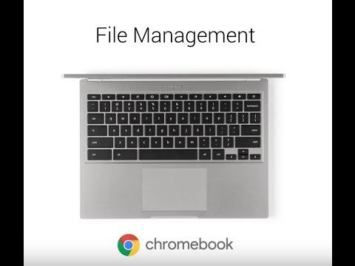

Chromebook Shortcuts Reference Sheet

Tabs and Windows
Ctrl+N | Open a new window
Ctrl+Shift+N | Open a new window in incognito mode
Ctrl+T | Open a new tab
Ctrl+O | Open a file in the browser
Ctrl+Shift+Q | Sign out of your Google Account on Chrome OS
Ctrl+W | Close the current tab
Ctrl+Shift+W | Close the current window
Ctrl+Shift+T | Reopen the last tab you've closed. Google Chrome remembers the last 10 tabs you've closed.
Ctrl+1 through Ctrl+8 | Go to the tab at the specified position in the window
Ctrl+9 | Go to the last tab in the window
Alt+1 through Alt+8 | Go to the window at the specified position
Alt+9 | Go to the last window open
Ctrl+Tab | Go to the next tab in the window
Ctrl+Shift+Tab | Go to the previous tab in the window
Alt+Tab | Go to the next window you have open
Alt+Shift+Tab | Go to the previous window you have open
Click and hold the Back or Forward arrow in the browser toolbar | See your browsing history for the tab
Backspace, or press Alt and the left arrow | Go to previous page in your browsing history.
Shift+Backspace, or press Alt and the right arrow | Go to the next page in your browsing history.
Press Ctrl and click a link | Open the link in a new tab in the background
Press Ctrl+Shift and click a link | Open the link in a new tab and switch to the newly opened tab
Press Shift and click a link | Open the link in a new window
Drag a link to a tab | Open the link in the tab
Drag a link to a blank area on the tab strip | Open the link in a new tab
Type a URL in the address bar, then press Alt+Enter | Open the URL in a new tab
Press Esc while dragging a tab | Return the tab to its original position
Ctrl+Shift+L | Locks your screen
Page Shortcuts
Press Alt and up arrow | Page up
Press Alt and down arrow | Page down
Space bar | Scroll down the web page
Press Ctrl+Alt and up arrow | Home
Press Ctrl+Alt and down arrow | End
Ctrl+P | Print your current page
Ctrl+S | Save your current page
Ctrl+R | Reload your current page
Ctrl+Shift+R | Reload your current page without using cached content
Ctrl and + | Zoom in on the page
Ctrl and - | Zoom out on the page
Ctrl+0 | Reset zoom level
Esc | Stop the loading of your current page
Press Alt and click a link | Open the link in a new tab in the background
Ctrl+D | Save your current webpage as a bookmark
Ctrl+Shift+D | Save all open pages in your current window as bookmarks in a new folder
Drag a link to bookmarks bar | Save the link as a bookmark
Ctrl+F | Open the find bar to search your current page
Ctrl+G or Enter | Go to the next match for your input in the find bar
Ctrl+Shift+G or Shift+Enter | Go to the previous match for your input in the find bar
Ctrl+K or Ctrl+E | Perform a search. Type a search term after the question mark in the address bar and press Enter.
Ctrl+Enter | Add www. and .com to your input in the address bar and open the resulting URL
Ctrl+ | Take a screenshot of your current page
Ctrl+ Shift+ | Take a partial screenshot
Ctrl+U | View page source
Ctrl+Shift+I | Toggle the display of the Developer Tools panel
Ctrl+Shift+J | Toggle the display of the DOM Inspector
Browser Settings
Ctrl+Shift+B | Toggle the display of the bookmarks bar. Bookmarks appear on the New Tab page if the bar is hidden.
Ctrl+M | Open the Files app
Ctrl+. | Display hidden files in the Files app
Ctrl+H | Open the History page
Ctrl+J | Open the Downloads page
Shift+Esc | Open the Task Manager
Ctrl+Alt+/ | Open the list of available keyboard shortcuts
Ctrl+? | Go to the Help Center
Ctrl+ | Configure monitor display
Shift+Alt+S | Place focus on the status area in the top-right corner of the screen. Use the actions listed for Shift+Alt+T to move the focus.
Shift+Alt+T | Place focus on the browser toolbar  - Press Tab or the right arrow to focus on the next item in the toolbar  - Press Shift+Tab or the left arrow to focus on the previous item in the toolbar  - Press Ctrl+Alt and the up arrow to focus on the first item in the toolbar  - Press Ctrl+Alt and the down arrow to focus on the last item in the toolbar  - Press Space or Enter to activate buttons, including page actions and browser actions  - Press Shift + to open the context menu for the button (if available).  - Press Esc to return focus to the page
Ctrl + or Ctrl + | Switches focus to the next keyboard-accessible pane. Panes include:  - Status bar containing the time, network icon, and battery icon in the upper-right corner of the screen  - Address bar  - Bookmarks bar (if visible)  - The main web content (including any infobars)  - Downloads bar (if visible)
Alt+Shift+B | Place focus on the bookmarks bar. Use the actions listed for Shift+Alt+T to move the focus.
Alt+E or Alt+F | Open the wrench menu on the browser toolbar
Ctrl+Alt+Z | Enable or disable accessibility features if you're not signed in with a Google
 | Account. If you're signed in, you can configure the accessibility feature on the Settings page.
Text Editing
Ctrl+A | Select everything on the page
Ctrl+L or Alt+D | Select the content in the address bar
Press Ctrl+Shift and right arrow | Select next word or letter
Press Ctrl+Shift and left arrow | Select previous word or letter
Press Ctrl and right arrow | Move to the end of the next word
Press Ctrl and left arrow | Move to the start of the previous word
Press Alt and up arrow | Page up
Press Alt and down arrow | Page down
Press Ctrl+Alt and up arrow | Home
Press Ctrl+Alt and down arrow | End
Ctrl+C | Copy selected content to the clipboard
Ctrl+V | Paste content from the clipboard
Ctrl+Shift+V | Paste content from the clipboard as plain text
Ctrl+X | Cut
Ctrl+Backspace | Delete the previous word
Alt+Backspace | Delete the next letter (forward delete)
Ctrl+Z | Undo your last action

Issues You May Experience with the Chromebook

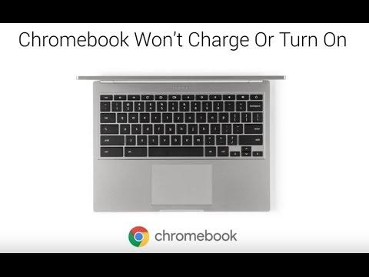
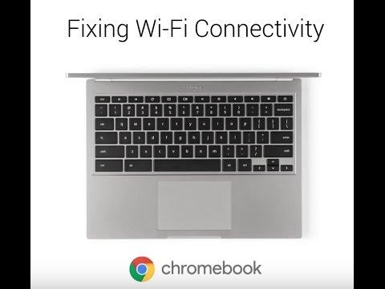

Care of the Chromebook

Faculty are responsible for general care of the Chromebook. If your experiencing problems with your Chromebook, bring it to the PTHS Tech Department in room 201. Faculty should not attempt to repair the Chromebook. General care of the Chromebook is as follows:
- Do not place food and/or liquids near the Chromebook
- Do not stack any objects on top of the Chromebook
- Never attempt to repair or reconfigure the Chromebook or any
- peripherals
- Do not write, draw, stick, or adhere anything to the Chromebook
- Do not decorate the Chromebook using markers, personalized stickers,
etc.
- Keep the Chromebook away from electromagnetic fields that can
erase or corrupt your data, such as stereo speakers
- Do not expose the Chromebook to direct sunlight, extreme
temperatures, or ultraviolet light for extended periods of time
- Do not leave the Chromebook in any vehicle
- Do not obstruct the Chromebook’s vents, and do not place the
Chromebook on surfaces such as paper or carpet while it is turned on
or charging
- When walking from class to class, the Chromebook must be properly
closed and stored in the provided case.
- Do not charge the Chromebook while it is in the provided case
- Log out of your Google account after accessing it from another device.
- You should not loan out your Chromebook or peripheral items to
anyone for any reason.
- Don’t hack or reset your Chromebook.

Specifics on the Chromebook

Screen Care

- Extreme care must be taken to protect the screen from accidental damage.
- Do not place anything on top of the Chromebook or lean on it when it
is closed
- Do not place anything in the case that may press against the cover of
the Chromebook including paperwork
- Do not poke the screen with anything. Your finger is the only means
that should be used to interact with the Chromebook
- Do not place anything on the keyboard before closing the lid (i.e. pens,
pencils, paper clips, stapled papers, etc.)
- Do not use any cleaning solution to clean the screen. Common
cleaners such as Windex and 409 will damage the LCD screen.

Camera

The Chromebook comes with a built-in camera. The Chromebook camera should only be used for educational purposes as instructed by your teacher. The Chromebook camera should not be used to take photos, post them online, or manipulate them for non-educational purposes or to embarrass others.

Lock & Unlock your Screen
If you step away from your Chromebook, we recommend locking your screen for extra security. Press & Hold the Search Key which looks like a magnifier glass. While holding the Search Key, Press the letter L & your Chromebook will be locked. In order to log back into the Chromebook, just enter your PTSD Google password & you’ll be able to resume your work on the Chromebook.

FAQ’S

What happens if a device is broken or lost?

If your Chromebook is lost or broken, you need to report it to PTHS Tech Department. If you find your Chromebook, notify the Technology Dept. If your device is stolen, it must be reported to the police ASAP.

What if the Chromebook needs service?

Bring your Chromebook to Tech Services in room 201 so the Chromebook can be repaired. You will be given another Chromebook to replace the broken device.

What if the device is stolen?

If your device is stolen, you must file a police report. you must report the incident to your Supervisor, & Tech Dept. If you find your Chromebook, notify the Technology Dept., Supervisor, & Security ASAP.

Is the device equipped with a camera?

The Chromebooks are equipped with a camera and may be used as an educational tool only. The district cannot remotely activate the camera and the camera will not be used to violate your privacy.

Technology Integration With Chromebooks

The link below will show you how to integrate the Chromebooks in the classroom & additional helpful links to help use the Chromebook

Technology Integration with Chromebooks

Additional Chromebook Help

