How To Use Kami's with Google Classroom Integration
Kami has a free version, and a paid version for educators. This article shows how to use Kami with Google Classroom on the paid version. The paid version includes deeper integration to Google Classroom, such as assignment creation for teachers and the built-in Turn In button for students.
To be able to use the Kami Google Classroom integration you must have:
- Google Classroom set up.
- The Kami Chrome extension and app installed into your own and your students' Chrome browser.
With the new Kami integration, there is now the ability to directly create a Kami assignment. To do this follow the steps below:

Step #1: Creating The Kami Assignment (Teachers)
You need to go to the Classwork tab in your Classroom course, click the Create button in Classroom, and select Kami Assignment from the list of options.
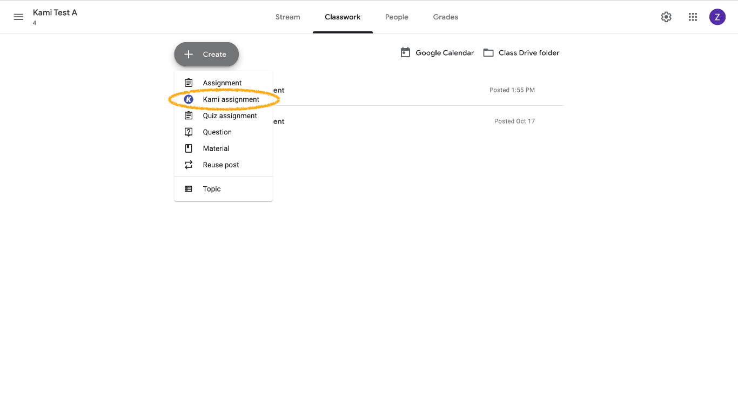
You can also create a Kami Assignment from the home view by clicking Create Classroom Assignment.
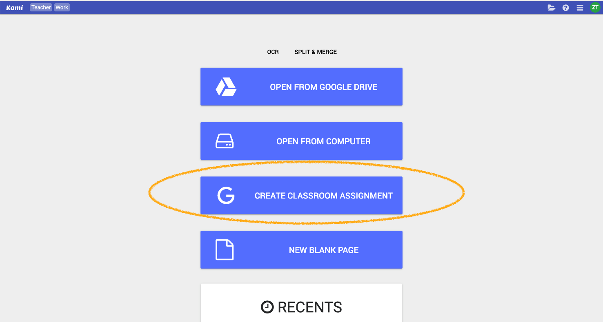

Step #2: Select Material To Assign (Teachers)
Creating a Kami Assignment is similar to creating a normal Google Classroom assignment. You can create a title, add instructions, and attach a file using Google Drive or a local file. This will create an assignment within Classroom as well. We recommend selecting Make a copy for each s87tudent (selecting Students share one copy means they will all be annotating the original).
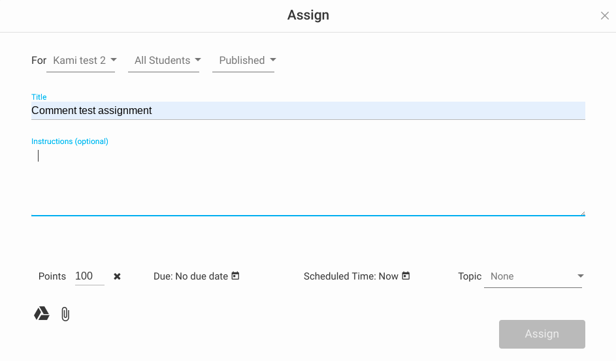

Step #1: Opening Your Kami Assignment
(Students)
The students can open the file directly from Classroom into Kami. If the students have the Google Chrome extension installed, they can open the file into Kami directly from the preview window.
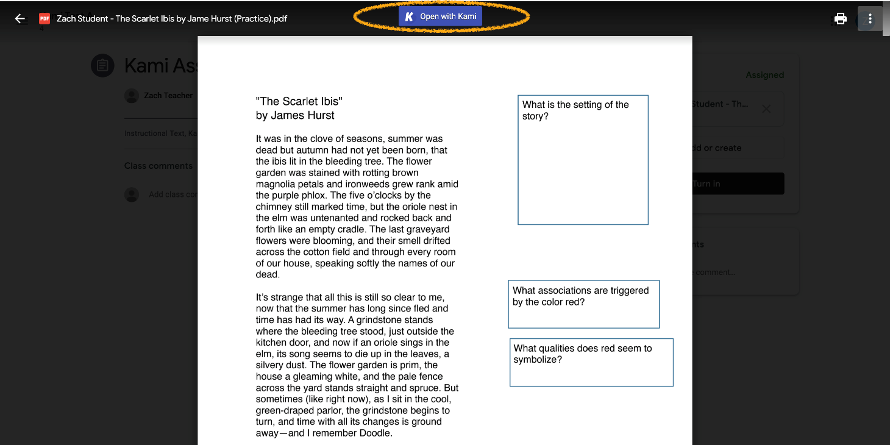

Step #2: Opening And Completing Your Kami Assignment (Students)
After opening the file, students are then able to complete their work using the Kami tools. See this collection for ideas on using the Kami tools for different subjects.

Step #3: Turning In Your Work For Grading (Students)
When the student is finished with their work they can then turn in the assignment directly into Classroom from Kami.
To turn in the file, the student can click the Turn In button in the top-right corner. This will force save the student's annotations and turn in the assignment into Google Classroom.
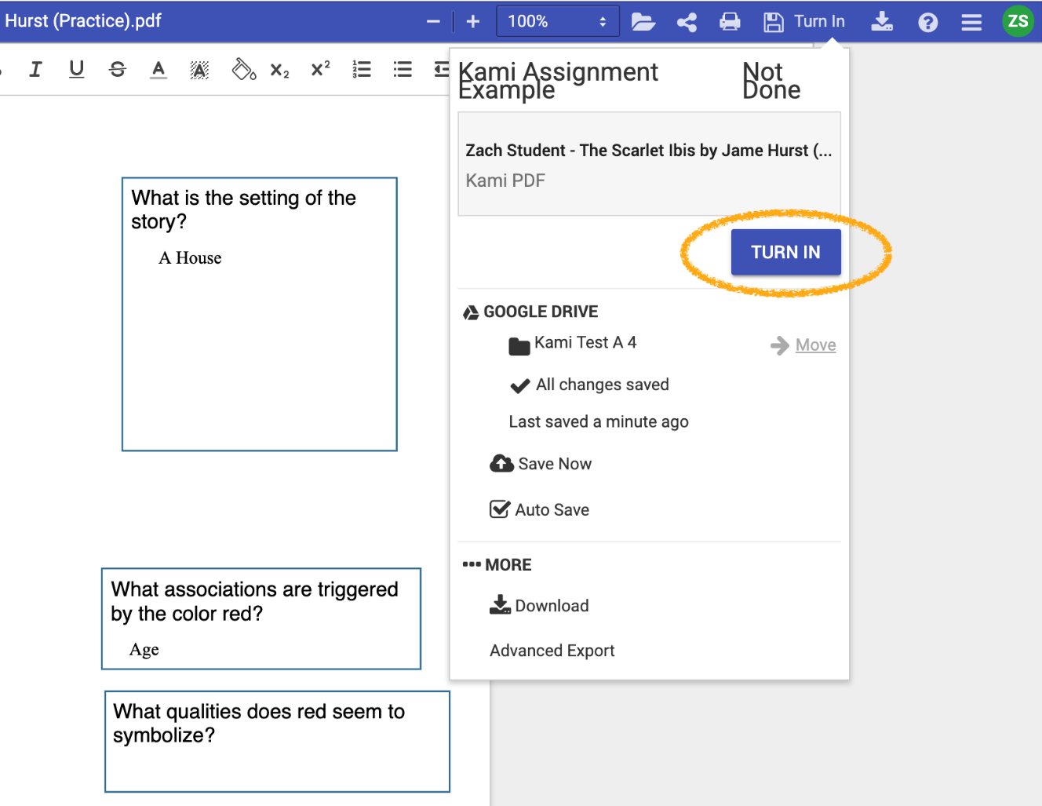

The main advantage of this feature is that it cuts down the steps needed to turn an assignment in. For example, students no longer need to manually save their work.

Step #4: Grading with Kami (Teachers)
Kami allows you to view the student's work within Kami. You may view it before or after their document is turned in. You can view their work like you would normally go to view the student's work in Google Classroom. Follow the instructions here to enable this feature.
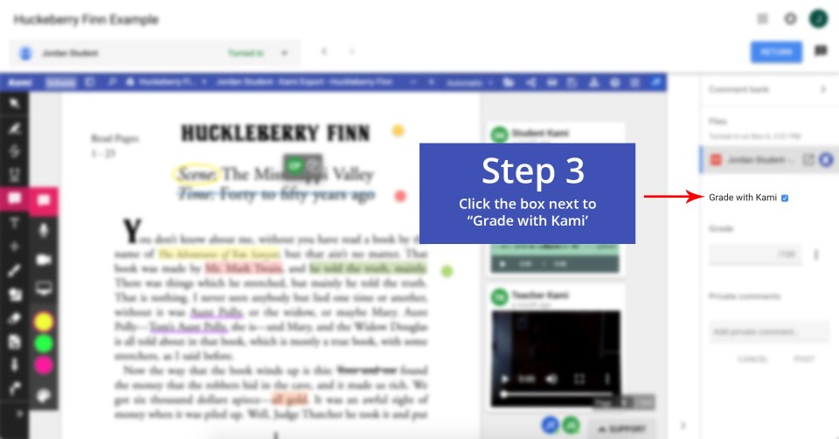

Also, the videos below will show you how to use KAMI in your respective classroom.
