HOWTO:

Install Genesys Cloud Desktop Application
  - (phone system. Avtex is the support company)

- Download the application either from
  - Our network - \\vs-file01\Software\Genesys
  - The web (if off VPN) Genesys Cloud for Windows (mypurecloud.com)
- Double click the .exe file either from the file server or wherever you saved it on your machine
- When asked for region, select “Americas (US West)
  - 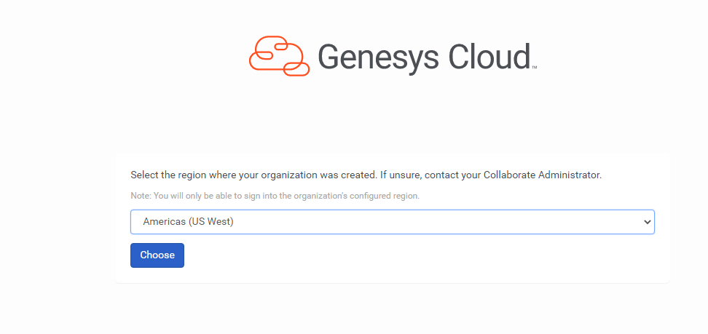
  - (you may need to select it twice) Click Choose.
- Once the software installs, you will be asked to enter your Username and password.
- That’s it! You can adjust settings and use Diagnostics is having problems. It is very similar to the browser app.

