Comcast Equipment List:

Standard Equipment –
- (1) Primary Access Modem: Broadband Connectivity
- (2) Meraki MX67C-HW-NA: Firewalls in HA
- (1) Meraki MS120-24-HW: Switch
- (1) Meraki MS120-24P-HW: POE Switch
- (2) Meraki MR20-HW: Indoor APs
- (1) WB-250-IPW: Wattbox Power Management
- (2) Panorama Antenna: Ultra-Wideband MiMo Antenna

Optional Equipment –
- (1) Cradlepoint AER1650 4G Modem: Temporary primary broadband (if needed)
- (1-2) Meraki MR70: Cloud Managed Outdoor AP
- (1) Meraki MS120-24-HW: Additional 24-Port Non-PoE Switch
- (2) Meraki MS120-48-HW: Additional 48-port Non-PoE Switch
- (1) 5u or 9u Cabinet: Equipment Cabinet for Managed Devices.

Network Diagram

Standard Deployment
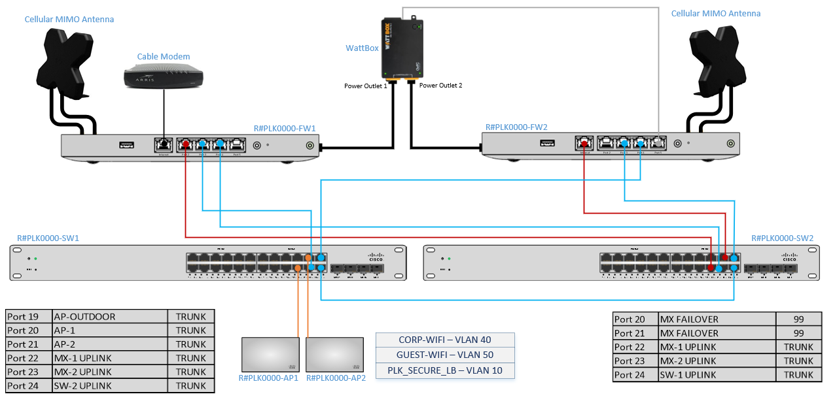

Standard Network Diagram with 48 Port Switch
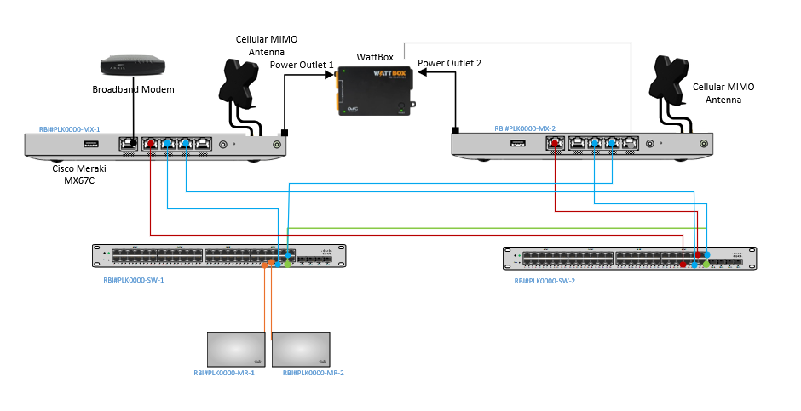

Standard + Optional 24-Port Switch
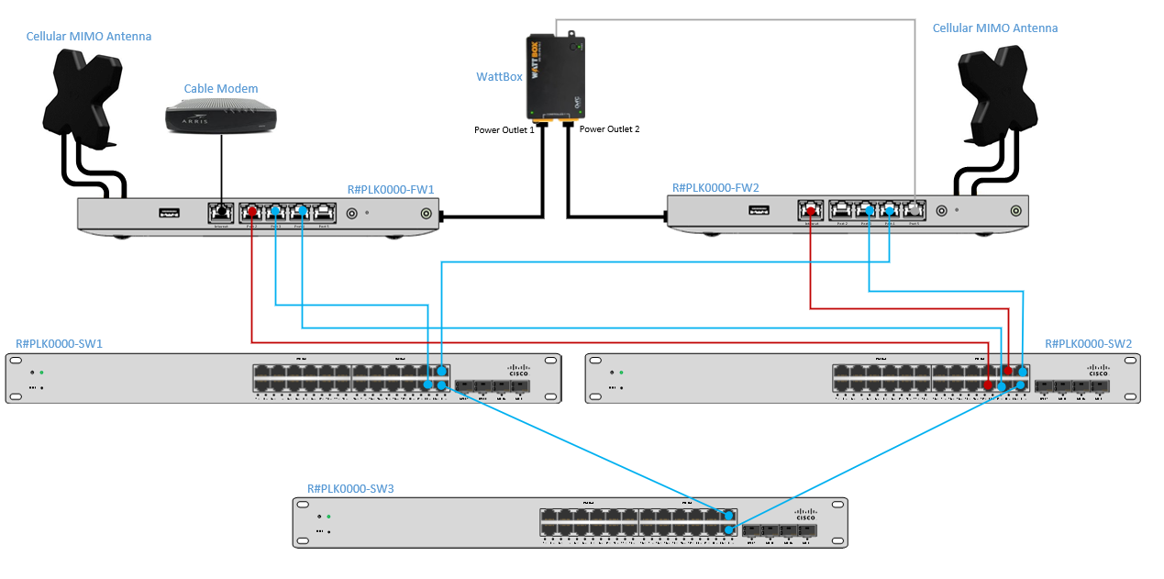

Network Layout
VLAN | VLAN NAME | SUBNET | DHCP? | PURPOSE
10 | POS-NCR | 192.168.16.0/24 | Yes | Secure CDE Environment for PCI activities.
10 | POS-XENIAL | 192.168.1.0/24 | No | Secure CDE Environment for PCI activities.
20 | DMB | 192.168.170.0/24 | Yes | Digital Menu Boards, DTD, etc
30 | FRANCHISE-DMZ | 192.168.3.0/24 | Yes | Store devices requiring Internet access
40 | CORP-WIFI | 192.168.4.0/24 | Yes | Store wifi for employees and managers
50 | GUEST-WIFI | 192.168.5.0/24 | Yes | Wifi for customers
70 | KIOSK | 192.168.7.0/24 | Yes | Lobby Ordering Kiosks
90 | DVR | 192.168.9.0/24 | Yes | Dedicated for DVR/Camera systems
99 | FAILOVER | 192.168.99.0/24 | Yes | Dashboard connectivity for FW2 utilizing the broadband connection of FW1.
254 | MANAGEMENT | 192.168.254.0/24 | Yes | Comcast device management for Meraki gear and Wattbox.
Managed Device Naming Conventions
Device: | Correct Convention:
Meraki MX67C (Firewall) | R#PLK00000-FW1  R#PLK00000-FW2
Meraki MS120-24P (POE Switch) | R#PLK00000-SW1
Meraki MS120-24 (Switch) | R#PLK00000-SW2
Meraki MR20 AP (Indoor Access Point) | R#PLK00000-AP1  R#PLK00000-AP2
Meraki MR70 AP (Outdoor Access Point) | R#PLK00000-AP3
WattBox | R#PLK00000-WB1

WIFI/SSIDs List
SSID | VLAN | Authentication | Pre-Shared Key | Shaping
Popeyes Internal | 40 | WPA2 w/ PSK | RedBlue2020! | N/A
Popeyes Guest | 50 | Splash Page (30m timeout) | N/A | 20Mbps per SSID
PLK_SECURE_LB | 10 | Hidden with WPA2 PSK | k2usMX6jup$ne293 | Priority
Important: PLK_SECURE_LB WIFI network is hidden. DHCP is not enabled, and static IP addressing is required for any device to connect.

SwitchPort Mapping
*DMB switches should be plugged into port 11 on each switch.
R#PLK00000-SW1 |  |  |  | R#PLK00000-SW2
Port | Description | VLAN |  | Port | Description | VLAN
Port 1 | POS-BACKOFFICE (NCR) or  POS-TERM0 (Xenial) | 10 |  | Port 1 | POS | 10
Port 2 | POS | 10 |  | Port 2 | POS | 10
Port 3 | POS | 10 |  | Port 3 | POS | 10
Port 4 | POS | 10 |  | Port 4 | POS | 10
Port 5 | POS | 10 |  | Port 5 | POS | 10
Port 6 | POS | 10 |  | Port 6 | POS | 10
Port 7 | POS | 10 |  | Port 7 | POS | 10
Port 8 | POS | 10 |  | Port 8 | POS | 10
Port 9 | POS | 10 |  | Port 9 | POS | 10
Port 10 | POS | 10 |  | Port 10 | POS | 10
Port 11 | IDMB-SWITCH | 20 |  | Port 11 | ODMB-SWITCH | 20
Port 12 | DMB | 20 |  | Port 12 | DMB | 20
Port 13 | DMB | 20 |  | Port 13 | DMB | 20
Port 14 | DMB | 20 |  | Port 14 | DMB | 20
Port 15 | DMB | 20 |  | Port 15 | DMB | 20
Port 16 | DMB | 20 |  | Port 16 | DMB | 20
Port 17 | DMZ-MGR-PC | 30 |  | Port 17 | FRANCHISE-DMZ | 30
Port 18 | FRANCHISE-DMZ | 30 |  | Port 18 | FRANCHISE-DMZ | 30
Port 19 | AP-OUTDOOR | TRUNK |  | Port 19 | DVR | 90
Port 20 | AP-1 | TRUNK |  | Port 20 | MX FAILOVER | 99
Port 21 | AP-2 | TRUNK |  | Port 21 | MX FAILOVER | 99
Port 22 | MX-1 UPLINK | TRUNK |  | Port 22 | MX-1 UPLINK | TRUNK
Port 23 | MX-2 UPLINK | TRUNK |  | Port 23 | MX-2 UPLINK | TRUNK
Port 24 | SW-2 UPLINK | TRUNK |  | Port 24 | SW-2 UPLINK | TRUNK

48 Port Switch Layout
SW-1 |  |  |  | SW-2
Port | Description | VLAN |  | Port | Description | VLAN
Port 1 | POS | 10 |  | Port 1 | POS | 10
Port 2 | POS | 10 |  | Port 2 | POS | 10
Port 3 | POS | 10 |  | Port 3 | POS | 10
Port 4 | POS | 10 |  | Port 4 | POS | 10
Port 5 | POS | 10 |  | Port 5 | POS | 10
Port 6 | POS | 10 |  | Port 6 | POS | 10
Port 7 | POS | 10 |  | Port 7 | POS | 10
Port 8 | POS | 10 |  | Port 8 | POS | 10
Port 9 | POS | 10 |  | Port 9 | POS | 10
Port 10 | POS | 10 |  | Port 10 | POS | 10
Port 11 | POS | 10 |  | Port 11 | POS | 10
Port 12 | POS | 10 |  | Port 12 | POS | 10
Port 13 | POS | 10 |  | Port 13 | POS | 10
Port 14 | POS | 10 |  | Port 14 | POS | 10
Port 15 | POS | 10 |  | Port 15 | POS | 10
Port 16 | POS | 10 |  | Port 16 | POS | 10
Port 17 | POS | 10 |  | Port 17 | POS | 10
Port 18 | POS | 10 |  | Port 18 | POS | 10
Port 19 | POS | 10 |  | Port 19 | POS | 10
Port 20 | POS | 10 |  | Port 20 | POS | 10
Port 21 | POS | 10 |  | Port 21 | DMB | 20
Port 22 | POS | 10 |  | Port 22 | DMB | 20
Port 23 | POS | 10 |  | Port 23 | DMB | 20
Port 24 | IDMB-SWITCH | 20 |  | Port 24 | ODMB-SWITCH | 20
Port 26 | DMB | 20 |  | Port 26 | DMB | 20
Port 27 | DMB | 20 |  | Port 27 | DMB | 20
Port 28 | DMB | 20 |  | Port 28 | DMB | 20
Port 29 | DMB | 20 |  | Port 29 | DMB | 20
Port 30 | DMB | 20 |  | Port 30 | DMB | 20
Port 31 | DMB | 20 |  | Port 31 | DMB | 20
Port 32 | DMB | 20 |  | Port 32 | DMB | 20
Port 33 | DMB | 20 |  | Port 33 | DMB | 20
Port 34 | DMZ-MGR-PC | 30 |  | Port 34 | DMZ-MGR-PC | 30
Port 35 | DMZ-MGR-PC | 30 |  | Port 35 | DMZ-MGR-PC | 30
Port 36 | DMZ-MGR-PC | 30 |  | Port 36 | DMZ-MGR-PC | 30
Port 37 | DMZ-MGR-PC | 30 |  | Port 37 | DMZ-MGR-PC | 30
Port 38 | DMZ-MGR-PC | 30 |  | Port 38 | DMZ-MGR-PC | 30
Port 39 | DMZ-MGR-PC | 30 |  | Port 39 | DMZ-MGR-PC | 30
Port 40 | DVR | 90 |  | Port 40 | DVR | 90
Port 41 | MXFAILOVER | 99 |  | Port 41 | DMZ-MGR-PC | 30
Port 42 | MXFAILOVER | 99 |  | Port 42 | DMZ-MGR-PC | 30
Port 43 | AP-OUTDOOR | TRUNK |  | Port 43 | DMZ-MGR-PC | 30
Port 44 | AP-1 | TRUNK |  | Port 44 | MX FAILOVER | 99
Port 45 | AP-2 | TRUNK |  | Port 45 | MX FAILOVER | 99
Port 46 | MX-1 UPLINK | TRUNK |  | Port 46 | MX-1 UPLINK | TRUNK
Port 47 | MX-2 UPLINK | TRUNK |  | Port 47 | MX-2 UPLINK | TRUNK
Port 48 | SW-2 UPLINK | TRUNK |  | Port 48 | SW-2 UPLINK | TRUNK

Switch Port Mapping For optional 3rd Switch
Important: If a site has Kiosk, they will be using the switch profile on the right labeled Kiosk
Optional 24 Port Switch Kiosk 24 Port Switch
R#PLK00000-SW3 |  |  |  | R#PLK00000-SW3
Port | Description | VLAN |  | Port | Description | VLAN
Port 1 | POS | 10 |  | Port 1 | POS | 10
Port 2 | POS | 10 |  | Port 2 | POS | 10
Port 3 | POS | 10 |  | Port 3 | POS | 10
Port 4 | POS | 10 |  | Port 4 | POS | 10
Port 5 | POS | 10 |  | Port 5 | POS | 10
Port 6 | POS | 10 |  | Port 6 | POS | 10
Port 7 | POS | 10 |  | Port 7 | POS | 10
Port 8 | POS | 10 |  | Port 8 | POS | 10
Port 9 | POS | 10 |  | Port 9 | ORB-Kiosk | 70
Port 10 | POS | 10 |  | Port 10 | Kiosk | 70
Port 11 | POS | 10 |  | Port 11 | Kiosk | 70
Port 12 | POS | 10 |  | Port 12 | Kiosk | 70
Port 13 | DMB | 20 |  | Port 13 | Kiosk | 70
Port 14 | DMB | 20 |  | Port 14 | Kiosk | 70
Port 15 | DMB | 20 |  | Port 15 | Kiosk | 70
Port 16 | DMB | 20 |  | Port 16 | Kiosk | 70
Port 17 | DMB | 20 |  | Port 17 | Kiosk | 70
Port 18 | DMB | 20 |  | Port 18 | DMB | 20
Port 19 | DMB | 20 |  | Port 19 | DMB | 20
Port 20 | FRANCHISE-DMZ | 30 |  | Port 20 | FRANCHISE-DMZ | 30
Port 21 | FRANCHISE-DMZ | 30 |  | Port 21 | FRANCHISE-DMZ | 30
Port 22 | FRANCHISE-DMZ | 30 |  | Port 22 | FRANCHISE-DMZ | 30
Port 23 | SW1-Port 24 UPLINK | TRUNK |  | Port 23 | SW1-Port 24 UPLINK | TRUNK
Port 24 | SW2-Port 24 UPLINK | TRUNK |  | Port 24 | SW2-Port 24 UPLINK | TRUNK

Device Connectivity
DEVICE | VENDOR | VLAN | SW1 | SW2
POS Back-Office | NCR, rPOS | POS: VL10 | Port 1 | N/A
POS Back-Office Printer | NCR, rPOS | POS: VL10 | Ports 1-10 | Ports 1-10
POS Terminal 0 | Xenial | POS: VL10 | Ports 1-10 | Ports 1-10
POS Terminals | NCR, Xenial | POS: VL10 | Ports 1-10 | Ports 1-10
POS Pinpads | Verifone | POS: VL10 | Ports 1-10 | Ports 1-10
POS/Expo Printers | Xenial, (NCR Printers have serial connections) | POS: VL10 | Ports 1-10 | Ports 1-10
Order Ready Screen | Xenial, Stratacache | POS: VL10 | Ports 1-10 | Ports 1-10
KDS/Expo Screens | Xenial | POS: VL10 | Ports 1-10 | Ports 1-10
Drive Thru Director (DTD) | Xenial | DMB: VL20 | Ports 11-16 | Ports 11-16
HME Drive Thru Timer | HME | DMB: VL20 | Ports 11-16 | Ports 11-16
IDMB Players | Xenial, Stratacache | DMB: VL20 | Ports 11-16 | Ports 11-16
IDMB Screens | LG, Samsung | DMB: VL20 | Ports 11-16 | Ports 11-16
ODMB Players | Xenial, Stratacache | DMB: VL20 | Ports 11-16 | Ports 11-16
ODMB Screens | LG, Samsung | DMB: VL20 | Ports 11-16 | Ports 11-16
Order Confirmation Unit (OCU) | Xenial, Stratacache | DMB: VL20 | Ports 11-16 | Ports 11-16
Chicken Chatta | SageNet | FRANCHISE-DMZ: VL30 | Ports 17-18 | Ports 17-18
Managers PC | Various | FRANCHISE-DMZ: VL30 | Ports 17-18 | Ports 17-18
Smart Safe | Various | FRANCHISE-DMZ: VL30 | Ports 17-18 | Ports 17-18
Music/Media Players | Various | FRANCHISE-DMZ: VL30 | Ports 17-18 | Ports 17-18
Security Systems | Various | FRANCHISE-DMZ: VL30 | Ports 17-18 | Ports 17-18
Phone - VOIP/ATA | Various | FRANCHISE-DMZ: VL30 | Ports 17-18 | Ports 17-18
DVR | Various | DVR: VL90 | N/A | Port 19

DVR Considerations
- DVR will be moved to separate network and will need to be reconfigured with the below IP address information for functionality.
  - IP Address: 192.168.9.10
  - Subnet Mask: 255.255.255.0
  - Default-Gateway: 192.168.9.1
  - Primary DNS: 8.8.8.8
  - Secondary DNS: 8.8.4.4

