Adding Printers to a Mac.
Open System Preferences
Select Printers
Select the + to add printers
Click on the Globe to add the printer by IP address.
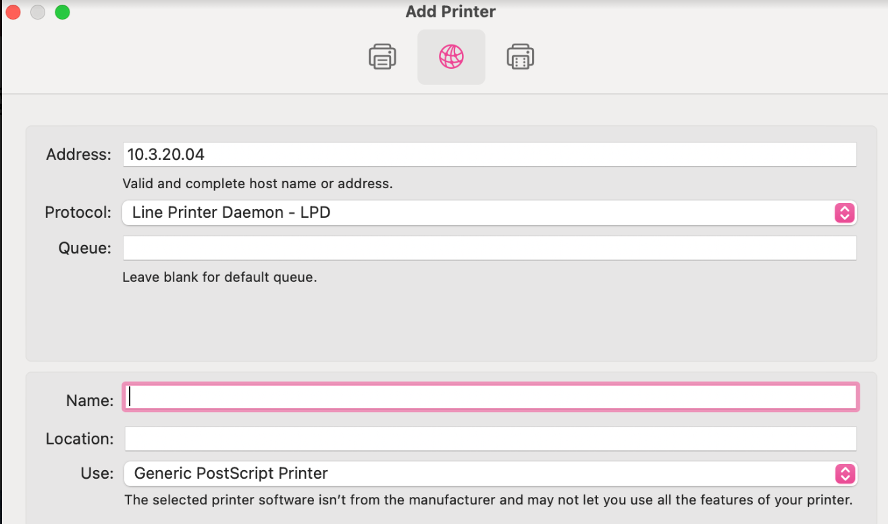
(Each printer is labeled with the name and IP address of the printer.)
Type in the IP address, make sure Protocol is LPD
Under Name, you can type in the name of the printer
If it asks for a password and yours does not work:
Username printer
Password printer

