-Sparta Township Public Schools VPN-

These are step-by-step instructions for connecting to the VPN from home. This is required when using CSI Budget and Personnel software. Only connect to the VPN when using CSI. When you are finished, please disconnect and continue to use Google Chrome to access your email, docs, sheets, and drive. These instructions assume you have connected to your home wifi access point. If you do not connect to the internet via wifi from your home, these instructions will be of little value.

Step 1: Click the arrow in the system tray to reveal additional icons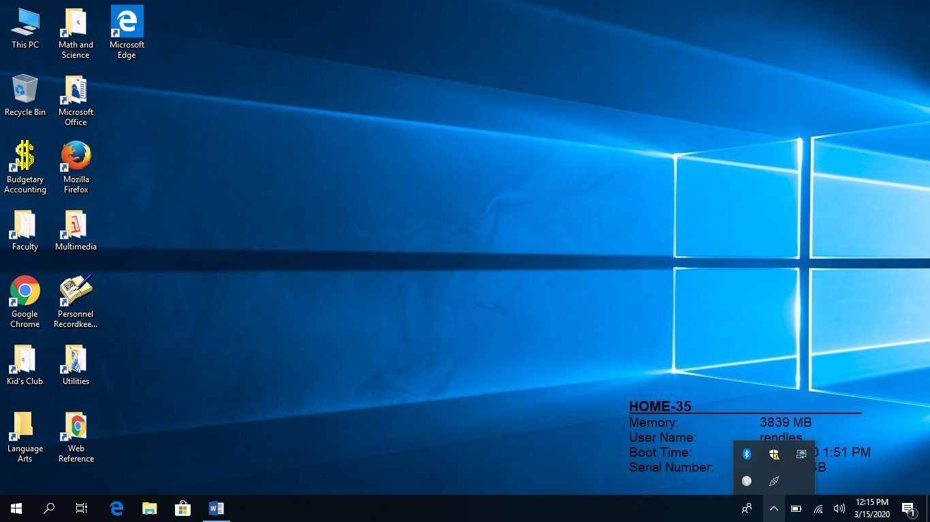
Step 2: Click on the icon that most resembles a globe. This is the GlobalProtect VPN client.
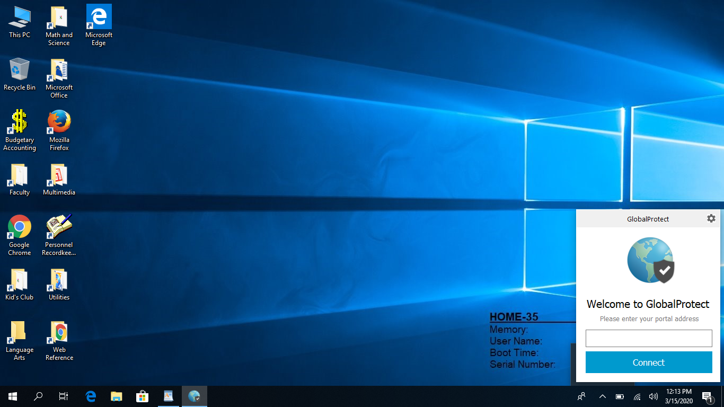
Step 3: You will be asked to enter the Portal Address.
The portal address is: 204.186.251.218
You will only need to enter this information once. It will save it for the future.
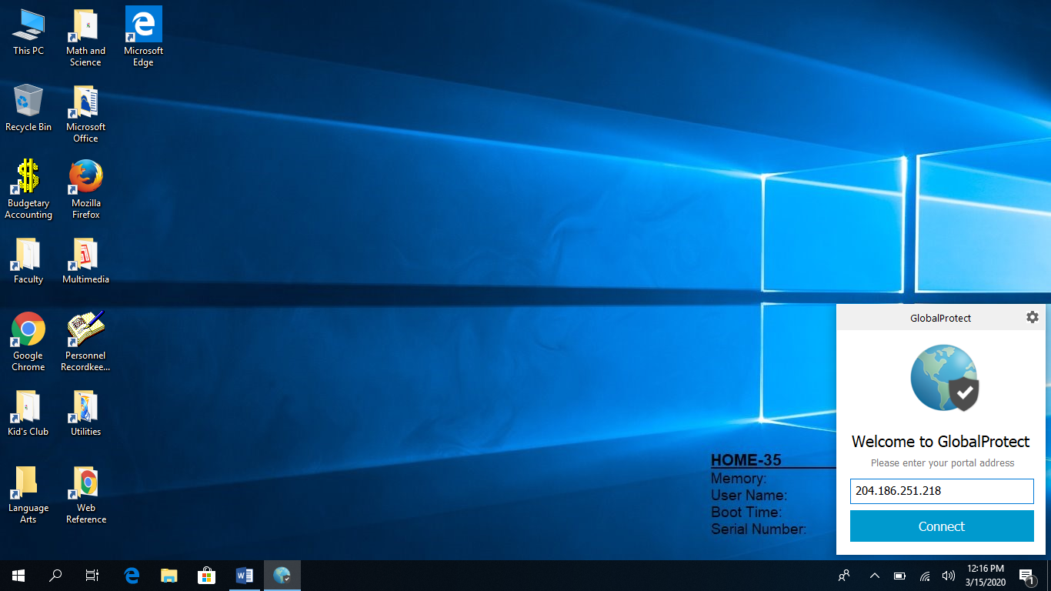
Step 4: Click “Connect.” If a pop up box pertaining to a certificate appears click “continue.”

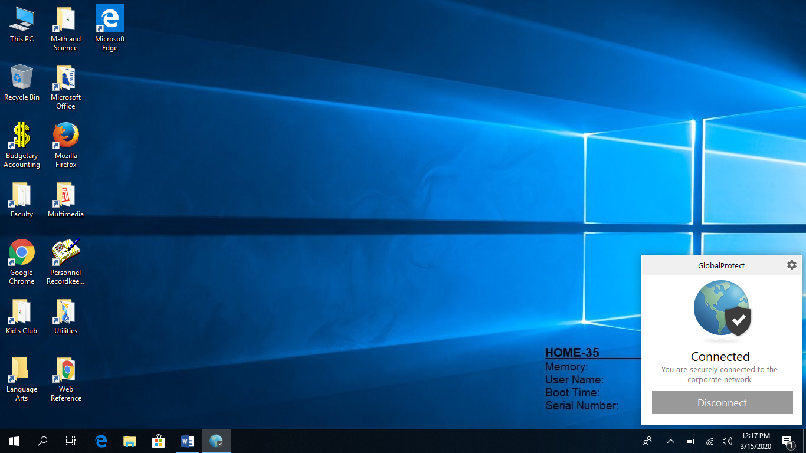
If you connect successfully it will tell you that you are connected. At this point, launching CSI Budget or Personnel will work as if you are sitting at your computer at work. When you are finished using either application, close them and disconnect from the VPN by clicking on the globe in the system tray and choosing “Disconnect.”

Remember, most of the work you will be doing will be done through Google Chrome and will not require the use of the VPN. Only CSI requires the VPN connection.

If you have any issue with connecting from home please submit a help desk request at the following URL: https://stps.happyfox.com/staff/login/?return_to=%2Fstaff%2Fdashboard%2F

