Setting up the Canon Copiers to use Secured Print in Windows 10

Step 1: Right click on the Windows Start Menu in the bottom left corner

Step 2: Select Control Panel

Step 3: Select View devices and printers

Step 4: Right Click on the Canon Copier you wish to set up with Secured Print, and select “Printing Preferences”
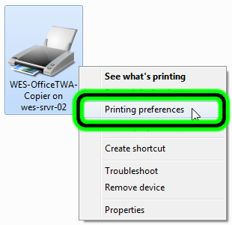
Step 5: Change the “Output Method” from “Print” to “Secured Print,” and select OK when box pops up.
Step 6: If presented with a secure Print Pin dialogue box, create a Pin Number and Press “Apply” then “OK”
Step 7: Retrieve your job by selecting the “Main Menu” button on the Copier you used and then select the “Secure Print “ button on the screen. Select your print job, select “Secure Print” and enter your code.

