Updating Chrome OS on Chromebook

Login to Chromebook, and then open Google Chrome.
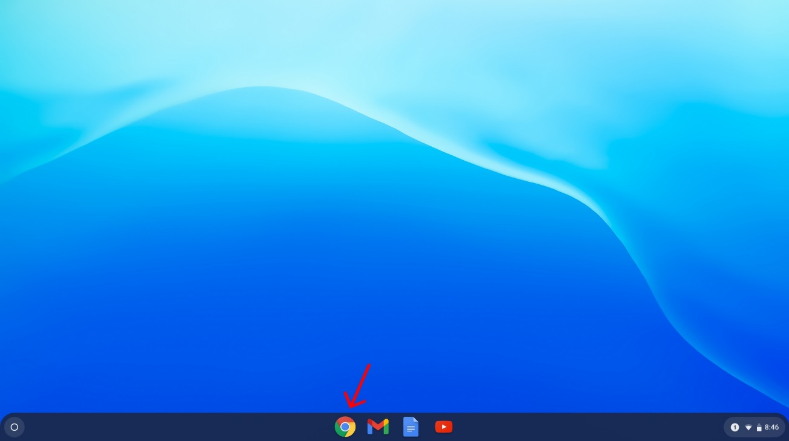

Go to Chrome settings by clicking the 3 dots in the upper right-hand corner.
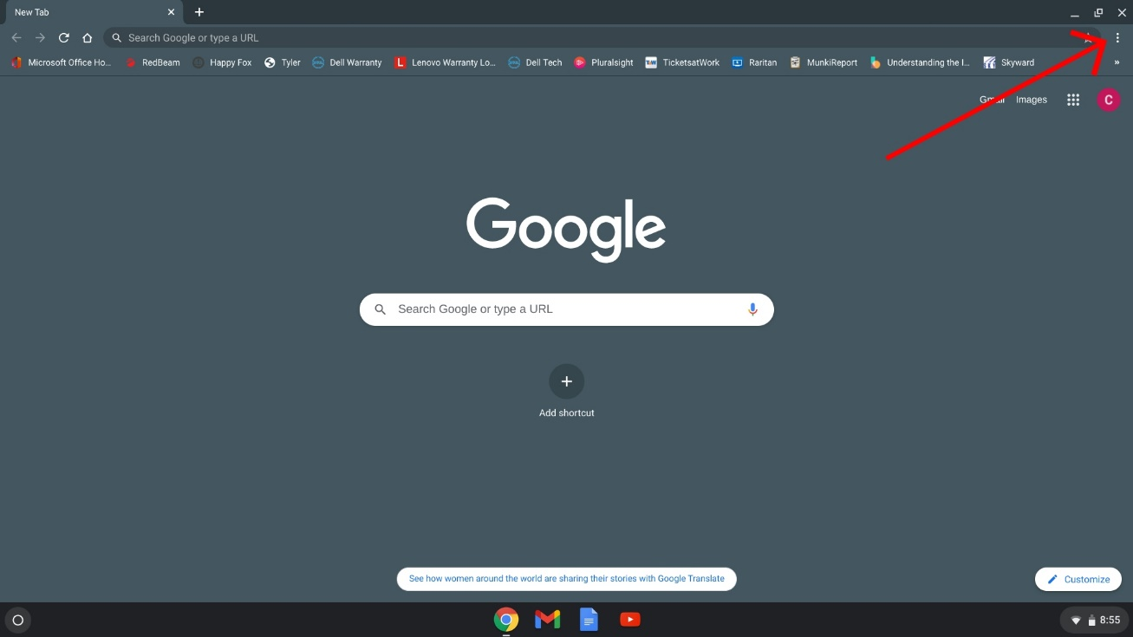
Select the Settings option.
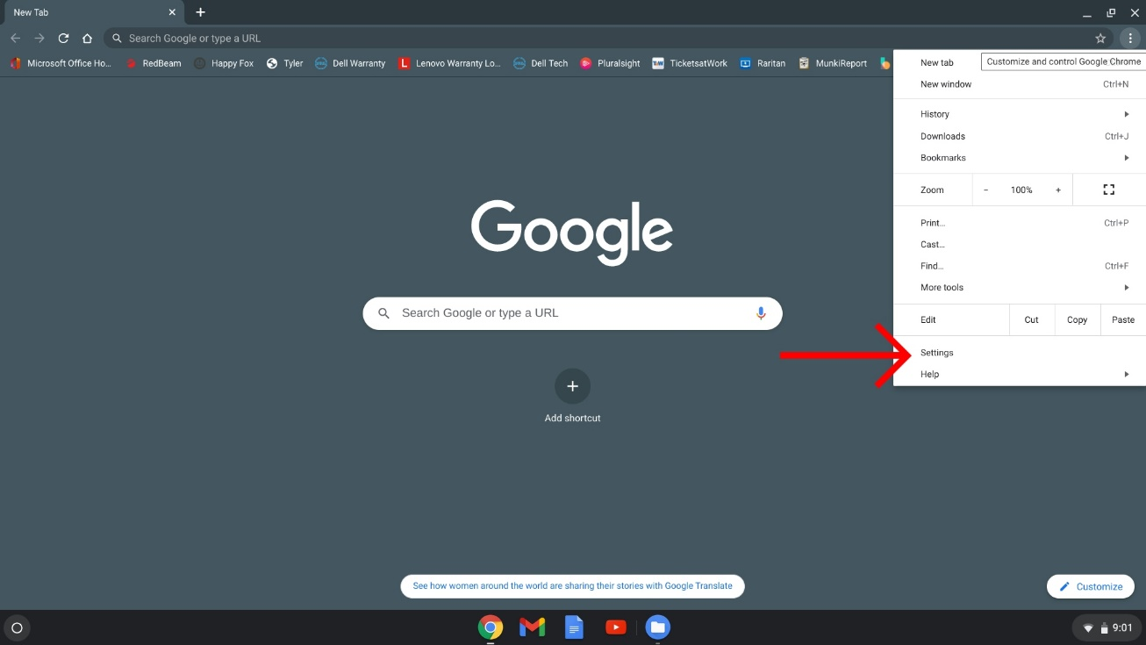

Select About Chrome on the left.
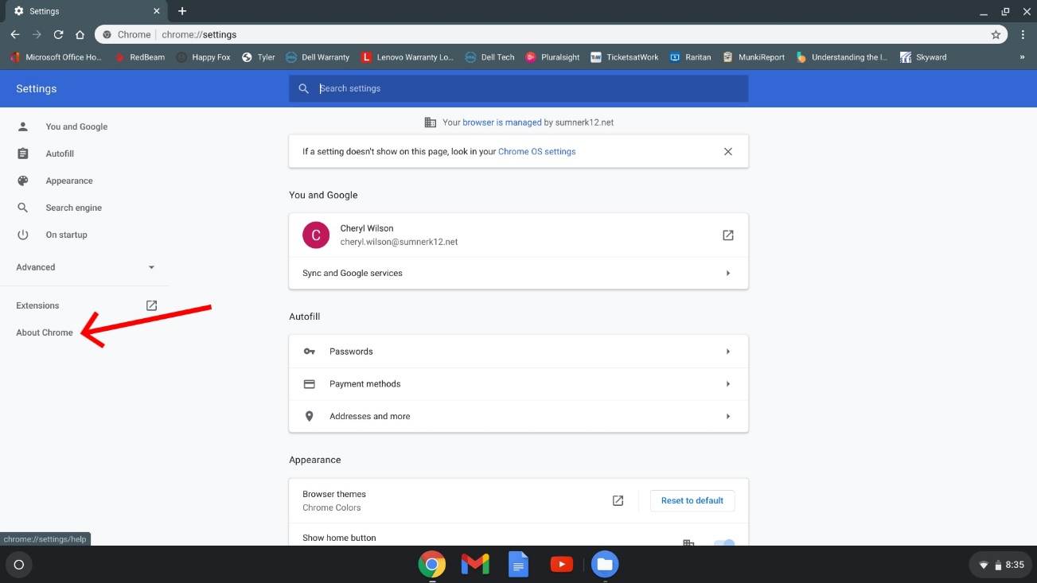

Click on the Chrome OS Settings link.
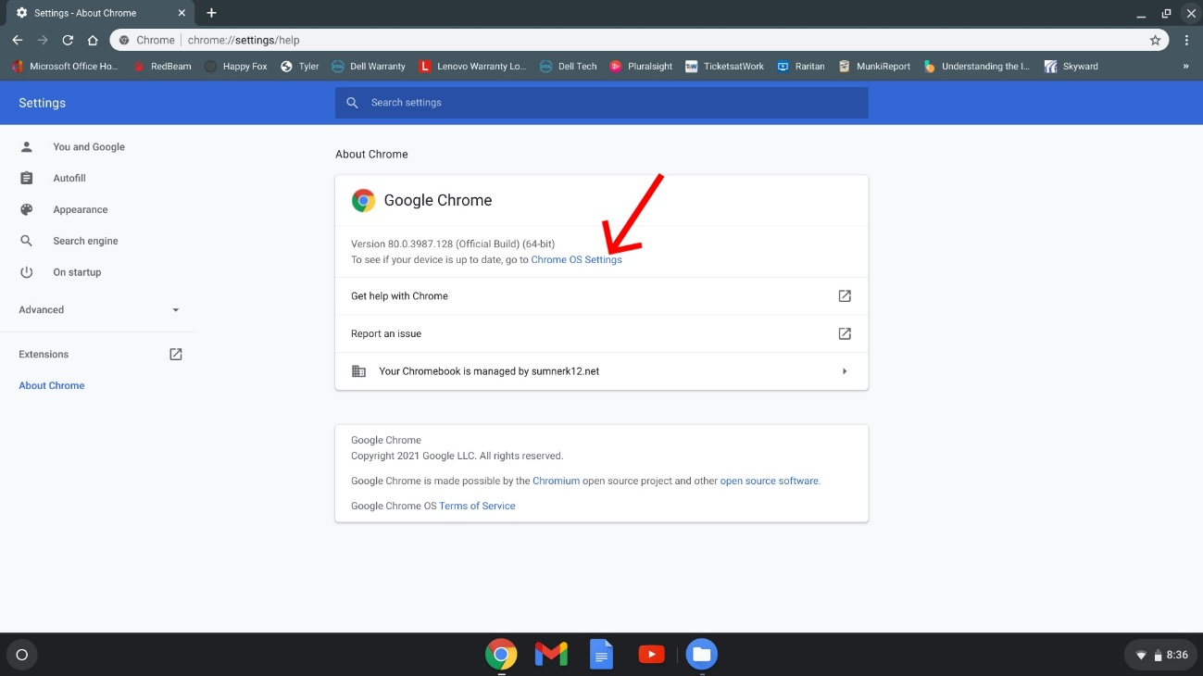

Click the Check for Updates button.
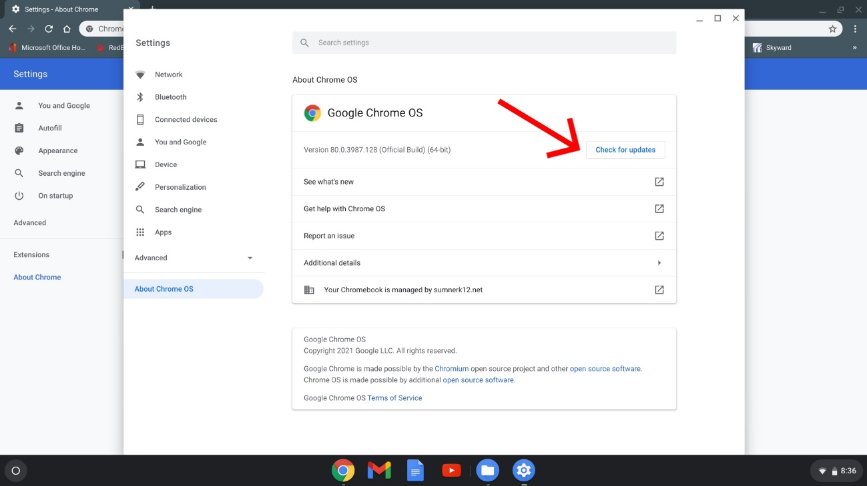

Once done updating, you should see a RESTART button. Restart the device.
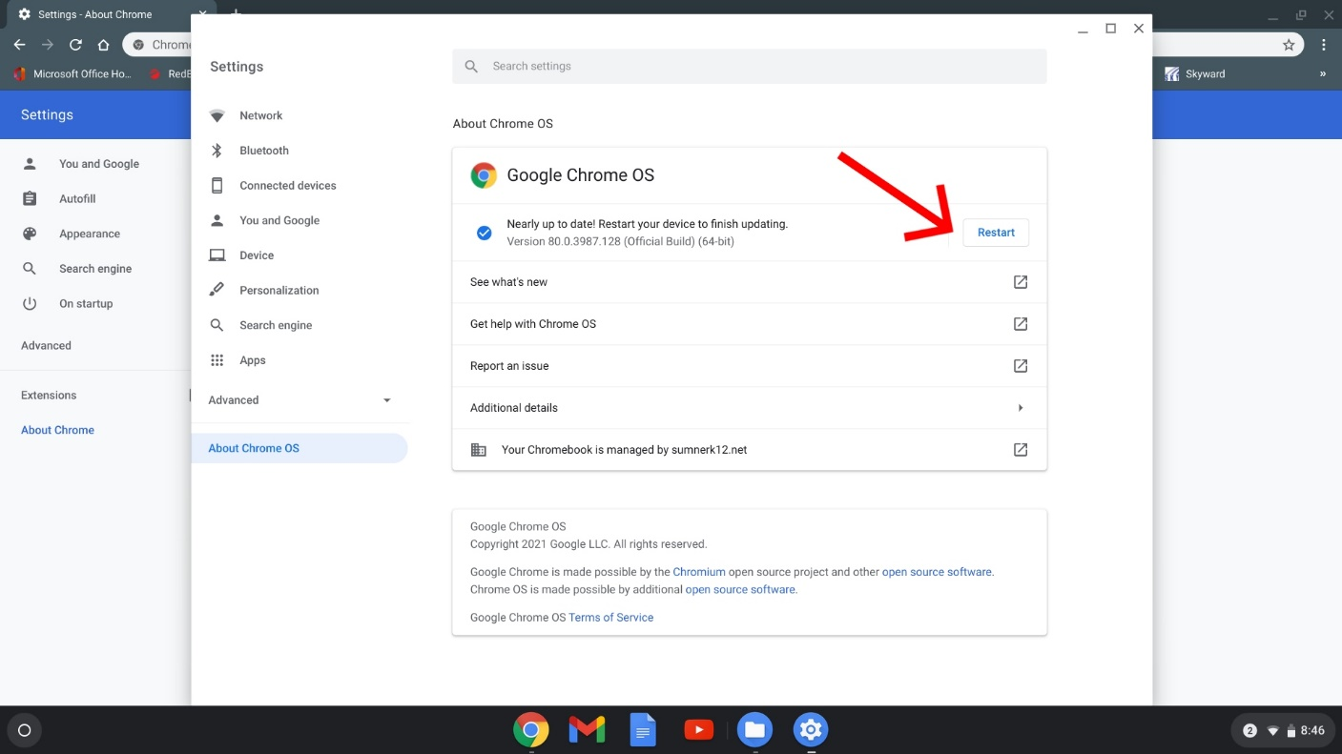

You can repeat the following steps to ensure there are no more updates.

