Lenovo |  | Apple
Laptop Models | Desktop Models | Macbooks/iMacs/MacMinis
11e 1st/2nd Gen | 1F3 | iMac (21.5-inch, Late 2009)
11e 3rd Gen | A25 | iMac (21.5-inch, Late 2012)
E430 | A32 | iMac (21.5-inch, Late 2013)
E470 | A1U | iMac (21.5-inch, Mid 2010)
E560 | A3U | iMac (21.5-inch, Mid 2011)
E570 | B1U | iMac (21.5-inch, Mid 2014)
L430 | B3U | iMac (27-inch, Late 2013)
L440 | B5U | iMac (Retina 5K, 27-inch, Late 2014)
L450 | B9U | Mac mini (Late 2012)
L460 | C2U | Mac mini (Late 2014)
L470 | E4U | MacBook Air (11-inch, Early 2014)
L560 | 10AG | MacBook Air (13-inch, Early 2014)
P50s | 10AX | MacBook Pro (13-inch, Mid 2010)
P51s | 10B3 | MacBook Pro (13-inch, Mid 2012)
T440s | 10B6 | MacBook Pro (15-inch, Mid 2012)
T460s | 10BT | MacBook Pro (Retina, 13-inch, Mid 2014)
x130e | 10BU | MacBook Pro (Retina, 15-inch, Late 2013)
x131e | 10CT | MacBook Pro (Retina, 15-inch, Mid 2014)
Yoga 260 | 10EY | MacBook Pro (Retina, 15-inch, Mid 2015)
When deploying devices, we often replace retiring devices and place them in a ‘Surplus Area’ at a school location. We have included a table below of various models* which would ideally be replaced, or at the minimum retired from usage as a primary instructional device/workstation. Please use this as a reference to help encourage replacement vs supplementing an existing outdated device.
A couple of notes regarding the included table:
- All are beyond manufacturer’s warranty and also exceed Technology’s supported hardware range.
- The majority devices listed are hardware which is approaching 6+ years old.
- If not already apparent, these devices do not offer an ideal experience for End-Users.
- Hardware requirements have increased over the past several years, the list includes many models
which do not meet recommended hardware requirements for various requested software.

*There are some models which may not appear on this list due to not being powered on or connected to network/utilized on a campus recently. If you have a question of a model which does not appear on the table above, please reach out to us with a serial # and we can advise on those instances.

Determining the Model of above referenced devices:
- Lenovo Laptop: These are easily identified while looking at the device below the Right Bottom corner
of the display.
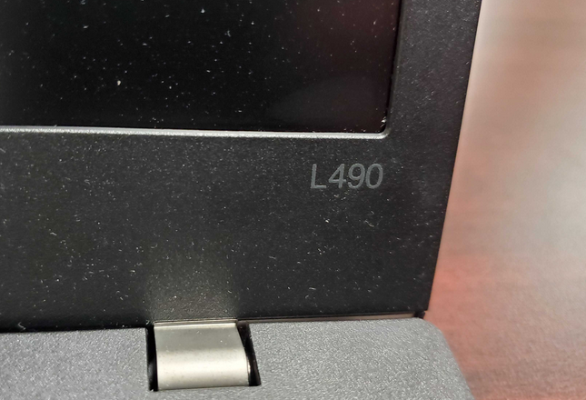
- Lenovo Desktop: There is a tag that is best referenced on these located on the case towards the rear of
the device. Lenovo altered their tag in 2014. The images below highlight the model location.
(Primarily Pre-2014) (2014 Onward)
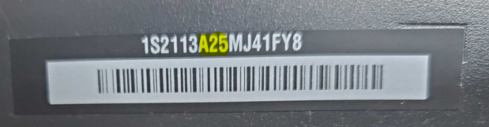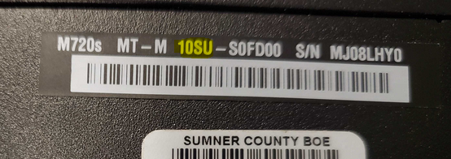
- Apple Devices: Navigate to the ‘Apple Icon’ in the top left and select ‘About this Mac’.
Within the ‘Overview’ tab which is shown as default, we see Mac Mini (2018) below as an example.
