Let’s create a Google Account with your WileyX email to save all your bookmarks. FOREVER. 😊

First let’s backup your bookmarks! Press CTRL + Shift + O in Chrome.

This page should come up, press the “three dots” for the options menu.

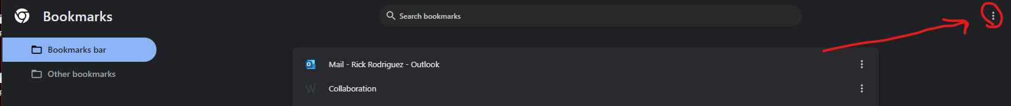

Then choose “export bookmarks”

Chrome will now let you save your bookmarks file! Take note of where you save it!

**Now let’s create a Google account.**

Go to accounts.google.com in Chrome. Choose “create account” in the bottom right. Then “for my personal use” when it pops up.

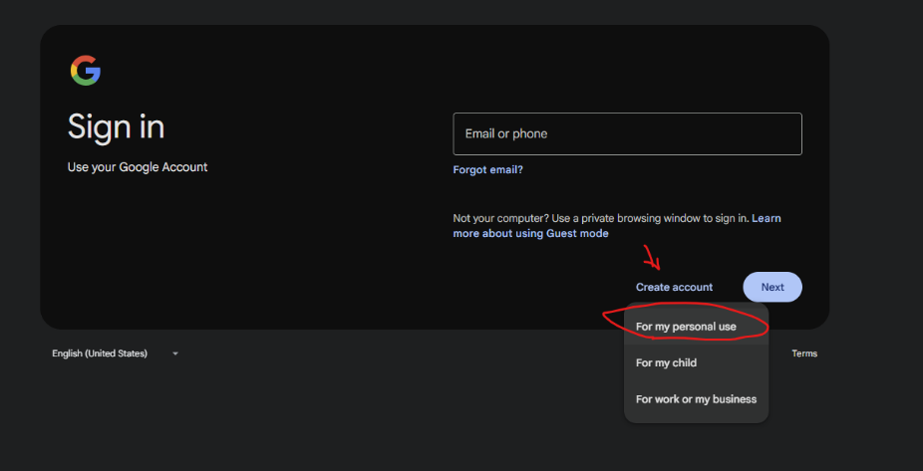

Then choose “for my personal use.”

Enter your name on the next page and click “next.”

Enter what you’d like in the next window.

On this window choose “use your existing email.”

Enter your Wiley X email and click next.

Google will send you a code to your email. Enter it for verification:

Enter a password:

The final step is to give them a phone number to verify and use as two factor authentication:

Sign in with your new user! Open chrome and click the “three dots” in the upper right corner.

Choose “Person 1” where it says “not signed in”:

Sign in with your new user, choose “turn on sync.”

Sign in with your new user! It should be your Wiley X email and whatever password you chose.

After you’re signed in, go back to the “three dots.”

Choose “bookmarks and lists” from the dropdown menu, then “import bookmarks and settings from the next menu that pops up on the left:

Chrome will open up a new page showing your new account and a window stating “Import bookmarks and settings”. Choose “Bookmarks HTML file” from the drop down menu and click next. Find the file you saved with your bookmarks, and select it.

Now, you can use this same account any time you get a new machine. You’ll never lose your bookmarks again.