Duo for PeopleSoft

Before you begin, you will need to have a valid employee id and password. Enrollment in Duo (for WILM) is required for accessing PeopleSoft HR, Finance and Campus Solutions. You will need to setup a default device for use with Duo.

After logging into PeopleSoft with your network password, you will be prompted on your mobile device to approve the log in or obtain a passcode from a FOB/token (limited availability) to use with your password.

Option #1  Send a Push Notification to your mobile device. |  | Option #2  Use the six-digit passcode from a FOB/token.
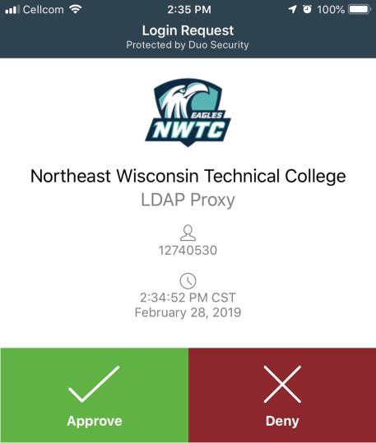 |  | 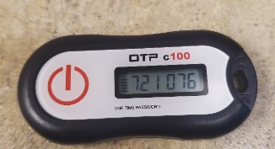

Login Option #1: Duo App Notification to your mobile device
- Log into MyCampus and choose the PeopleSoft database that you need to access.
- As the page waits, a Duo app-notification will be sent to your mobile device. Once you hit "Approve". You will be allowed into PeopleSoft.

This page is waiting for approval.
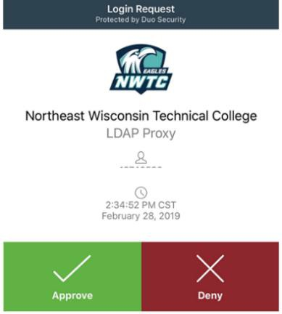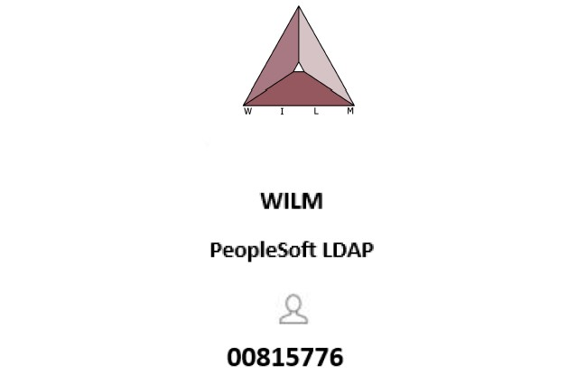

  - Choose Approve on your mobile device.
  - If you do not approve the Duo notification, it will time out, you will then be able to enter your credentials. Another Duo notification will be sent to your mobile device. You will need to approve it before you are allowed into PeopleSoft.
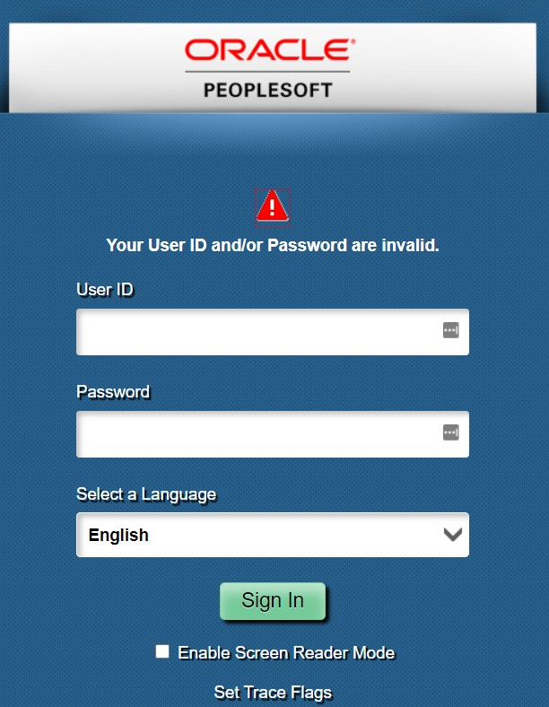
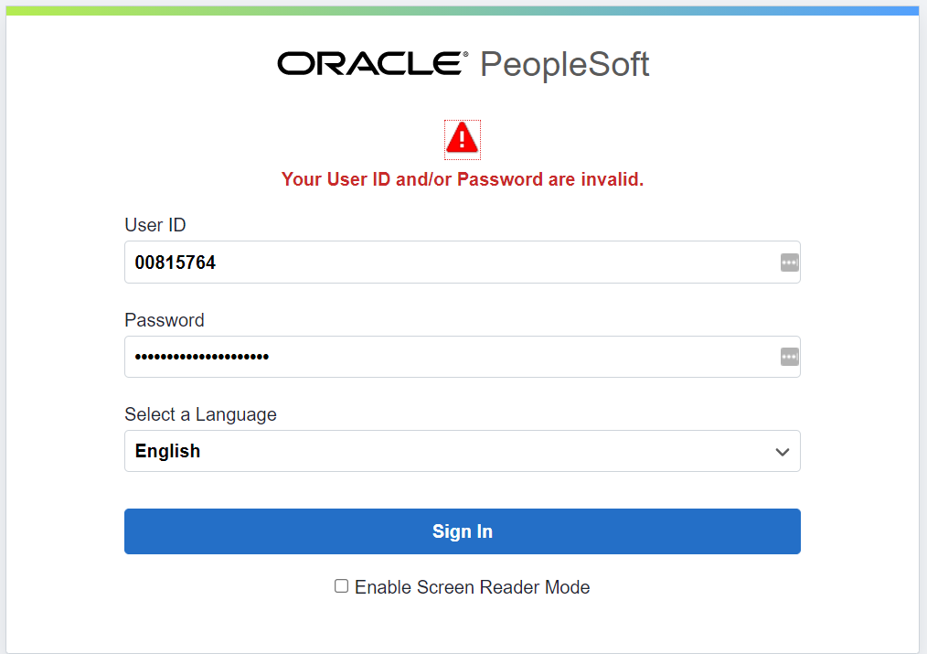
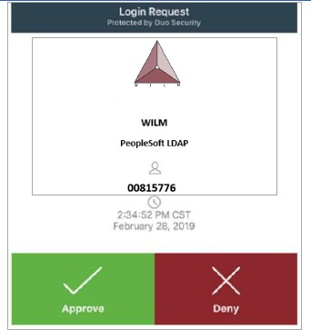

2

Login Option #2: Duo Passcode
- Log into MyCampus and choose the PeopleSoft database that you need to access.

- You will be presented with a PeopleSoft login page.

- You will enter your Emplid as the User ID and your network password followed by a comma, then passcode from your token.

- To get a passcode from your Duo token, press the button and a new passcode will be displayed.

- Password example: enter your college network password, followed by a comma and the six-digit passcode displayed on your DUO token. Example: MyPasswordComma,721076

Example:

5. Press the “Sign In” button. Please be patient, it may take a few seconds for the sign-on process to complete.

For assistance, please see create a help desk ticket at myhelp.witc.edu

